|  |  |
| --- | --- |
|  | **MINISTRY OF EDUCATION AND TRAINING** |

|  |
| --- |
| **FPT UNIVERSITY** |
| Capstone Project Document |
| Learner Management and 3D Simulation System for Crane Training Center |

|  |  |
| --- | --- |
| **Group GFA25SE59** | |
| **Group Members** | Duong Minh Nhat - SE182236  Dao Trong Duc - SE180110  Pham Dang Khoi - SE170462  Le Nhat Quang - SE170415 |
| **Supervisor** | Mr. Ngo Dang Ha An Mr. Pham Thanh Tri |
| **Ext Supervisor** |  |
| **Capstone Project code** | FA25SE097 |

- Ho Chi Minh City, December 2025 -

**Table of Contents**

[Acknowledgement 7](#_Toc25737)

[Definition and Acronyms 7](#_Toc27195)

[I. Project Introduction 9](#_Toc24087)

[1. Overview 9](#_Toc18650)

[1.1 Project Information 9](#_Toc30209)

[1.2 Project Team 9](#_Toc9451)

[2. Product Background 9](#_Toc14587)

[3. Existing Systems 9](#_Toc3726)

[3.1 ITI (Industrial Training International) 9](#_Toc15360)

[3.2 CM Labs Simulations (Vortex) 10](#_Toc16091)

[3.3 NCCER (National Center for Construction Education and Research) 10](#_Toc5027)

[4. Business Opportunity 10](#_Toc16502)

[5. Software Product Vision 10](#_Toc24944)

[6. Project Scope & Limitations 11](#_Toc31275)

[6.1 Major Features 11](#_Toc24904)

[6.1.1 Web Application for Admin 11](#_Toc4466)

[6.1.2 Web Application for Simulation Manager 11](#_Toc9250)

[6.1.3 Web Application for Instructor 11](#_Toc18301)

[6.1.4 Web Application for Trainee 12](#_Toc15452)

[6.1.5 3D Simulation Application for Trainee 12](#_Toc11612)

[6.2 Limitations & Exclusions 12](#_Toc26159)

[II. Project Management Plan 13](#_Toc26668)

[1. Overview 13](#_Toc11523)

[1.1 Scope & Estimation 13](#_Toc19847)

[1.2 Project Objectives 14](#_Toc28817)

[1.3 Project Risks 15](#_Toc17568)

[2. Management Approach 15](#_Toc28698)

[2.1 Project Process 15](#_Toc6442)

[2.2 Quality Management: 16](#_Toc29742)

[2.3 Training Plan: 17](#_Toc5748)

[3. Project Deliverables: 17](#_Toc13279)

[4. Responsibility Assignments 17](#_Toc13406)

[5. Project Communications 18](#_Toc14416)

[6. Configuration Management 19](#_Toc11548)

[6.1 Document Management 19](#_Toc23043)

[6.2 Source Code Management 19](#_Toc18909)

[6.3 Tools & Infrastructures 19](#_Toc3412)

[III. Software Requirement Specification 20](#_Toc26059)

[1. Product Overview 20](#_Toc8192)

[2. User Requirements 20](#_Toc25097)

[2.1 Actors 20](#_Toc22438)

[2.2 Use Case 21](#_Toc23187)

[2.2.1 Use Case Diagram 21](#_Toc8620)

[2.2.2 Descriptions 23](#_Toc11056)

[3. Functional Requirements 29](#_Toc18157)

[3.1 System Functional Overview 29](#_Toc3279)

[3.1.1 Screens Flow 29](#_Toc27150)

[3.1.1.1 Admin Flow 29](#_Toc5902)

[3.1.1.2 Trainee Flow 29](#_Toc3458)

[3.1.1.2 Instructor Flow 30](#_Toc3774)

[3.1.1.2 Simulation Manager Flow 30](#_Toc1649)

[3.1.2 Screen Descriptions 30](#_Toc29075)

[3.1.3 Screen Authorization 32](#_Toc11303)

[3.1.4 Non-Screen Functions 34](#_Toc28784)

[3.1.5 Entity Relationship Diagram 35](#_Toc20408)

[3.1.6 Entity Relationship Description 35](#_Toc21735)

[3.2 Feature 1: Trainee Learning & Progress Tracking 38](#_Toc9718)

[3.3 Feature 2: Trainee Simulation Practice 40](#_Toc29670)

[3.4 Feature 3: Program & Course Management 43](#_Toc24049)

[3.5 Feature 4: Trainee Final Examination 45](#_Toc7852)

[4. Non-Functional Requirements 47](#_Toc12439)

[4.1 Security 47](#_Toc19573)

[4.2 Performance & Scalability 47](#_Toc23085)

[4.3 Interoperability & Compatibility 48](#_Toc19075)

[4.4 Availability & Reliability 48](#_Toc13494)

[5. Business Rules 48](#_Toc28011)

[IV. Software Design Description 56](#_Toc8846)

[1. System Design 56](#_Toc21969)

[1.1 System Architecture Diagram 56](#_Toc12980)

[1.2 Component Diagram 57](#_Toc11253)

[2. Database Design 59](#_Toc29857)

[3. Detailed Design 65](#_Toc4291)

[3.1 Program & Course Management 65](#_Toc24477)

[3.1.1 Class Diagram 65](#_Toc14400)

[3.1.2 Sequence Diagram - Admin Creates Program 66](#_Toc4590)

[3.1.3 Sequence Diagram - Admin Creates Course 67](#_Toc143)

[3.1.4 Sequence Diagram - Admin Adds Course To Program 68](#_Toc3675)

[3.2 Class Management & Enrollment 69](#_Toc12767)

[3.2.1 Class Diagram 69](#_Toc4814)

[3.2.2 Sequence Diagram - Trainee Enrolls to Class 70](#_Toc14077)

[3.2.3 Sequence Diagram - Admin Confirms Enrollment 71](#_Toc14633)

[3.3 Simulation Practice Management 72](#_Toc23405)

[3.3.1 Class Diagram 72](#_Toc23421)

[3.3.2 Sequence Diagram - Simulation Manager Creates Practice 73](#_Toc17191)

[3.3.3 Sequence Diagram - Trainees Attempt Practice 74](#_Toc16202)

[3.4 Final Exam Management 75](#_Toc12659)

[3.4.1 Class Diagram 75](#_Toc26480)

[3.4.2 Sequence Diagram - Final Exam Configuration 76](#_Toc8060)

[3.5 Dashboard & Reports 77](#_Toc11002)

[3.5.1 Class Diagram 77](#_Toc26763)

[3.5.2 Sequence Diagram - Admin Views Dashboard 78](#_Toc24297)

[V. Software Testing Documentation 79](#_Toc16651)

[1. Overall Description 79](#_Toc5029)

[1.1 Test Model 79](#_Toc5830)

[1.2 Testing Levels 79](#_Toc10952)

[1.3 Testing Types 79](#_Toc11263)

[2. Test Plan 79](#_Toc28759)

[2.1 Test Stages 79](#_Toc3148)

[2.2 Resources 79](#_Toc31396)

[2.3 Test Milestones 80](#_Toc12645)

[2.4 Deliverables 80](#_Toc28276)

[3. Test Cases 80](#_Toc8002)

[4. Test Reports 81](#_Toc28954)

[VI. Release Package & User Guides 81](#_Toc14902)

[1. Deliverable Package 81](#_Toc8361)

[1.1 Source codes & documents 81](#_Toc28401)

[1.2 Known Issues, Limitations & Restrictions 82](#_Toc27237)

[2. Installation Guides 82](#_Toc17297)

[2.1 System Requirements 82](#_Toc6690)

[2.1.1 Hardware Requirements 82](#_Toc25124)

[2.1.2 Software Requirements 83](#_Toc4399)

[2.2 Setup Files 83](#_Toc28744)

[2.2.1 Database Files 83](#_Toc18941)

[2.2.2 Backend Files 83](#_Toc25809)

[2.2.3 Frontend Files 83](#_Toc13735)

[2.2.4 Configuration Files 84](#_Toc21406)

[2.3 Installation Instruction 84](#_Toc11007)

[2.3.1 Setup Environment 84](#_Toc10492)

[2.3.2 Setup Database 85](#_Toc6868)

[2.3.3 Setup and Run Backend API 86](#_Toc22863)

[2.3.4 Setup and Run Frontend Web Application 88](#_Toc7046)

[2.3.5 Deployment to Production 89](#_Toc28377)

[3. User Manual 90](#_Toc11817)

[3.1 Terms and definitions 90](#_Toc28369)

[3.2 System requirements 91](#_Toc29119)

[3.3 Application Usage 92](#_Toc6193)

[3.3.1 Overview 92](#_Toc23897)

[3.3.2 Feature 1: Authentication & User Management 92](#_Toc20954)

[3.3.3 Feature 2: Program & Course Management 92](#_Toc8217)

[3.3.4 Feature 3: Class Management 111](#_Toc2822)

[3.3.5 Feature 4: Learning Content Management 118](#_Toc32365)

[3.3.6 Feature 5: Simulation Practice 123](#_Toc10274)

[3.3.7 Feature 6: Simulation Management 142](#_Toc32250)

[3.3.8 Feature 7: Trainee Learning Portal 159](#_Toc10106)

# Acknowledgement

We would like to extend our deepest appreciation to our supervisors, Mr. Ngo Dang Ha An and Mr. Pham Thanh Tri. Your expertise, guidance, and constructive feedback throughout the development of the We would like to express our deepest gratitude to **FPT University** for providing us with a professional academic environment and the necessary resources to support us throughout this Capstone Project.

We would like to extend our sincere appreciation to our supervisors, **Mr. Ngo Dang Ha An** and **Mr. Pham Thanh Tri**. Your expertise, dedicated guidance, and constructive feedback were invaluable in helping us navigate the challenges of developing the ***Learner Management and 3D Simulation System for Crane Training Center***. Your mentorship kept our project on the right track and aligned with its core objectives.

We also want to thank the instructors and subject matter experts who shared their insights into crane operation training, which were crucial for defining the requirements of our system.

Finally, we are grateful to our families and friends for their unwavering support and encouragement during this journey. This project is the result of the hard work, collaboration, and dedication of all members of **Group GFA25SE59**.

# Definition and Acronyms

|  |  |
| --- | --- |
| **Acronym** | **Definition** |
| LSSCTC | Learner Management and 3D Simulation System for Crane Training Center |
| BA | Business Analysis |
| BR | Business Rule |
| ERD | Entity Relationship Diagram |
| GUI | Graphical User Interface |
| PM | Project Manager |
| SDD | Software Design Description |
| SPMP | Software Project Management Plan |
| SRS | Software Requirement Specification |
| UAT | User Acceptance Test |
| UC | Use Case |
| API | Application Program Interface |
| FE | Feature |
| SI | Simulation Feature |
| LI | Limitation |
| EX | Exclusion |
| SIM | Simulation |
| VR | Virtual Reality |
| HTTPS | Hypertext Transfer Protocol Secure |
| CORS | Cross-Origin Resource Sharing |
| NCCER | National Center for Construction Education and Research |
| ITI | Industrial Training International |
| REST | Transmission Control Protocol |
| DBMS | Database Management System |
| ORM | Object-Relational Mapping |
| PK | Primary Key |
| FK | Foreign Key |
| SMTP | Simple Mail Transfer Protocol |
| SQL | Structured Query Language |
| TE | Theory Exam (of Final Exam) |
| SE | Simulation Exam (of Final Exam) |
| PE | Practical Exam (of Final Exam) |

# I. Project Introduction

## 1. Overview

### 1.1 Project Information

1. Project name: Learner Management and 3D Simulation System for Crane Training Center
2. Project code: FA25SE097
3. Group name: GFA25SE59
4. Software type: Web App, Desktop App

### 1.2 Project Team

|  |  |  |  |
| --- | --- | --- | --- |
| **Full Name** | **Role** | **Email** | **Mobile** |
| Ngo Dang Ha An | Supervisor | [AnNDH2@fe.edu.vn](mailto:AnNDH2@fe.edu.vn) | 0906782333 |
| Pham Thanh Tri | Supervisor | [TriPT9@fe.edu.vn](mailto:TriPT9@fe.edu.vn) | 0937359396 |
| Duong Minh Nhat | Leader | [nhatdmse182236@fpt.edu.vn](mailto:Nhatdmse182236@fpt.edu.vn) | 0704585671 |
| Le Nhat Quang | Member | [quanglnse170415@fpt.edu.vn](mailto:quanglnse170415@fpt.edu.vn) | 0862008529 |
| Dao Trong Duc | Member | [ducdtse180110@fpt.edu.vn](mailto:ducdtse180110@fpt.edu.vn) | 0987039122 |
| Pham Dang Khoi | Member | [khoipdse170462@fpt.edu.vn](mailto:khoipdse170462@fpt.edu.vn) | 0854489295 |

## 2. Product Background

Crane operation training requires a combination of theoretical understanding and significant practical experience. Traditional training methods that rely exclusively on real cranes present several major challenges. These include high operational costs (fuel, maintenance, instructor time), limited availability of physical equipment for trainees, and most importantly, significant safety risks for beginners operating heavy machinery.

Training centers often struggle with the logistics of managing training schedules, effectively tracking the progress of numerous trainees, and ensuring a consistent quality of instruction. Furthermore, without modern simulation tools, trainees may lack sufficient and safe preparation before they are required to operate real, high-risk equipment. This situation leads to a demand for an integrated system that can streamline training center management while also providing a safe, realistic, and cost-effective 3D simulation environment to enhance learning efficiency and reduce operational risks.

## 3. Existing Systems

### 3.1 ITI (Industrial Training International)

Link 1: [ITI Simulator Capture](https://www.youtube.com/watch?v=uc56yh4-W8c)

Link 2: [ITI Courses](https://www.iti.com/simulations)

ITI offers a complete ecosystem that combines its Learning Management System with a massive library of VR Crane Simulations. Performance metrics from the simulation (e.g., pass/fail, efficiency) are automatically fed back into the student's record in the LMS.

They offer a wide variety of scenarios and crane models. However, ITI Simulator relies on high-cost Virtual Reality (VR) hardware, which can be expensive to deploy to a large number of trainees simultaneously.

### 3.2 CM Labs Simulations (Vortex)

Link: [CM Labs Main Site](https://www.cm-labs.com/en/simulators/crawler-crane-simulator-training-pack/)

CM Labs is a market leader in high-fidelity, physics-based simulation for heavy equipment. They are widely regarded for providing the most accurate simulation of crane physics and machine behaviour. CM Labs support both normal setup and high-cost alternative.

However, they are not a complete LMS and require training center to maintain a separate LMS integration. That leads to significant complexity and cost.

### 3.3 NCCER (National Center for Construction Education and Research)

Link: [NCCER Mobile Crane Course](https://www.nccer.org/craft-catalog/mobile-crane-operations/)

NCCER provides a standardized curriculum and a registry system (LMS) for managing craft training, assessments, and certifications, including for crane operators. This system is a leader in managing the theoretical and book-learning components of training.

However, NCCER is not integrated with any 3D Simulator, and highly relies on available devices. This creates a significant gap between theory and practice, introduces high safety risks for new trainees, and incurs high operational costs (fuel, machine wear, instructor time).

## 4. Business Opportunity

The heavy equipment training industry faces persistent operational and financial challenges. Training centers are constrained by the high operational costs of machine fuel and maintenance, significant safety risks for novice operators, and the low scalability of one-on-one physical instruction. Concurrently, the administrative burden of managing trainee schedules, tracking theoretical progress, and logging practical results is a major logistical inefficiency.

There is a strong demand for a single, cost-effective system that can streamline workflows through a central web-based Learning Management System, while cutting the gap between theory and high-risk practice by providing a safe, low-cost, and repeatable 3D simulation environment.

## 5. Software Product Vision

For crane training centers seeking to modernize their curriculum, enhance safety, and reduce operational costs, LSSCTC is an integrated software suite that provides a unified system for both theoretical and practical training.

The system combines a comprehensive web-based LMS for managing courses, users, and progress, with an accessible desktop 3D simulation application for hands-on practice. This approach empowers training centers to deliver a scalable and cost-effective program that improves trainee preparedness and safety, while simultaneously providing administrators and instructors with a centralized tool to manage the learning lifecycle.

## 6. Project Scope & Limitations

### 6.1 Major Features

#### 6.1.1 Web Application for Admin

FE-01: Login/Logout.

FE-02: Manage personal profile: view profile, update profile, change password.

FE-03: Manage user account: view user account, add user account, deactivate user account.

FE-04: Manage program: view program, add new program, update program, assign course for program.

FE-05: Manage course: view course, add new course, update course.

FE-07: Manage class: view class, add new class for specific course, update class, assign instructor.

FE-08: Manage simulation timeslot: view slot, add new slot, update slot, assign practice to slot.

#### 6.1.2 Web Application for Simulation Manager

FE-09: Manage personal profile: view profile, update profile, change password.

FE-10: Manage simulation component: view component, add new component, update component.

FE-11: Manage simulation task: view action, add new action, update action.

FE-12: Manage simulation practice: view practice, add new practice, update practice.

#### 6.1.3 Web Application for Instructor

FE-13: Login/Logout.

FE-14: Manage personal profile: view profile, update profile, change password.

FE-15: Manage class member: view member, add new member.

FE-16: Manage class section: view section, add new section, update section.

FE-17: Manage learning material: view material, add new material, update material, assign material to section.

FE-18: Manage quiz: view quiz, add new quiz, update quiz, assign quiz to section.

FE-19: View list practices and can assign practices to class section.

FE-20: View trainee result on quizzes and practices and can provide direct feedback.

FE-21: View trainee overall performance in class and can confirm pass or fail result for each trainee in class.

FE-22: Manage final exam: setup Theory Exam, Simulation Exam, Practical Exam.

FE-23: Take attendance.

#### 6.1.4 Web Application for Trainee

FE-24: Login/Logout.

FE-25: Manage personal profile: view profile, update profile, change password.

FE-26: View available programs, courses, classes, and can make enrolment.

FE-27: View class syllabus and sections.

FE-28: View learning material assigned to class section and can access or download material.

FE-29: View quizzes assigned to class section and can make attempt or view recorded results.

FE-30: View practices assigned to class section and can view recorded results.

FE-31: Take final exam

#### 6.1.5 3D Simulation Application for Trainee

SI-01: Login/Logout.

SI-02: View list practices in which trainee is assigned to and can select a practice to make new attempt.

SI-03: View simulation guides and settings.

SI-04: View practice steps and step details (including target components, target actions, expected outcome).

SI-05: View simulation components, and can make action (inspect definition, lift, rotate).

SI-06: View step result and warning message when committing an error.

SI-07: View post-practice result (time, completion status).

### 6.2 Limitations & Exclusions

Limitations:

LI-01: Simulation Platform: The 3D Simulation Application (6.1.5) is a desktop-only application (Windows/Linux/macOS) and is not accessible via web browser or mobile device.

LI-02: Simulation Scope: The simulation practice does not perfectly represent real-world crane models and physics.

LI-03: Content Management: The system provides feature to manage program content and simulation settings, but it does not include creating core assets and scripts inside simulation environment.

Exclusions:

EX-01: Payment and Billing: The system does not support any payment processing or billing features.

EX-02: Communication: The system does not support comments, live chat or discussion forum. Feedback feature is private.

EX-03: Final Examination: The system is a training and preparedness tool, not a final certification authority. All official, final examinations (the hands-on, practical test with real crane vehicle, in-person written exams) are conducted offline and are outside the scope of this system.

EX-04: Course Certificate: The system issues Certificate of Training / Certificate of Completion to validate that a trainee has finished a course within the training centre. The issuance does not connect to, or submit result to, any government and regulatory body.

# II. Project Management Plan

## 1. Overview

### 1.1 Scope & Estimation

|  |  |  |  |
| --- | --- | --- | --- |
| **#** | **WBS Item** | **Complexity** | **Est. Effort**  **(man-days)** |
| **1** | **Web Application for Admin** |  | **22** |
| 1.1 | FE-01: Login/Logout | Simple | 2 |
| 1.2 | FE-02: Manage personal profile | Simple | 2 |
| 1.3 | FE-03: Manage user account | Medium | 4 |
| 1.4 | FE-04: Manage program (assign courses) | Medium | 5 |
| 1.5 | FE-05: Manage course | Simple | 3 |
| 1.6 | FE-07: Manage class (assign instructor) | Medium | 6 |
| **2** | **Web Application for Simulation Manager** |  | **32** |
| 2.1 | FE-08 & FE-09: Auth & Profile | Simple | 2 |
| 2.2 | FE-10: Manage simulation component | Complex | 6 |
| 2.3 | FE-11: Manage simulation action | Medium | 5 |
| 2.4 | FE-12: Manage simulation practice | Complex | 7 |
| 2.5 | FE-13: Manage practice step | Complex | 6 |
| 2.6 | FE-14: Manage practice warning | Medium | 3 |
| 2.7 | FE-15: Manage simulation timeslot | Medium | 3 |
| **3** | **Web Application for Instructor** |  | **28** |
| 3.1 | FE-16 & FE-17: Auth & Profile | Simple | 2 |
| 3.2 | FE-18: Manage class member | Simple | 2 |
| 3.3 | FE-19 & FE-20: Manage sections & materials | Medium | 6 |
| 3.4 | FE-21: Manage quiz (assign to section) | Medium | 6 |
| 3.5 | FE-22: View & assign practices | Simple | 3 |
| 3.6 | FE-23: View results & provide feedback | Medium | 5 |
| 3.7 | FE-24: View overall performance & grading | Medium | 4 |
| **4** | **Web Application for Trainee** |  | **24** |
| 4.1 | FE-25 & FE-26: Auth & Profile | Simple | 2 |
| 4.2 | FE-27: View programs/enrollment | Medium | 4 |
| 4.3 | FE-28 & FE-29: View syllabus & materials | Simple | 3 |
| 4.4 | FE-30: Quiz attempt & history | Complex | 8 |
| 4.5 | FE-31: View practice results | Simple | 3 |
| 4.6 | **System Integration (API & Database)** | **Complex** | **4** |
| **5** | **3D Simulation Application (Desktop)** |  | **45** |
| 5.1 | SI-01: Login/Logout (API Integration) | Simple | 3 |
| 5.2 | SI-02: List practices & selection | Medium | 4 |
| 5.3 | SI-03 & SI-04: Guides, Settings & Steps UI | Medium | 6 |
| 5.4 | SI-05: Simulation Physics (Lift, Rotate, Inspect) | Complex | 15 |
| 5.5 | SI-06: Error detection & warning system | Complex | 10 |
| 5.6 | SI-07: Result calculation & submission | Medium | 7 |
|  | **Total Estimated Effort (man-days)** |  | **151** |

### 1.2 Project Objectives

|  |  |  |  |  |
| --- | --- | --- | --- | --- |
| **#** | **Testing Stage** | **No. of Defects** | **% of Defect** | **Notes** |
| 1 | Reviewing | 40 | 35% |  |
| 2 | System Test | 45 | 40% |  |
| 3 | Acceptance Test | 20 | 25% |  |

### 1.3 Project Risks

|  |  |  |  |  |
| --- | --- | --- | --- | --- |
| **#** | **Risk Description** | **Impact** | **Possibility** | **Response Plans** |
| 1 | Technology risk: to target available tools and framework for project overall requirements | High | Medium | Do research and testing of different technical solutions before developing main features. |
| 2 | Requirement misunderstanding risk: to correctly specify each requirement based on real-world scenarios and best-practice solution | High | High | Verify requirements with evaluation from realistic data or references, have reviews with stakeholders. |

## 2. Management Approach

### 2.1 Project Process

The project will be executed using the Agile software development methodology, specifically the Scrum framework. This approach allows the team to adapt to changes quickly, deliver incremental value, and ensure continuous feedback throughout the development lifecycle.

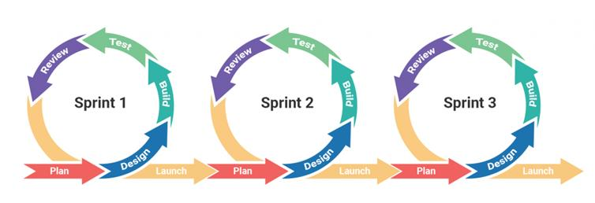

Sprints: The development timeline is divided into 2-week Sprints. Each sprint focuses on delivering a specific set of features (from the Product Backlog) that results in a potentially shippable product increment.

**Key Roles:**

* Product Owner (Leader): Responsible for defining the product vision, managing the Product Backlog, and prioritizing features based on stakeholder value.
* Scrum Master (Rotational/Assigned): Ensures the team adheres to Scrum practices, removes obstacles (blockers), and facilitates meetings.
* Development Team (All Members): Cross-functional members responsible for designing, coding, testing, and integrating the software.

**Scrum Ceremonies:**

* Sprint Planning (Day 1 of Sprint): The team selects items from the Product Backlog to work on during the sprint and breaks them down into tasks.
* Daily Stand-up (15 mins): A brief daily meeting where members report what they did yesterday, what they will do today, and any blockers they are facing.
* Sprint Review (Last Day of Sprint): The team demonstrates the completed work to supervisors/stakeholders to gather feedback.
* Sprint Retrospective (After Review): The team discusses what went well, what didn't, and how to improve processes for the next sprint.

### 2.2 Quality Management:

To ensure the "Learner Management and 3D Simulation System" meets high-quality standards and functional requirements, the team will implement the following quality assurance measures:

**Defect Prevention:**

* Coding Standards: The team will adhere to standard C# (.NET) and JavaScript (React) coding conventions to ensure code readability and maintainability.
* Static Code Analysis: Tools will be used in the IDE (Visual Studio/VS Code) to catch syntax errors and potential bugs early during development.
* Clear Requirements: All User Stories must have defined "Acceptance Criteria" before development begins to prevent misunderstanding.

**Reviewing:**

* Peer Code Reviews: All code changes must be submitted via Pull Requests (PR) on GitHub. At least one other team member must review the code for logic errors, style violations, and potential performance issues before it is merged into the main or develop branch.
* Document Reviews: Project documents (SRS, SDD) are reviewed by the Supervisor and team members to ensure consistency and completeness.

**Testing Strategy:**

* Unit Testing: Developers are responsible for writing unit tests for critical business logic, particularly for the API (Backend) services and complex Simulation algorithms.
* Integration Testing: Verifying that different modules work together correctly.
  + Web App: Testing communication between the React Frontend and .NET Backend APIs.
  + Simulation: Testing the data exchange between the Unity Desktop App and the Backend Server (e.g., login, score submission).
* System Testing (Functional Testing): The team will execute manual test cases based on the SRS to verify that the system functions as a whole and meets all user requirements (e.g., An instructor assigning a quiz, a trainee completing a simulation).
* User Acceptance Testing (UAT): Conducted near the end of the project (or Sprint Reviews) where the Supervisors/Instructors test the system to confirm it meets their business needs.

**Bug Tracking:**

* Defects found during testing will be logged in GitHub Issues or the project management tool (Jira/Excel) with a priority level (Critical, High, Medium, Low) and assigned to a developer for fixing.

### 2.3 Training Plan:

|  |  |  |  |
| --- | --- | --- | --- |
| **Training Area** | **Participants** | **When, Duration** | **Waiver Criteria** |
| Unity | All members | 2 weeks | Mandatory |
| Blender | All members | 2 weeks | Mandatory |
| ASP.NET | All members | 2 weeks | Mandatory |
| React | All members | 2 weeks | Mandatory |
| GitHub | All members | 2 weeks | Mandatory |

## 3. Project Deliverables:

|  |  |  |  |
| --- | --- | --- | --- |
| **#** | **Deliverable** | **Due Date** | **Notes** |
| 1 | Project Introduction document | 24/10/2025 | Overall project description |
| 2 | Project Management document | 26/10/2025 | Project estimation and management approach |
| 3 | SRS document | 05/11/2025 | Software Requirement Specification |
| 4 | Software Design Document | 15/11/2025 | System Design, Detailed Design, Database |
| 5 | Software Testing Document | 05/12/2025 | Test Document, Test Report |
| 6 | Final Report Document | 10/12/2025 | Project Final Report |
| 7 | Web Application | 10/12/2025 | Project Web Application Product |
| 8 | 3D Simulation Application | 10/12/2025 | Project Desktop Application Product |
| 9 | Source Code Repository | 10/12/2025 | Complete source code for all subsystems. |
| 10 | Project Package | 10/12/2025 | Final codes & documents |

## 4. Responsibility Assignments

D-Do; R-Review; S-Support; I-Informed; <blank>- Omitted

|  |  |  |  |  |
| --- | --- | --- | --- | --- |
| **Responsibility** | **NhatDNSE182236** | **DucDTSE180110** | **KhoiPDSE170462** | **QuangLNSE170415** |
| Project Introduction document | D | R | R | R |
| Project Management document | D | R | R | R |
| SRS Document | S | R | D | D |
| Software Design Document | D | S | D | R |
| Software Testing Document | R | S | R | D |
| Final Report Document | D | R | S | S |
| Web Application | D | R | D | D |
| 3D Simulation Application | R | D | R | S |
| Source Code Repository | D | R | R | R |
| Project Package | R | D | D | D |

## 5. Project Communications

|  |  |  |  |  |
| --- | --- | --- | --- | --- |
| **Communication Item** | **Who/ Target** | **Purpose** | **When, Frequency** | **Type, Tool, Method(s)** |
| Working with supervisor | Supervisors (Mr. Ngo Dang Ha An and Mr. Pham Thanh Tri) and team members | • Review  Project requirement and documentation  • Demonstrate  Major features  • Evaluate technologies, solutions and result | 1 time per week | Face to face, Google Meet |
| Working in team | Team members | • Specify tasks, reviews and opinions  • Ask for member’s help  • Report working  status to leader | Always | Discord, Zalo, Face to face |

## 6. Configuration Management

### 6.1 Document Management

* Using Google Drive to save documentations: [Documentations](https://drive.google.com/drive/folders/1WCULwKcoH_a3Fs3iA7kNoNuCjay2VSU2)
* Using Google Sheet to take notes: [Sheet notes](https://docs.google.com/spreadsheets/d/1T0FGoJQd6yg5hZ1aGeWRrXiEXOs_Av8wCk5YZ66LtnM/edit?gid=0" \l "gid=0)
* Using Draw.io to save design and diagrams: [Diagrams](https://app.diagrams.net/" \l "G1ZBxHY11O7l_lCcSxI_mZIU-oJc2f-xNk)

### 6.2 Source Code Management

* Using GitHub to store source code:
  + Backend API Repository: [github.com/hieuvau198/lssctc-api](https://github.com/hieuvau198/lssctc-api)
  + Frontend Web App Repository: [github.com/hieuvau198/lssctc-web](https://github.com/hieuvau198/lssctc-web)
  + Simulation Desktop App Repository: [github.com/hieuvau198/lssctc-simulator](https://github.com/hieuvau198/lssctc-simulator)
* Follow these rules when using Git:
  + Commit convention:
    - Commit code with syntax: git commit -m "type: what-commit-does"
    - Types of commits include:
      * feat: new feature
      * fix: handle bug
      * config: change related to config file
      * docs: changes related to config file documentation
      * test: adding testing code
  + Pull request convention:
    - Attach a link to the task on Notion in the description of the pull request.
    - Do not push code directly to main/master branch. Let’s create a new branch for every new task.
    - Tag the leader for code review.

### 6.3 Tools & Infrastructures

|  |  |
| --- | --- |
| **Category** | **Tools / Infrastructure** |
| **Technology** | Unity (Simulator), Blender (Modelling), .NET (Backend), React (frontend) |
| **Database** | Microsoft SQL Server |
| **IDEs/Editors** | Visual Studio, Visual Studio Code |
| **Diagramming** | Draw.io, Lucid chart |
| **Documentation** | Ms Office, Google Docs/Sheets |
| **Version Control** | GitHub (Source Codes), Google Drive (Documents) |
| **Deployment server** | Microsoft Azure |
| **Project management** | Jira, Google Sheets |

# III. Software Requirement Specification

## 1. Product Overview

The Learner Management and 3D Simulation System for Crane Training Center (LSSCTC) is an integrated software suite designed to address the high costs, significant safety risks, and logistical challenges of traditional crane operation training. The system provides a unified solution for both theoretical and simulated practical training.

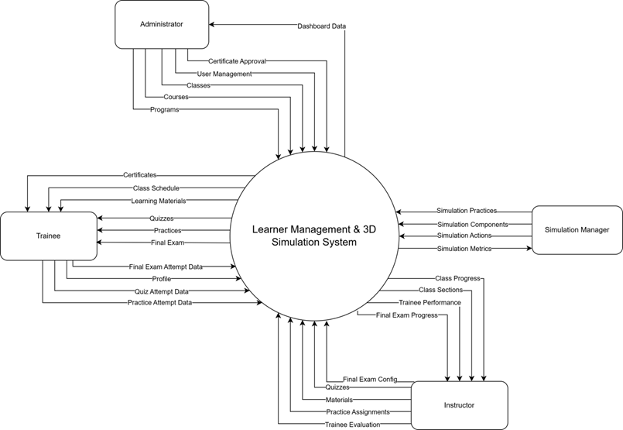

## 2. User Requirements

### 2.1 Actors

|  |  |  |
| --- | --- | --- |
| **#** | **Actor** | **Description** |
| 1 | Administrator | The Administrator is the top-level user responsible for the overall system setup and user management. Using the web application, they manage all user accounts, create and organize the academic structure by managing programs, courses, and classes. |
| 2 | Simulation Manager | The Simulation Manager is responsible for defining all aspects of the 3D simulation content. They manage the simulation practices, including simulation components, actions, and warnings. |
| 3 | Instructor | The instructor is responsible for managing the content and trainees within their assigned classes. Using the web application, they manage class members, organize class sections, and upload learning materials and quizzes. They also assign simulation practices to the class and are responsible for tracking trainee results, providing feedback, and confirming the final status for each trainee. |
| 4 | Trainee | The Trainee is the primary learner in the system. They use the web application to manage their profile, enroll in classes, access learning materials, and complete theoretical quizzes. They also use the separate 3D simulation desktop application to log in and perform practical crane simulation exercises. |

### 2.2 Use Case

#### 2.2.1 Use Case Diagram

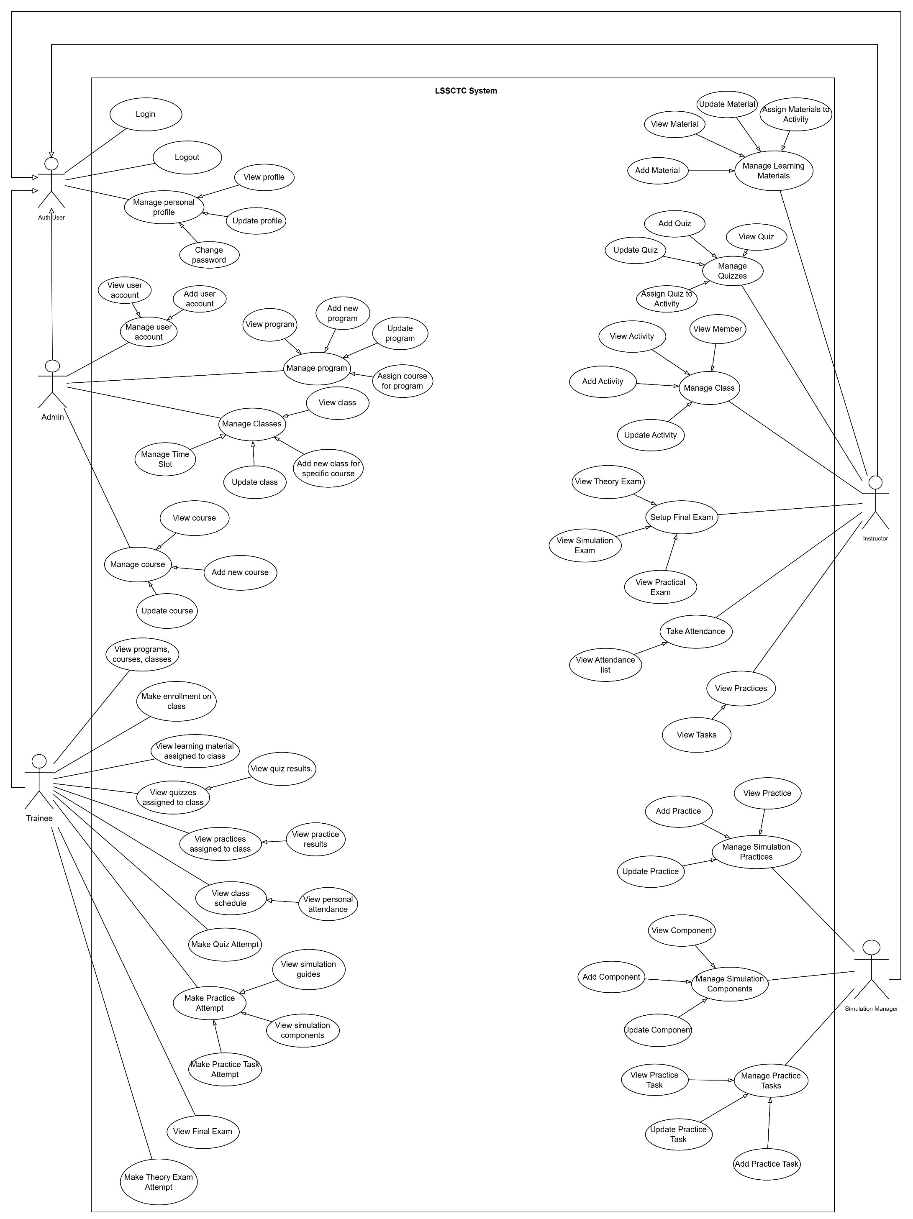

#### 2.2.2 Descriptions

|  |  |  |  |
| --- | --- | --- | --- |
| **ID** | **Use Case** | **Actors** | **Use Case Description** |
| UC-01 | Add Material | Instructor | This feature allows instructor add a new learning material (PDF, video, link) for teaching. |
| UC-02 | Update Material | Instructor | This feature allows instructor update an existing learning material’s info or file. |
| UC-03 | View Material | Instructor | This feature allows instructor view the list and details of learning materials. |
| UC-04 | Assign Materials to Section | Instructor | This feature allows instructor link selected materials to a section/partition for trainees to access. |
| UC-05 | Add Quiz | Instructor | This feature allows instructor create a new quiz with basic information. |
| UC-06 | Update Quiz | Instructor | This feature allows instructor edit a quiz’s information. |
| UC-07 | View Quiz | Instructor | This feature allows instructor view quizzes and their details. |
| UC-08 | Assign Quiz to Section | Instructor | This feature allows instructor attach a quiz to a specific section/partition for delivery. |
| UC-09 | Add Member | Instructor | This feature allows instructor add a trainee to the class roster. |
| UC-10 | View Member | Instructor | This feature allows instructor view trainee profiles and class membership. |
| UC-11 | Track Member Process | Instructor | This feature allows instructor track each trainee’s study progress and results. |
| UC-12 | View Section | Instructor | This feature allows instructor track each trainee’s study progress and results. |
| UC-13 | Add Section | Instructor | This feature allows instructor create a new section for the class. |
| UC-14 | Update Section | Instructor | This feature allows instructor edit section information. |
| UC-15 | Assign Practices to Section | Instructor | This feature allows instructor link practice activities to a section/partition. |
| UC-16 | View Practices | Instructor | This feature allows instructor view practice list and details in the class/section. |
| UC-17 | Confirm Pass/Fail Results | Instructor | This feature allows instructor view practice list and details in the class/section. |
| UC-18 | Add Practice | Instructor | This feature allows instructor create a new practice activity. |
| UC-19 | Update Practice | Instructor | This feature allows instructor edit an existing practice activity. |
| UC-20 | View Practices | Instructor | This feature allows instructor view details of a specific practice activity. |
| UC-21 | Add Component | Instructor | This feature allows instructor add a simulation component needed for practice. |
| UC-22 | Update Component | Instructor | This feature allows instructor update a simulation component’s information. |
| UC-23 | View Component | Instructor | This feature allows instructor view the list and details of simulation components. |
| UC-24 | Add Action | Instructor | This feature allows instructor add a simulation action/step used in practices. |
| UC-25 | Update Action | Instructor | This feature allows instructor update a simulation action/step. |
| UC-26 | View Action | Instructor | This feature allows instructor view the list and details of simulation actions. |
| UC-27 | Add Component | Simulation Manager | This feature allows the simulation manager to add a new simulation component to the system. |
| UC-28 | Update Component | Simulation Manager | This feature allows the simulation manager to edit or update existing simulation component information. |
| UC-29 | View Component | Simulation Manager | This feature allows the simulation manager to view the list and details of simulation components. |
| UC-30 | Add Action | Simulation Manager | This feature allows the simulation manager to add a new simulation action used in training practices. |
| UC-31 | Update Action | Simulation Manager | This feature allows the simulation manager to edit or update existing simulation actions. |
| UC-32 | View Action | Simulation Manager | This feature allows the simulation manager to view the list and details of simulation actions. |
| UC-33 | Add Slot | Simulation Manager | This feature allows the simulation manager to create a new simulation timeslot for scheduling practices. |
| UC-34 | Update Slot | Simulation Manager | This feature allows the simulation manager to update or reschedule an existing simulation timeslot. |
| UC-35 | View Slot | Simulation Manager | This feature allows the simulation manager to view all simulation timeslots and their details. |
| UC-36 | Assign Practice to Slot | Simulation Manager | This feature allows the simulation manager to assign a specific practice activity to a simulation timeslot. |
| UC-37 | Add Practice Step | Simulation Manager | This feature allows the simulation manager to define and add new steps for a practice scenario. |
| UC-38 | Update Practice Step | Simulation Manager | This feature allows the simulation manager to modify or reorder steps within a practice scenario. |
| UC-39 | View Practice Step | Simulation Manager | This feature allows the simulation manager to view practice steps assigned to each practice activity. |
| UC-40 | Add Warning | Simulation Manager | This feature allows the simulation manager to create new warning messages or alerts for simulation steps. |
| UC-41 | Update Warning | Simulation Manager | This feature allows the simulation manager to modify or remove existing simulation warnings. |
| UC-42 | View Warning | Simulation Manager | This feature allows the simulation manager to view all defined warnings and their details. |
| UC-43 | Make enrollment programs/courses/classes | Trainee | This feature allows trainee submit an enrolment request to a program, course, or class. |
| UC-44 | View programs, courses, classes | Trainee | This feature allows trainee view the catalog and details of available programs, courses, and classes. |
| UC-45 | Access learning material | Trainee | This feature allows trainee access learning materials provided for their study. |
| UC-46 | View learning material assigned to class section | Trainee | This feature allows trainee view materials specifically assigned to their class section. |
| UC-47 | Download material | Trainee | This feature allows trainee download learning files for offline use. |
| UC-48 | View quizzes assigned to class section | Trainee | This feature allows trainee see newly assigned quizzes for their section. |
| UC-49 | Make attempt quizzes | Trainee | This feature allows trainee start and submit a quiz attempt. |
| UC-50 | View recorded results | Trainee | This feature allows trainee view their quiz scores and attempt history. |
| UC-51 | View practices assigned to class section | Trainee | This feature allows trainee view the list of practices assigned to their section. |
| UC-52 | Select a practice to make a new attempt | Trainee | This feature allows trainee choose a practice and create a new attempt. |
| UC-53 | View list practices | Trainee | This feature allows trainee browse the practice list available to them. |
| UC-54 | Settings simulation guides | Trainee | This feature allows trainee configure guidance options and hints for simulation. |
| UC-55 | View simulation guides | Trainee | This feature allows trainee read the simulation guidance before or during practice. |
| UC-56 | View practice steps and step details | Trainee | This feature allows trainee review each step and its detailed instructions. |
| UC-57 | View simulation components | Trainee | This feature allows trainee view components used in the simulation scenario. |
| UC-58 | Perform simulation actions | Trainee | This feature allows trainee perform the required actions in the simulator. |
| UC-59 | View post-practice result | Trainee | This feature allows trainee see overall results after completing a practice. |
| UC-60 | View step result and warning message | Trainee | This feature allows trainee check each step’s result and any warning messages. |
| UC-61 | View user account | Admin | This feature allows admin view the list and details of user accounts in the system. |
| UC-62 | Add user account | Admin | This feature allows admin create a new user account and assign a role. |
| UC-63 | Deactivate user account | Admin | This feature allows admin deactivate or disable a user account. |
| UC-64 | Manage user account | Admin | This feature allows admin manage all user accounts, including creating, viewing, and deactivating users. |
| UC-65 | View program | Admin | This feature allows admin view the list and details of existing training programs. |
| UC-66 | Add new program | Admin | This feature allows admin create a new training program in the system. |
| UC-67 | Update program | Admin | This feature allows admin edit information of an existing training program. |
| UC-68 | Assign course for program | Admin | This feature allows admin assign specific courses to a training program. |
| UC-69 | Manage program | Admin | This feature allows admin manage all training programs, including viewing, updating, and course assignment. |
| UC-70 | View class | Admin | This feature allows admin view the list and details of all classes in the system. |
| UC-71 | Add new class for specific course | Admin | This feature allows admin create a new class linked to a selected course. |
| UC-72 | Update class | Admin | This feature allows admin modify class information such as schedule or instructor. |
| UC-73 | Manage classes | Admin | This feature allows admin manage all classes, including creating, updating, and viewing them. |
| UC-74 | View course | Admin | This feature allows admin view the list and details of all courses in the system. |
| UC-75 | Add new course | Admin | This feature allows admin create a new course record in the system. |
| UC-76 | Update course | Admin | This feature allows admin edit the details of an existing course. |
| UC-77 | Manage course | Admin | This feature allows admin manage all courses, including adding, updating, and viewing them. |
| UC-78 | View programs, courses, classes | Admin | This feature allows admin view an overview list of all programs, courses, and classes in the system. |
| UC-79 | Login | Auth User | This feature allows user login to the system by verifying their credentials and accessing authorized functions. |
| UC-80 | Logout | Auth User | This feature allows user logout from the system securely and end their session. |
| UC-81 | View profile | Auth User | This feature allows user view their personal profile information stored in the system. |
| UC-82 | Update profile | Auth User | This feature allows user edit and update their personal profile details. |
| UC-83 | Change password | Auth User | This feature allows user change their password for account security. |
| UC-84 | Manage personal profile | Auth User | This feature allows user manage their personal profile, including viewing, editing, and changing password. |

## 3. Functional Requirements

### 3.1 System Functional Overview

#### 3.1.1 Screens Flow

##### 3.1.1.1 Admin Flow

**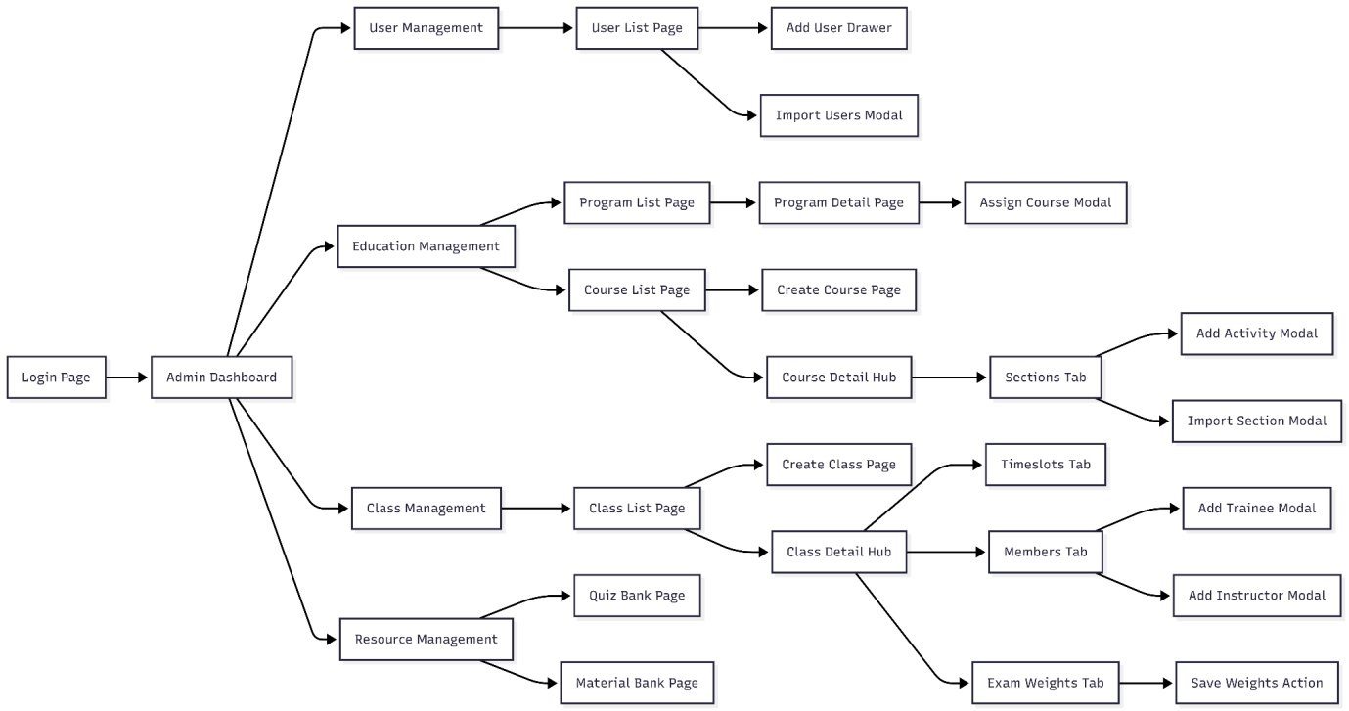**

##### 3.1.1.2 Trainee Flow

**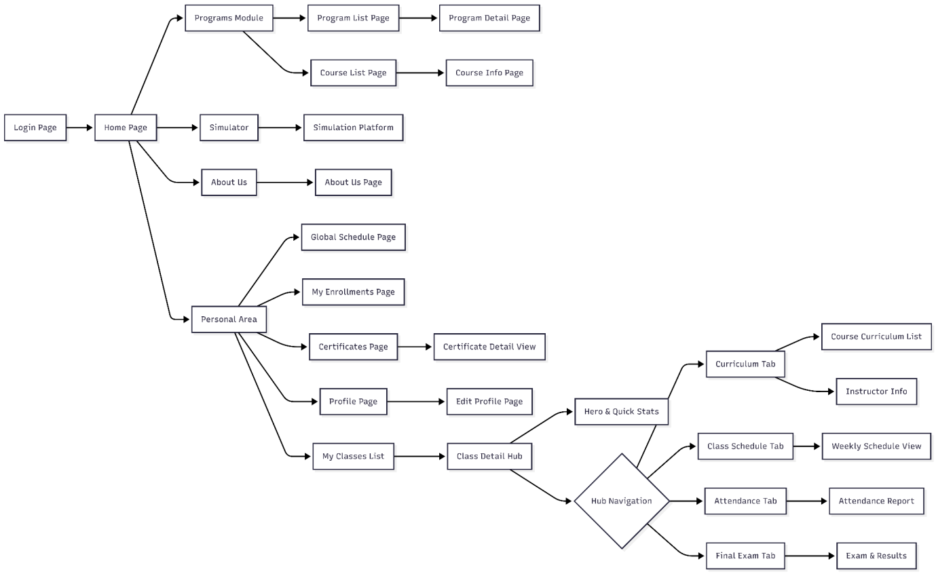**

##### 3.1.1.2 Instructor Flow

**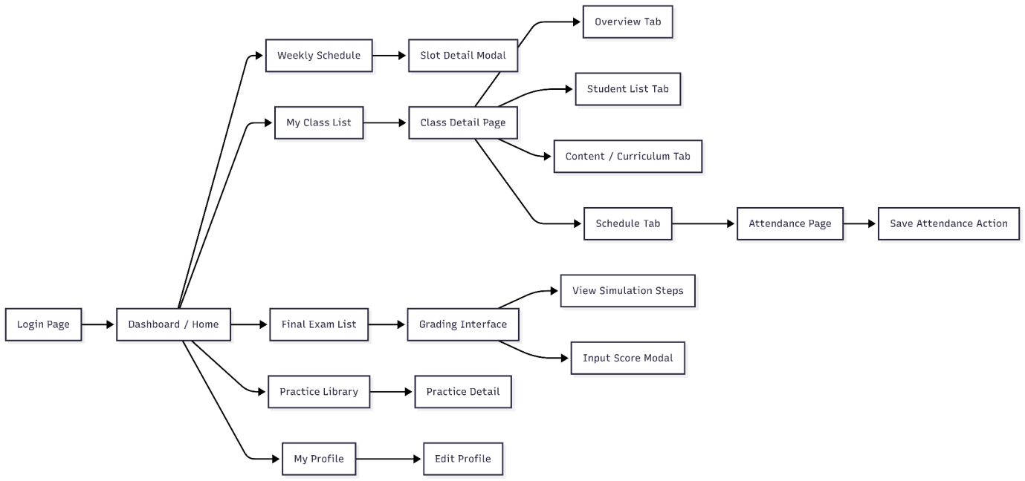**

##### 3.1.1.2 Simulation Manager Flow

**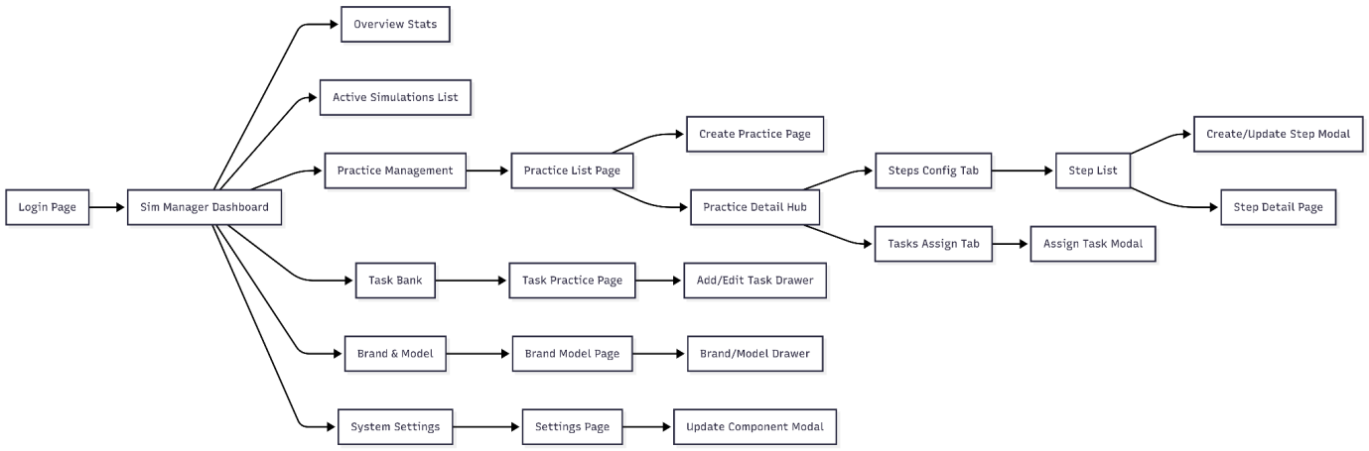**

#### 3.1.2 Screen Descriptions

|  |  |  |  |
| --- | --- | --- | --- |
| **#** | **Feature** | **Screen** | **Description** |
| **1** | **Authentication** | **Login Screen** | Allows users (Admin, Instructor, Trainee, Sim Manager) to log into the system using Email/Password or Google OAuth. Supports a link to the "Forgot Password" page. |
| **2** | **Authentication** | **Forgot Password Screen** | Allows users to request a password reset via email verification and enter a new password. |
| **3** | **Common** | **Landing Page / Home** | Introductory page for the training center, displaying featured courses, featured instructors, and related news. Visible to unauthenticated users or Trainees. |
| **4** | **Common** | **User Profile Screen** | Allows users to view and update personal information, profile pictures, and change their password. |
| **5** | **Admin** | **Admin Dashboard** | Displays a statistical overview of the system: total users, class statuses, course completion rates, and role distribution charts. |
| **6** | **Admin** | **User Management Screen** | Lists all users in the system. Admins can add new users, edit details, disable accounts, or Import lists from Excel files. |
| **7** | **Admin** | **Program Management Screen** | Manages training programs (frameworks). Allows creating new programs, assigning courses to programs, and setting up hierarchical structures. |
| **8** | **Admin** | **Course Management Screen** | Manages the list of courses. Admins can create new courses, set up content (Sections, Lessons), upload learning materials, and configure Quizzes. |
| **9** | **Admin** | **Class Management Screen** | Manages active classes. Allows creating classes based on courses, scheduling sessions, assigning instructors, and adding trainees to classes. |
| **10** | **Admin** | **Certificate Template Screen** | Allows Admins to design and manage certificate templates to be issued to trainees upon course completion. |
| **11** | **Instructor** | **Instructor Dashboard** | Displays upcoming teaching schedules, statistics on the number of assigned classes, and the status of assignments/exams needing grading. |
| **12** | **Instructor** | **Teaching Schedule Screen** | Displays a detailed weekly or monthly schedule of the instructor's teaching time slots. |
| **13** | **Instructor** | **My Classes Screen** | Lists classes assigned to the instructor. Specific class details can be accessed from here for management. |
| **14** | **Instructor** | **Class Detail & Attendance Screen** | Detailed management screen for a class: performing attendance checks per session, viewing the trainee list, and monitoring their learning progress. |
| **15** | **Instructor** | **Quiz & Question Bank Screen** | Manages the multiple-choice question bank. Creates and configures Quizzes to assign to course content. |
| **16** | **Instructor** | **Grading Screen** | Allows instructors to view trainee submissions/results (including theoretical exams and simulation results) and enter grades. |
| **17** | **Trainee** | **My Learning/Classes Screen** | Displays the list of classes the trainee is enrolled in and the completion progress of each class. |
| **18** | **Trainee** | **Learning Player Screen** | The main interface for trainees to watch video lectures, read PDF materials, or take Quizzes following the course curriculum. |
| **19** | **Trainee** | **Exam Taking Screen** | Interface for taking multiple-choice exams (Final Exam/Quiz) with a countdown timer, question list, and submission function. |

#### 3.1.3 Screen Authorization

|  |  |  |  |  |  |
| --- | --- | --- | --- | --- | --- |
| **#** | **Screen** | **Admin** | **Instructor** | **Trainee** | **Sim Manager** |
| 1 | **Landing Page / Home** | x | x | x | x |
| 2 | **Login Screen** | x |  |  |  |
| 3 | **Forgot Password Screen** | x |  |  |  |
| 4 | **User Profile Screen** |  | x | x | x |
| 5 | **Admin Dashboard** |  | x |  |  |
| 6 | **User Management Screen** |  | x |  |  |
| 7 | **Program Management Screen** |  | x |  |  |
| 8 | **Course Management Screen** |  | x |  |  |
| 9 | **Class Management Screen** |  | x |  |  |
| 10 | **Certificate Template Screen** |  | x |  |  |
| 11 | **Instructor Dashboard** |  |  | x |  |
| 12 | **Teaching Schedule Screen** |  |  | x |  |
| 13 | **My Classes Screen (Instructor)** |  |  | x |  |
| 14 | **Class Detail & Attendance Screen** |  |  | x |  |
| 15 | **Quiz & Question Bank Screen** |  |  | x |  |
| 16 | **Grading Screen** |  |  | x |  |
| 17 | **My Learning/Classes Screen (Trainee)** |  |  |  | x |
| 18 | **Learning Player Screen** |  |  |  | x |

#### 3.1.4 Non-Screen Functions

|  |  |  |  |
| --- | --- | --- | --- |
| **#** | **Feature** | **System Function** | **Description** |
| **1** | **JWT Token Management** | User login or API request. | Generates Access Tokens and Refresh Tokens containing user claims and roles. Validates token signature and expiration on every incoming HTTP request to ensure secure access. |
| **2** | **Password Hashing** | User registration or password change. | Secures user passwords using **HMACSHA512** hashing algorithms with unique salts before storing them in the database, preventing plain-text storage. |
| **3** | **Google OAuth Validation** | "Login with Google" action. | Communicates directly with Google APIs to validate the IdToken received from the client, retrieving user profile information to authenticate or register the user automatically. |
| **4** | **Email Notification Service** | Forgot Password request or System Alerts. | Generates dynamic HTML email content (e.g., OTP codes) and dispatches emails to users via an SMTP server configuration. |
| **5** | **Excel Data Import Processor** | Admin uploads an Excel file. | Parses binary Excel files (.xlsx) to bulk import complex data structures such as User lists, Quiz Question banks, and Training Programs into the database. |
| **6** | **Cloud Storage Integration** | User uploads media (Avatar, Materials). | Handles file uploads to **Firebase Storage**. It manages file naming to prevent conflicts and generates public download URLs for storage in the database. |
| **7** | **Auto-Grading Engine** | Trainee submits a Quiz or Simulation task. | **For Quizzes:** Compares user answers with the answer key, calculates the final score, and determines Pass/Fail status.  **For Simulation:** Processes JSON telemetry data from the simulation client to evaluate safety violations and execution time. |
| **8** | **Class Status Automation** | Scheduled task or Data change. | Automatically evaluates class schedules and progress to transition class statuses (e.g., automatically marking a class as Completed when the end date is passed and requirements are met). |
| **9** | **Data Cleanup Service** | Scheduled maintenance. | Identifies and removes orphaned records, temporary files, or soft-deleted data to optimize database performance and storage usage. |

#### 3.1.5 Entity Relationship Diagram

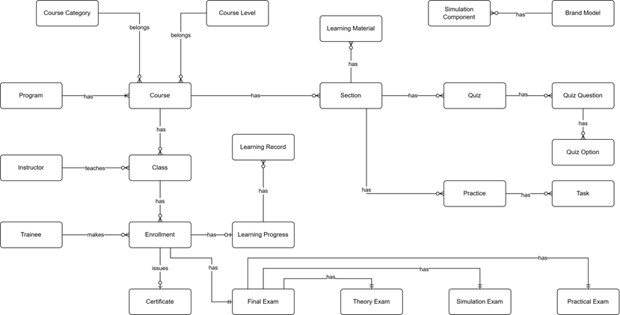

### 

#### 3.1.6 Entity Relationship Description

|  |  |  |
| --- | --- | --- |
| **#** | **Entity** | **Description** |
| 1 | Course Category | Classification or categorization of courses by subject area or domain (e.g., Basic Crane Operations, Safety Procedures, Advanced Techniques). Provides organizational structure for grouping related courses. Each course belongs to one category. |
| 2 | Course Level | Defines the difficulty or skill level of a course (e.g., Entry Level, Intermediate, Advanced). Used to establish learning progression paths and prerequisite requirements. Each course is assigned one level to indicate target trainee proficiency. |
| 3 | Program | Comprehensive training program consisting of multiple courses designed to achieve specific certification or skill objectives. Programs define structured learning paths for trainees, combining courses in a logical sequence to build competencies for crane operator certification. |
| 4 | Course | Individual training course representing a specific subject or skill area within the crane training curriculum. Contains course content structured into sections, can be assigned to multiple programs, and serves as the foundation for class creation. Belongs to one category and one level. |
| 5 | Instructor | Teaching staff member responsible for delivering course instruction, managing class activities, creating learning materials and assessments, and evaluating trainee performance. Instructors are assigned to teach specific classes and provide guidance throughout the learning process. |
| 6 | Class | Scheduled instance of a course with defined start/end dates, assigned instructor, and enrolled trainees. Represents the actual delivery of course content to a specific group of trainees. Classes are where learning activities, assessments, and instruction occur. |
| 7 | Trainee | Student or learner enrolled in training programs to become certified crane operators. Trainees make enrollments in classes, access learning materials, complete quizzes and practices, take final exams, and track their learning progress toward certification. |
| 8 | Enrollment | Record of a trainee's registration in a specific class. Creates the relationship between trainee and class, enabling access to course materials, activities, and assessments. Enrollment triggers creation of learning progress tracking and final exam records. |
| 9 | Learning Material | Educational content resources such as videos, documents, presentations, or external links used to deliver course instruction. Materials are assigned to sections to provide trainees with reference and study resources. Can be reused across multiple sections. |
| 10 | Section | Logical unit or module within a course syllabus representing a specific topic or learning objective. Sections organize course content into manageable chunks and contain learning materials, quizzes, and practices. Defines the structure and sequence of course curriculum. |
| 11 | Quiz | Assessment tool containing multiple questions used to evaluate trainee understanding of theoretical concepts. Quizzes are assigned to sections, have defined pass criteria and time limits, and contribute to overall learning progress. Results are tracked through quiz attempts. |
| 12 | Quiz Question | Individual question within a quiz presenting a problem or prompt for trainees to answer. Questions are assigned point values (contributing to total quiz score of 10 points) and can support single or multiple correct answers through associated quiz options. |
| 13 | Quiz Option | Possible answer choice for a quiz question. Each option is marked as correct or incorrect and may have associated explanations. Multiple options per question enable various question types (multiple choice, select all that apply). |
| 14 | Practice | Simulation-based training scenario performed in the 3D crane simulator environment. Practices consist of ordered tasks that trainees must complete to demonstrate hands-on skills. Assigned to sections as practical learning activities with defined difficulty levels and attempt limits. |
| 15 | Task | Individual step or action within a simulation practice that trainees must perform correctly. Tasks define expected results for validation, and task completion is tracked during practice attempts. Tasks are reusable components across different practices. |
| 16 | Simulation Component | 3D virtual representation of crane parts, controls, or environment objects used in simulation practices. Components are linked to brand models to represent real-world equipment and are referenced in tasks for interaction requirements. |
| 17 | Brand Model | Specification of real crane equipment brands and models being simulated in the training system. Defines manufacturer information, specifications, and links to simulation components that represent the physical equipment in virtual environment. |
| 18 | Learning Record | Historical record of trainee interactions with course sections, tracking what content has been accessed and when. Maintains audit trail of learning activities for compliance, reporting, and progress monitoring purposes. |
| 19 | Learning Progress | Comprehensive tracking of trainee advancement through enrolled courses. Records overall progress percentage, theory and practical scores, completion status, and timestamps. Central entity for monitoring trainee performance and determining certification readiness. |
| 20 | Certificate | Official document template awarded to trainees upon successful course or program completion. Defines certificate design, content structure, and requirements. Issued certificates are permanent records of trainee achievement for verification and credentialing purposes. |
| 21 | Final Exam | Comprehensive assessment conducted at course completion to evaluate trainee readiness for certification. Consists of three components (Theory, Practical, Simulation) that are weighted and combined for total score. Results determine pass/fail status and certificate eligibility. |
| 22 | Theory Exam | Written assessment component of final exam evaluating trainee understanding of theoretical concepts and safety knowledge. Implemented using the quiz system with defined pass criteria. One of three partial exams that compose the final exam. |
| 23 | Simulation Exam | Performance-based assessment component conducted in 3D simulator requiring trainees to demonstrate crane operation skills. Uses practice system with task-by-task evaluation. One of three partial exams contributing to final exam score and certification decision. |
| 24 | Practical Exam | Hands-on assessment component where trainees demonstrate physical crane operation skills evaluated by instructors using predefined checklists. Assesses real-world competencies beyond simulation environment. One of three partial exams required for certification. |

### **3.2 Feature 1: Trainee Learning & Progress Tracking**

**3.2.1 Description**

This is the core functional area for Trainees. It provides an interactive Learning Management System (LMS) interface where trainees perform their daily training activities. The system delivers multimedia content (Videos, PDFs), conducts assessments (Quizzes), and provides specifications for Simulation tasks. Crucially, it tracks the trainee's progress in real-time, ensuring they follow the structured curriculum path defined by the administration.

**3.2.2 Functional Requirements**

|  |  |  |
| --- | --- | --- |
| **ID** | **Require** | **Description** |
| **FR-LRN-01** | **Access My Classes** | Trainees can view a list of all classes they are currently enrolled in, along with the current completion percentage and status (OnGoing, Completed) for each class. |
| **FR-LRN-02** | **View Course Curriculum** | Within a class, the system displays the full hierarchy of the course: Sections (Modules) and Activities (Lessons). It indicates which activities are completed, in progress, or locked. |
| **FR-LRN-03** | **Multimedia Player** | The system provides an embedded player to view MP4 video lectures and a PDF viewer for reading training manuals and safety guidelines directly within the browser. |
| **FR-LRN-04** | **Take Section Quizzes** | Trainees can attempt quizzes assigned to specific sections. The system records the attempts, scores, and pass/fail status. Infinite or limited retakes are enforced based on configuration. |
| **FR-LRN-05** | **Simulation Task Guidance** | For simulation activities, the web portal displays the task objectives, step-by-step instructions, and passing criteria (e.g., "Move container A to B within 5 minutes"), guiding the trainee before they enter the 3D simulator. |
| **FR-LRN-06** | **Automatic Progress Tracking** | The system automatically marks activities as "Completed" when specific conditions are met (e.g., video watched 90%, PDF scrolled to bottom, Quiz passed). |
| **FR-LRN-07** | **Sequential Learning Enforcement** | The system enforces a linear learning path (if configured), locking subsequent sections until the trainee has completed the prerequisite activities in the current section. |
| **FR-LRN-08** | **View Personal Profile & History** | Trainees can view their own activity history, including past quiz scores, simulation practice results, and attendance records. |

**3.2.3 Screen Flow & UI Components**

The learning experience involves two primary screens:

1. **My Learning Screen (Dashboard):**
   * **UI:** A grid view of ClassCard components.
   * **Information:** Class Name, Course Code, Instructor Name, Progress Bar (visual indicator of completion), and "Continue Learning" button.
2. **Learning Player Screen (The Classroom):**
   * **Layout:** A split-screen layout (Sidebar on the left, Content Area on the right).
   * **Sidebar:** Displays the CourseSection list (Accordion style). Icons indicate the type of activity (Video, Doc, Quiz) and its status (Green Check for done, Lock icon for locked).
   * **Content Area:**
     + **Video:** Uses a custom video player wrapper (VideoContent.jsx).
     + **Document:** Embeds a PDF viewer (ReadingContent.jsx).
     + **Quiz:** Renders the quiz interface (QuizContent.jsx) with question navigation.
     + **Practice:** Shows simulation task details and history of attempts (PracticeContent.jsx).

**3.2.4 Backend Implementation Logic**

The backend manages state tracking and content delivery:

* **Controllers:**
  + ProgressController: Aggregates data to calculate the overall percentage (LearningProgress).
  + ActivityRecordsController: Handles the granular status of each item (e.g., POST /api/activity-records to mark a video as watched).
  + SectionRecordsController: Monitors the completion of entire sections to unlock new content.
* **Entities:**
  + ActivityRecord: The pivotal entity linking a Trainee, a Class, and a specific Activity. It stores Status (Completed/Incomplete) and timestamps.
  + LearningMaterial: Stores the URL (Firebase) and metadata for the content.
* **Business Logic:**
  + **Progress Calculation:** ProgressesService.cs calculates progress as: *(Count of Completed Activities / Total Activities in Course) \* 100*.
  + **State Transition:** When a Trainee passes a Quiz, the QuizAttemptsService triggers an update to the ActivityRecord, setting it to Completed.
  + **Security:** Content URLs are often signed or verified to prevent unauthorized access outside the learning platform.

### 3.3 Feature 2: Trainee Simulation Practice

**3.3.1 Description**

This feature bridges the gap between theoretical knowledge and real-world application. It allows Trainees to engage in practical crane operation exercises within a safe, physics-based 3D virtual environment. Unlike the Final Exam, these practices are part of the regular course curriculum (Learning Path). The system provides detailed scenario guides, tracks every movement and safety violation (collisions, dangerous swaying), and provides immediate automated grading and feedback.

**3.3.2 Functional Requirements**

|  |  |  |
| --- | --- | --- |
| **ID** | **Require** | **Description** |
| **FR-SIM-01** | **View Practice Objectives** | Before starting, the Trainee can view the specific tasks required for the session (e.g., "Lift the red container," "Navigate through the obstacle course") and the criteria for passing (e.g., "Complete within 10 minutes"). |
| **FR-SIM-02** | **Launch Simulation** | The system initializes the 3D simulation environment directly within the browser (WebGL) or authenticates the user into a desktop client using a generated session token. |
| **FR-SIM-03** | **Real-time Telemetry Tracking** | While practicing, the simulation client tracks critical metrics: execution time, collision counts (crane-to-obstacle, load-to-ground), and limit switch violations. |
| **FR-SIM-04** | **Step-by-Step Guidance** | The system highlights the active task in the UI (e.g., "Step 1: Move to Point A"), updating automatically as the trainee completes actions in the 3D world. |
| **FR-SIM-05** | **Automatic Submission & Grading** | Upon finishing the scenario or running out of time, the system automatically submits the performance data. The backend calculates a score (0-100) based on pre-defined penalties for safety violations. |
| **FR-SIM-06** | **View Attempt History** | Trainees can view a history of their attempts for a specific practice module, allowing them to track improvement in their scores and completion times over multiple tries. |
| **FR-SIM-07** | **Safety Violation Alerts** | Immediate visual feedback is provided in the simulation HUD (Heads-Up Display) if a safety rule is violated (e.g., "Warning: Load Swinging"). |

**3.3.3 Screen Flow & UI Components**

The feature utilizes an integrated approach within the Learning Player:

1. **Practice Overview Screen (LMS View):**
   * **Location:** Inside the *Learning Player Screen* (see Feature 5).
   * **Components:**
     + **Task List:** Displays the sequence of PracticeTask items.
     + **Stats Panel:** Shows Allowed Time, Max Score, and Passing Score.
     + **History Table:** Uses PracticeAttemptsHistory.jsx to list previous attempts (Date, Duration, Score, Status).
     + **Action:** "Start Practice" button launches the simulation.
2. **Simulation Platform Screen (Active State):**
   * **UI:** Full-screen or embedded 3D Canvas (SimulationPlatform.jsx).
   * **HUD Elements:**
     + **Dashboard:** Shows simulated crane indicators (wind speed, load weight, boom angle).
     + **Notifications:** Pop-ups for successful step completion or errors.
     + **Controls:** On-screen controls (if no hardware joystick is connected) or mapping overlay.

**3.3.4 Backend Implementation Logic**

The backend acts as the authoritative judge for the simulation results:

* **Controllers:**
  + PracticesController: Retrieves the scenario configuration (start positions, target zones) to initialize the 3D world.
  + PracticeAttemptsController: Handles the start (POST /start) and submission (POST /submit) of practice sessions.
* **Entities:**
  + Practice: Stores the metadata of the exercise.
  + PracticeTask: Defines the individual steps (e.g., "Lift", "Move", "Place").
  + PracticeAttempt: Stores the result of a single session.
* **Grading Algorithm (PracticeAttemptsService.cs):**
  + The system receives a SubmitPracticeTaskDto containing telemetry.
  + **Base Score:** Starts at 100 (or max defined).
  + **Deductions:** Subtracts points for:
    - Collisions (Severity \* Penalty Weight).
    - Time Overrun (Time exceeded \* Penalty per second).
    - Dangerous Operations (e.g., moving while load is too low).
  + **Pass/Fail:** Updates the ActivityRecord status based on whether the final score meets the PassScore threshold.

### 3.4 Feature 3: Program & Course Management

**3.4.1 Description**

This feature serves as the academic backbone of the LSSCTC system. It empowers Administrators to construct and organize the educational hierarchy. The system allows for the creation of Training Programs (curriculum frameworks) and individual Courses. Furthermore, it enables the detailed structuring of course content into Sections and specific Activities (Lessons, Videos, PDFs, Quizzes), effectively digitizing the crane training curriculum.

**3.4.2 Functional Requirements**

|  |  |  |
| --- | --- | --- |
| **ID** | **Requirement** | **Description** |
| **FR-PROG-01** | **Manage Training Programs** | Admins can create, update, delete, and view Training Programs. A program acts as a container for multiple related courses (e.g., "Basic Crane Operation Program"). |
| **FR-PROG-02** | **Program Hierarchy & Assignment** | The system allows Admins to assign specific Courses to a Program. It maintains the relationship between programs and courses to structure the learning path. |
| **FR-COURSE-01** | **Manage Courses** | Admins can manage the lifecycle of a Course, defining its title, description, level (Beginner/Intermediate/Advanced), and category. |
| **FR-COURSE-02** | **Curriculum Builder** | The system provides an interface to structure a Course into **Sections** (Modules) and **Activities** (Lessons). Admins can arrange the order of learning content. |
| **FR-MAT-01** | **Learning Materials Management** | Admins can upload and manage digital learning resources. Supported formats include PDF documents for reading and MP4 videos for lectures. |
| **FR-MAT-02** | **Cloud Storage Integration** | The system integrates with **Firebase Storage** to securely upload and serve large media files (videos/documents), ensuring scalability and fast access. |
| **FR-QUIZ-01** | **Quiz Assignment** | Admins can attach Quizzes (created in the Quiz Management feature) to specific sections within a course to assess trainee understanding. |
| **FR-IMP-01** | **Bulk Import Programs** | The system supports importing complex program structures (Program -> Course -> Section) via Excel files to speed up initial data entry. |

**3.4.3 Screen Flow & UI Components**

The management flow involves the following key screens:

1. **Program Management Screen:**
   * **UI:** A list view of existing programs with options to "Add New Program" or "Import from Excel".
   * **Action:** Clicking on a program redirects to the *Program Detail View*, where linked courses are listed.
2. **Course Management Screen:**
   * **UI:** Displays a catalog of all courses. Filters available by Category and Status (Active/Inactive).
   * **Components:** "Create Course" modal collecting basic info (Name, Code, Image).
3. **Course Detail & Curriculum Editor:**
   * **UI:** A hierarchical view (often an Accordion or Tree view) displaying Sections.
   * **Actions:**
     + **Add Section:** Create a new topic/module.
     + **Add Activity:** Within a section, the Admin selects the type of activity: *Video, PDF, or Quiz*.
     + **Upload:** Drag-and-drop zone for uploading course materials.

**3.4.4 Backend Implementation Logic**

The backend handles the hierarchical data structure and file operations:

* **Controllers:**
  + ProgramsController: Manages the high-level program entities.
  + CoursesController: Handles course metadata.
  + SectionsController: Manages the subdivisions within a course.
  + MaterialsController & ActivitiesController: Handle the specific learning content.
* **Services & Patterns:**
  + **Onion Architecture:** Separates the domain entities (TrainingProgram, Course, Section) from the business logic.
  + **Firebase Storage Service:** The FirebaseStorageService.cs is invoked when uploading course materials. It returns a public URL which is then stored in the SQL Database.
  + **Import Logic:** ProgramImportService.cs uses NPOI to parse Excel files, automatically creating the necessary database relationships (Program-Course-Section) in a single transaction.
* **Data Integrity:**
  + The system enforces foreign key constraints to ensure that if a Course is deleted, related Enrollments or Sections are handled appropriately (Soft Delete pattern).

### 3.5 Feature 4: Trainee Final Examination

**3.5.1 Description**

The Final Examination feature is the culmination of the training process. To ensure comprehensive competency, the system evaluates Trainees through three distinct **Final Exam Partials**:

1. **Theory Exam (TE):** A computer-based multiple-choice test with a strict time limit.
2. **Simulation Exam (SE):** A practical test performed in the 3D Simulation Platform, graded automatically by the system based on safety and precision.
3. **Practical Exam (PE):** An offline, real-world crane operation test graded by an Instructor using a digital checklist.

The system aggregates scores from these three partials based on pre-configured weights to determine the final Pass/Fail status.

**3.5.2 Functional Requirements**

|  |  |  |
| --- | --- | --- |
| **ID** | **Require** | **Description** |
| **FR-EXAM-01** | **View Exam Structure** | The Trainee can view the Final Exam dashboard, which lists the three partials (TE, SE, PE), their current status (Locked, Open, Completed), and their weightage (e.g., 30%, 40%, 30%). |
| **FR-EXAM-02** | **Take Theory Exam (TE)** | The system allows the Trainee to start the TE. The interface enables answering questions, flagging questions for review, and navigating between questions. |
| **FR-EXAM-03** | **TE Timer Enforcement** | A server-side and client-side countdown timer enforces the exam duration. The system automatically submits the exam when the timer reaches zero. |
| **FR-EXAM-04** | **TE Auto-Grading** | Upon submission, the system immediately calculates the score based on the answer key stored in the database and updates the TE status to "Completed". |
| **FR-EXAM-05** | **Generate Simulation Code (SE)** | To take the Simulation Exam, the Trainee must request a unique, time-sensitive **Exam Code** via the web portal. This code is used to authenticate within the separate 3D Simulation Client. |
| **FR-EXAM-06** | **Process Simulation Results** | The system receives telemetry data (collisions, time taken, load handling) from the 3D Client, calculates a score (0-100), and updates the SE record in the web portal. |
| **FR-EXAM-07** | **View Practical Results (PE)** | Trainees cannot "take" the PE online. Instead, they view the grades and feedback checklist submitted by the Instructor after their real-world assessment. |
| **FR-EXAM-08** | **Final Grading Calculation** | Once all partials are graded, the system calculates the weighted average. If the score meets the threshold, the Final Exam status is updated to **Passed**. |

**3.5.3 Screen Flow & UI Components**

The examination flow is managed through the **Final Exam Dashboard** and specific execution screens:

1. **Final Exam Dashboard:**
   * **UI:** A tabbed interface (IndustrialTabs) separating TE, SE, and PE.
   * **Information:** Displays current score, status badge (e.g., "In Progress"), and "Start" buttons (if applicable).
   * **Logic:** Locks specific tabs if the Class Schedule indicates the exam date has not arrived.
2. **Exam Taking Screen (TE):**
   * **Components:**
     + **Header:** Countdown Timer (HeaderTimer.jsx), Progress Bar.
     + **Body:** Question Text, Option Radio Buttons (QuestionCard.jsx).
     + **Sidebar:** Grid of question numbers color-coded by status (Answered, Flagged, Unseen) (QuestionSidebar.jsx).
   * **Action:** "Submit Exam" button triggers a confirmation modal (SubmitModal.jsx).
3. **Simulation Exam View (SE):**
   * **UI:** Informational card explaining the scenario.
   * **Action:** "Generate Exam Code" button.
   * **Display:** Shows the 6-digit code needed to login to the Unity Simulation.
4. **Exam Result View:**
   * **UI:** Shows the score (e.g., "85/100"), the outcome ("Passed"), and a breakdown of correct/incorrect answers (for TE).

**3.5.4 Backend Implementation Logic**

The backend uses a complex relational structure to manage these diverse exam types:

* **Entities:**
  + FinalExam: The root entity linking a Trainee to a Class.
  + FinalExamPartial: Represents the specific instance of a TE, SE, or PE.
  + FeTheory: Stores specific data for TE (Quiz ID, Answers).
  + FeSimulation: Stores specific data for SE (Exam Code, Safety Violations).
  + PeChecklist: Stores the Instructor's evaluation for PE.
* **Services (Lssctc.ProgramManagement):**
  + **FEService.cs:** The orchestrator. It checks if the trainee is eligible to take the exam (Enrollment Status = Approved) and aggregates the final result.
  + **FEPartialService.cs:** Manages the lifecycle of a specific partial (e.g., checking if EndTime has passed).
  + **SEService.cs:** Specifically handles the logic for Simulation. It generates a random alphanumeric code and stores it in the FeSimulation table. When the 3D Client sends results, this service validates the code and saves the score.
  + **QuizAttemptsService.cs:** Reused for the Theory Exam to handle question randomization and scoring logic.
* **Safety & Integrity:**
  + **TE:** Preventing "tab switching" or multiple submissions is handled via browser events and backend validation of IsSubmitted flags.
  + **SE:** The **Exam Code** is valid only for a specific TimeSlot, preventing trainees from practicing simulations at home and counting it as an exam.

## 4. Non-Functional Requirements

### 4.1 Security

* NFR-SEC-01 (Authentication): The system must use JWT (JSON Web Tokens) for stateless, secure API authentication.
* NFR-SEC-02 (Token Management): The system must support token revocation (blacklist) using Distributed Cache to prevent usage of compromised tokens before expiry.
* NFR-SEC-03 (Data Protection): Sensitive data (like passwords) must be hashed. The API must communicate over HTTPS (though RequireHttpsMetadata is currently false for dev, production requires true).
* NFR-SEC-04 (Access Control): API endpoints must be protected by Role-Based Authorization policies ensuring users can only access data pertinent to their role.

### 4.2 Performance & Scalability

* NFR-PERF-01: The system uses Distributed Memory Cache to handle high-frequency data access like token validation and OTP storage.
* NFR-PERF-02: Database interactions must use asynchronous operations (async/await) to prevent thread blocking under load.
* NFR-PERF-03: Large data sets (Users, Classes, Enrolments) must be returned via Pagination (Paged Result) to reduce network payload and database load.

### 4.3 Interoperability & Compatibility

* NFR-INT-01: The API must expose a Swagger/OpenAPI documentation interface for client integration.
* NFR-INT-02: The system must support CORS (Cross-Origin Resource Sharing) to allow requests from specific web clients (e.g., lssctc.site, localhost).
* NFR-INT-03: The system must support standard file formats for imports/exports, specifically Excel (.xlsx) and CSV.

### 4.4 Availability & Reliability

* NFR-REL-01: The system is built on .NET Core and Entity Framework Core, designed for cross-platform deployment.
* NFR-REL-02: External integrations (e.g., Email Service) must be implemented as Transient services to ensure fresh connections and reliability.

## 5. Business Rules

|  |  |
| --- | --- |
| **ID** | **Rule Definition** |
| BR-01 | Upon successful login to the web app, the system must redirect users to their role-based landing page:  - Admin: Admin Dashboard  - Simulation Manager: Simulation Manager Dashboard  - Instructor: Instructor Dashboard  - Trainee: Trainee Home Page |
| BR-02 | Upon successful login to the **simulation app**, users with the 'Trainee' role **must** be redirected to the home screen. |
| BR-03 | Deactivated accounts **cannot** log in or interact with the system. |
| BR-04 | The Username, Email, and Phone Number fields **must** be unique for each user account. |
| BR-05 | A user's Phone Number **must** be between 4 and 15 digits. |
| BR-06 | The Email field **must** adhere to a standard email format (e.g., user@domain.com). |
| BR-07 | A user's account profile **can** only be updated by the account owner. |
| BR-07 | A password reset request **must** require email verification. |
| BR-08 | The 'Admin' role has exclusive permissions to manage 'Simulation Manager', 'Instructor', and 'Trainee' accounts. |
| BR-09 | The 'Admin' role has exclusive permissions to:  - Create and update programs.  - Assign courses to a program.  - Create and update courses.  - Create and update course syllabi.  - Manage classes. |
| BR-10 | Instructors **can** only manage content for classes to which they are assigned. |
| BR-11 | A new program **must** be created with a Name and an Active Status. |
| BR-12 | A program **cannot** contain duplicate course assignments. |
| BR-13 | A program **cannot** be assigned more than 10 courses. |
| BR-14 | Each course **must** have a unique Name and a unique Course Code. |
| BR-15 | A new course **must** be created with a Name, Course Code. |
| BR-16 | A course’s learning section **can** only be updated if no classes are currently assigned to that course. |
| BR-17 | Each class **must** have a unique Name and a unique Class Code. |
| BR-18 | A class **must** be linked to a specific course upon creation. |
| BR-19 | A class **must** have exactly one assigned 'Instructor'. |
| BR-20 | Before a class starts, its learning content **must** mirror the learning sections of its parent course. |
| BR-21 | Class content **can** only be updated when class status is ‘Draft’ or ‘Open’. |
| BR-22 | A class **can** only be started if all conditions are met:  - At least one 'Trainee' is enrolled.  - One 'Instructor' is assigned only.  - Every class section contains at least one activity. |
| BR-23 | Each class **must** have a unique Name and a unique Class Code. |
| BR-24 | A 'Trainee' **must** have a valid account before enrolling in any program. |
| BR-25 | A 'Trainee' **cannot** be enrolled in the same class more than once. |
| BR-26 | A 'Trainee' **cannot** be enrolled in two different classes that have conflicted schedules. |
| BR-27 | 'Trainees' **can** only attempt quiz and practice when their session is valid. |
| BR-28 | Each learning activity **must** be one of the following types: 'Material', 'Quiz', or 'Practice'. |
| BR-29 | A new activity **must** be created with a Name, Type, and Order (sequence) number. |
| BR-30 | A new learning material (e.g., 'Video', 'Document') **must** include a Name and either a Source File or Source URL. |
| BR-31 | A Source File for learning material **cannot** exceed 50MB in size. |
| BR-32 | A new quiz **must** be created with a Name and a Max Attempts value. |
| BR-33 | A quiz **must** contain one or more questions. |
| BR-34 | Each question **must** include answer options, and each option **must** be flagged as 'Correct' or 'Incorrect'. |
| BR-35 | A quiz **cannot** contain more than 100 questions. |
| BR-36 | A quiz question **cannot** have more than 20 answer options. |
| BR-37 | The total score for every quiz **must** be exactly 10 points. |
| BR-38 | The score of any single question **must** be greater than 0 and less than 10. |
| BR-39 | The sum of all question scores within a quiz **must** equal 10. |
| BR-40 | Only users with the 'Trainee' role **can** attempt a quiz. |
| BR-41 | Every quiz attempt by a 'Trainee' **must** be recorded. |
| BR-42 | A 'Trainee's' final quiz score **must** be determined by their latest attempt. |
| BR-43 | 'Trainees' **cannot** retake a quiz after reaching the Max Attempts limit. |
| BR-44 | A simulation practice **must** contain between 1 and 20 tasks. |
| BR-45 | Each practice task **must** have a unique ‘task\_code’. |
| BR-46 | Each practice must have a unique ‘practice\_code’. |
| BR-47 | A task cannot be assigned to a practice more than once. |
| BR-48 | A new practice task **must** be created with a Name, Description, and Task Code. |
| BR-49 | A new simulation practice **must** have a unique Name and a unique Practice Code. |
| BR-50 | A new simulation Component **must** have a unique Name, and a unique Component Code. |
| BR-51 | 'Trainees' **must** be authenticated before accessing a simulation practice. |
| BR-52 | 'Trainees' **can** only start practices that are marked as 'Active' and are part of their assigned class. |
| BR-53 | 'Trainees' **must** complete all simulation tasks to finish a practice. |
| BR-54 | While a 'Trainee' is taking a simulation practice:  - The system **must** display guides and step descriptions.  - The system **must** automatically advance to the next step upon successful completion of the current step.  - The system **must** record the result of every step for evaluation. |
| BR-55 | 'Trainees' **cannot** retake a simulation practice after reaching the Max Attempts limit. |
| BR-56 | 'Trainees' **must** be authenticated before accessing a simulation practice. |
| BR-57 | 'Trainees' **can** only start a simulation final exam after input a correct Exam Code. |
| BR-58 | 'Trainees' **can** only access to the simulation final exam belongs to their enrolled classes. |
| BR-59 | While a 'Trainee' is taking a simulation final exam:  - The system **must** display guides and step descriptions.  - The system **must** automatically advance to the next task upon successful completion of the current step.  - The system **must** record the result of every task for evaluation. |
| BR-60 | 'Trainees' **cannot** retake a simulation final exam after reaching the Max Attempts limit. |
| BR-61 | New user accounts registered via email must complete **Email Verification** (via OTP or Link) before access is granted. |
| BR-62 | Users with a status of Inactive or Banned must be blocked from logging into the system immediately, regardless of valid credentials. |
| BR-63 | A Class cannot be created or set to Open status if its parent Course does not have a complete structure (at least one Section, Activity, and associated Material/Quiz). |
| BR-64 | The Class EndDate must be strictly greater than the StartDate. The StartDate cannot be set more than 30 days in the past. |
| BR-65 | The Class Code must be unique across the entire system (case-insensitive) to prevent data conflicts. |
| BR-66 | A Class can only transition from Draft to Open status if it has at least one assigned Instructor and at least one defined TimeSlot. |
| BR-67 | The sum of question max score for a quiz must explicitly equal 100%. |
| BR-68 | Trainees can only self-enroll in classes that have the status Open. Enrollment is strictly disabled for classes in Draft, Completed, or Cancelled status. |
| BR-69 | The system must prevent enrollment if the current class size (count of Enrolled + Pending trainees) has reached the defined MaxCapacity. |
| BR-70 | A Trainee cannot enroll in a class if they already have an existing enrollment record with a status of Pending or Enrolled for that specific class. |
| BR-71 | **Enrollment Status Default:**  - Self-enrollment by Trainee defaults to Pending (requires approval).  - Manual addition by Staff/Instructor defaults to Enrolled (bypasses approval). |
| BR-72 | Sections of a specific course can only be edited if there is no active classes which are opened from that course. |
| BR-73 | Access to specific class activities is restricted if the class status is ‘Draft’, or ‘Cancelled’, or ‘Completed’ |
| BR-74 | To start a strictly controlled assessment (e.g., Final Exam), the Trainee must input a valid, case-sensitive **Exam Code** provided by the Instructor. |
| BR-75 | Trainees are blocked from starting a Quiz or Practice session if their total attempts exceed the configured Max Attempts limit. |
| BR-76 | The **Final Grade** must be automatically recalculated by the system whenever a component score (Theory/Practice/Exam) is updated, based on the defined Class Weights. |
| BR-77 | A **Certificate** is automatically issued to a Trainee only when **all** the following conditions are met:  1. The Class status is set to Completed.  2. The Trainee's learning progress is set to Completed.  3. The Trainee's Final Exam is set to Completed and is graded as Pass. |
| BR-78 | Once a Certificate is issued and a Certificate Number (License ID) is generated, it cannot be modified or deleted unless the entire Enrollment record is reset by an Administrator. |
| BR-79 | The system determines a Trainee's fina examl result based on the weighted sum of: (Theory Exam Score \* Weight) + (Practical Exam Score \* Weight) + (Simulation Exam Score \* Weight). |
| BR-80 | Once an Instructor submits the grades for the "Final Exam" column and marks the status as Completed, the scores are **locked** (Read-only) and cannot be edited. |
| BR-81 | **File Type Constraint:** The system must restrict file uploads for Learning Materials to specific formats: .pdf for documents and .mp4 for videos. |
| BR-82 | A Course cannot be deleted if it has any associated Classes. |
| BR-83 | When importing data (User, Course, or Class) via Excel/CSV:  1. The file structure must strictly match the system provided template.  2. If **any** row contains invalid data (e.g., invalid email format, duplicate code), the **entire** import batch must be rejected to prevent data inconsistency. |
| BR-84 | Trainees can only access Practice Simulations when authorized via the class session check, typically enforcing access only within the assigned period. |
| BR-85 | An Administrator cannot **Delete** their own account while logged in. They also cannot change their own Role. |
| BR-86 | If a User authenticated session expires, the system provides a new session based on valid token. |
| BR-87 | The sum of weight percentages for all Assessment components (Theory, Practical, and Simulation) within a single Class must strictly equal 100%. The system shall prevent saving grading configurations if the total weight deviates from this value. |
| BR-87 | An Instructor cannot be assigned to a Class TimeSlot if they are already scheduled for another Class during the same time interval. The system must validate instructor availability before confirming the assignment. |
| BR-88 | A Trainee is prohibited from enrolling in a new Class if its schedule overlaps with any TimeSlots of their currently active Classes. The system must detect and block conflicting enrollments. |
| BR-89 | A Trainee is considered to have "Completed" a class only if they meet both of the following conditions:  1. The Final Exam Grade meets or exceeds the system-defined passing threshold (e.g., ≥ 5.0).  2. Learning progress is marked as completed. |
| BR-90 | A Class cannot be deleted if it contains any enrolled Trainees. |
| BR-91 | A Trainee is restricted from participating in the Final Exam if their Enrollment Status is marked as "Cancelled" (due to excessive absence) or if they have not completed all mandatory prerequisites. |
| BR-92 | Once a Class status transitions to "Completed" or “Cancelled”, all associated Trainee grades and activity records shall become read-only. Instructors are restricted from modifying grades unless an Administrator explicitly re-opens the Class. |
| BR-93 | The system must automatically reject new enrollment requests for a Class once the count of enrolled Trainees reaches the defined MaxCapacity limit set during Class creation. |
| BR-94 | The total weight percentage of all final exam assessments (Theory, Practical, and Simulation) within a specific Class must exactly equal 100%. The system shall prevent the Instructor or Admin from saving the configuration if the sum deviates from 100. |
| BR-95 | The system must restrict the deletion of any Course, Program, or Class if there are currently active Enrollments or associated Historical Data (e.g., Grades, Attendance records) linked to them to preserve data integrity. |
| BR-96 | The final exam session of a specific class can only be opened and closed by the assigned instructors. |
| BR-97 | For Simulation Exams, the system must follow the maximum number of attempts (e.g., 1 attempt for Final Exam). Any further attempts must be blocked. |
| BR-98 | For Theory Exams, the system must follow the maximum number of attempts (e.g., 1 attempt for Final Exam). Any further attempts must be blocked. |
| BR-99 | For Practical Exams, the overall status can only be graded as ‘Pass’ if more than half the checklists are passed. |
| BR-100 | The system shall only generate a downloadable Certificate (PDF) for a Trainee when the Class Status is "Completed" and trainee passes the final exam. |
| BR-101 | Once a user account is created or deactivated, the system must send a notification email to that user. |
| BR-102 | Once a class status is changed, the system must send a notification email to assigned instructors and trainees. |
| BR-103 | All system timestamps (Start Date, End Date, Logs) are stored and processed in UTC. |

# IV. Software Design Description

## 1. System Design

### 1.1 System Architecture Diagram

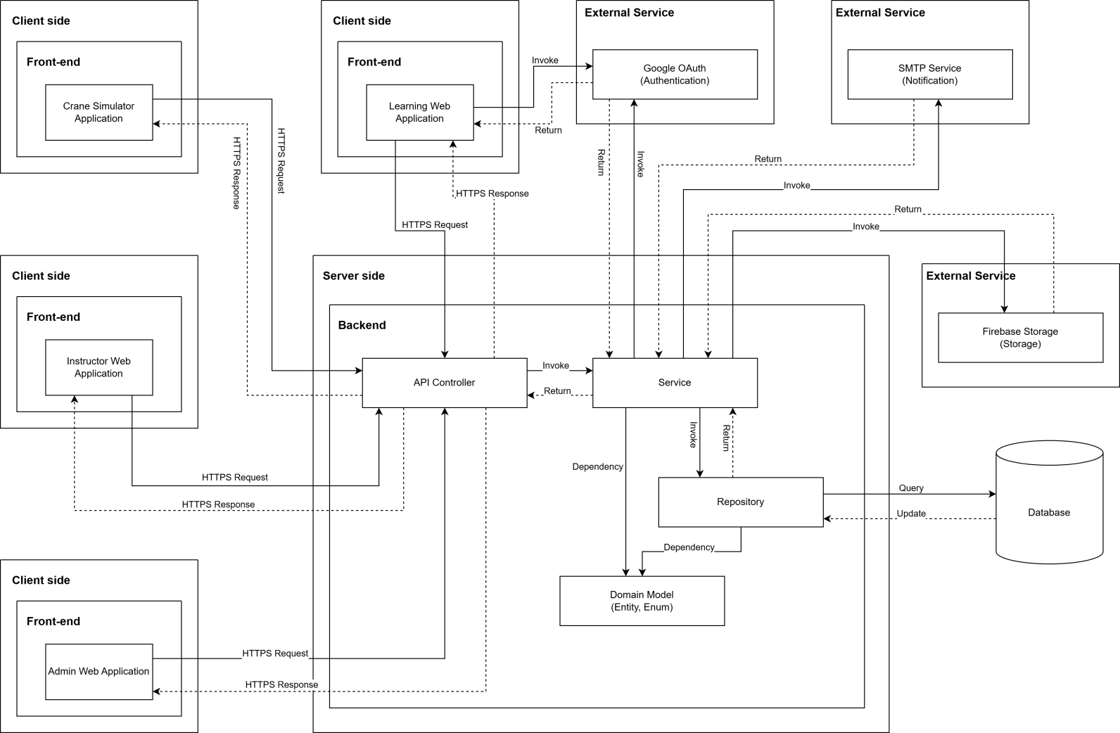

***System Architecture Diagram Descriptions***

|  |  |  |
| --- | --- | --- |
| **No** | **Name** | **Description** |
| 1 | Crane Simulator Application | Desktop application for practical crane operation training, communicates with backend via HTTPS to access training content and submit practice results |
| 2 | Learning Web Application | Web-based application for trainees to access learning materials, complete courses, take quizzes, and track their learning progress |
| 3 | Instructor Web Application | Web application for instructors to manage classes, create and grade quizzes, provide feedback, and monitor student progress |
| 4 | Admin Web Application | Web application for administrators to manage users, programs, courses, system settings, and overall platform administration |
| 5 | API Controller | RESTful API layer that receives HTTPS requests from client applications, routes them to appropriate services, and returns responses |
| 6 | Service | Business logic layer containing core application logic, processing business rules, orchestrating workflows, and coordinating between controllers and repositories |
| 7 | Repository | Data access layer that abstracts database operations, handles CRUD operations, and manages data persistence using Entity Framework or similar ORM |
| 8 | Domain Model (Entity, Enum) | Domain entities and enumerations representing the core business objects and data structures (Users, Courses, Classes, Quizzes, etc.) |
| 9 | Database | SQL Server database storing all system data including users, courses, enrollments, quiz attempts, practice results, and certificates |
| 10 | Google OAuth (Authentication) | External authentication service for user login using Google accounts, providing secure OAuth 2.0 authentication flow |
| 11 | SMTP Service (Notification) | External email service for sending notifications, alerts, password resets, and course-related communications to users |
| 12 | Firebase Storage (Storage) | Cloud storage service for storing and serving media files including course materials, videos, images, documents, and user-uploaded content |

### 1.2 Component Diagram

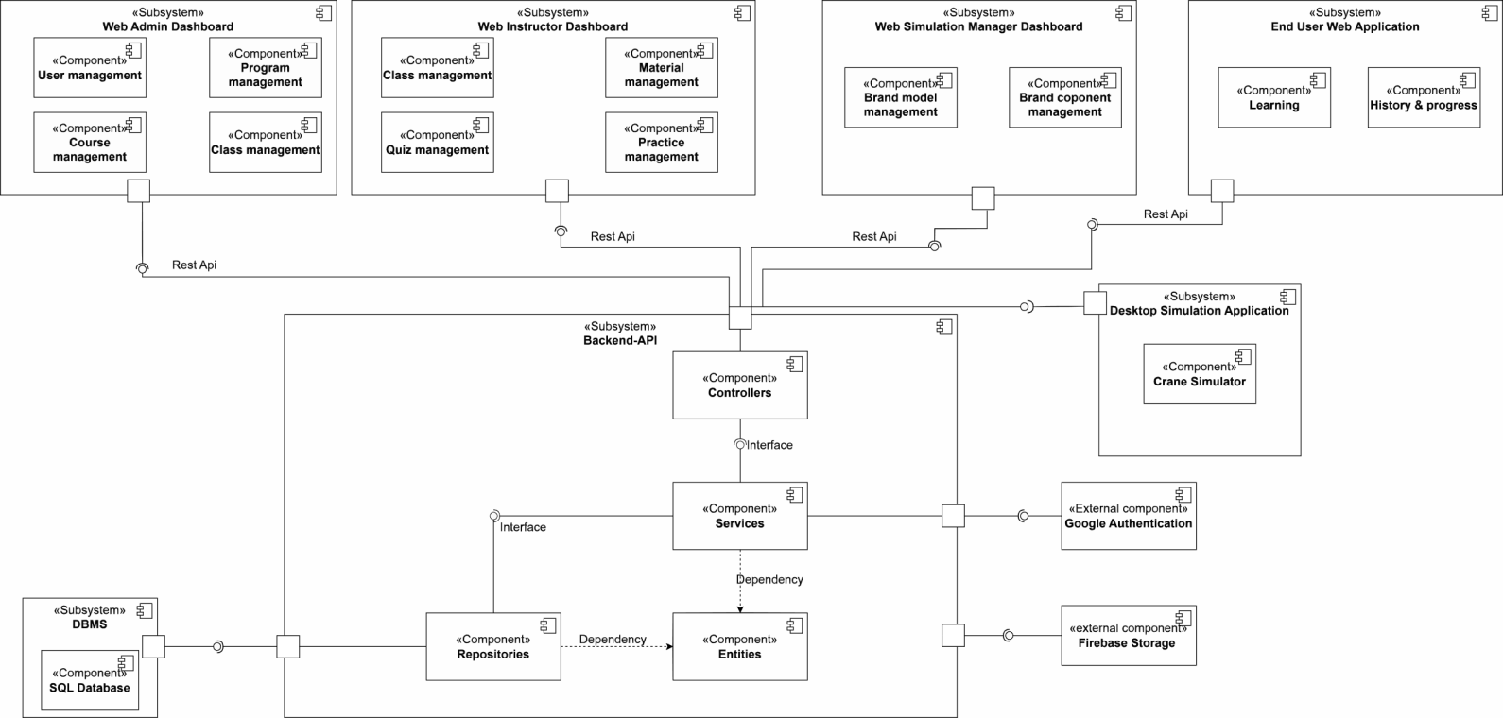

***Component Diagram Descriptions***

|  |  |  |
| --- | --- | --- |
| **No** | **Name** | **Description** |
| 1 | Web Admin Dashboard | Web administrative interface for Admin, including user management, program management, and course management features |
| 2 | User management | Component for managing users, handling account information, permissions, and user administration in the system |
| 3 | Program management | Component for managing training programs, organizing courses and curriculum |
| 4 | Course management | Component for managing courses, learning content, lectures, and materials |
| 5 | Web Instructor Dashboard | Web interface for instructors, including class management and quiz management |
| 6 | Class management | Component for managing classes, student lists, schedules, and attendance |
| 7 | Material management | Component for managing learning materials, lectures, videos, and attached files |
| 8 | Quiz management | Component for managing quizzes, questions, answers, and test results |
| 9 | Practice management | Component for managing practice exercises, assignments, and homework |
| 10 | Web Simulation Manager Dashboard | Simulation management interface, including brand model management and brand component management |
| 11 | Brand model management | Component for managing brand models in business simulation |
| 12 | Brand component management | Component for managing components and competitors in simulation |
| 13 | End User Web Application | Web application for end users (students), including learning features and history & progress tracking |
| 14 | Learning | Component handling the learning process, viewing lectures, and completing exercises for students |
| 15 | History & progress | Component tracking learning history and course completion progress for students |
| 16 | End User Desktop Application | Desktop application for end users, including practical training features |
| 17 | Practical Training | Component handling practical exercises on desktop application |
| 18 | Firebase Storage | Firebase file storage service for storing images, videos, documents, and attached files |
| 19 | Backend API | Backend API system handling business logic, including Controllers, Services, Repositories, and Entities |
| 20 | Controllers | Controller layer handling HTTP requests from clients, routing to corresponding services |
| 21 | Services | Business logic layer containing business rules and system processing logic |
| 22 | Repositories | Data access layer handling CRUD operations with the database |
| 23 | Entities | Layer defining data objects (data models) mapped to the database |
| 24 | Google Authentication | Component authenticating users through Google OAuth, supporting Google account login |
| 25 | DBMS | Database management system containing SQL Database storing all system data |
| 26 | SQL Database | SQL database (PostgreSQL/MySQL) storing user data, courses, exercises, and learning results |

## Database Design

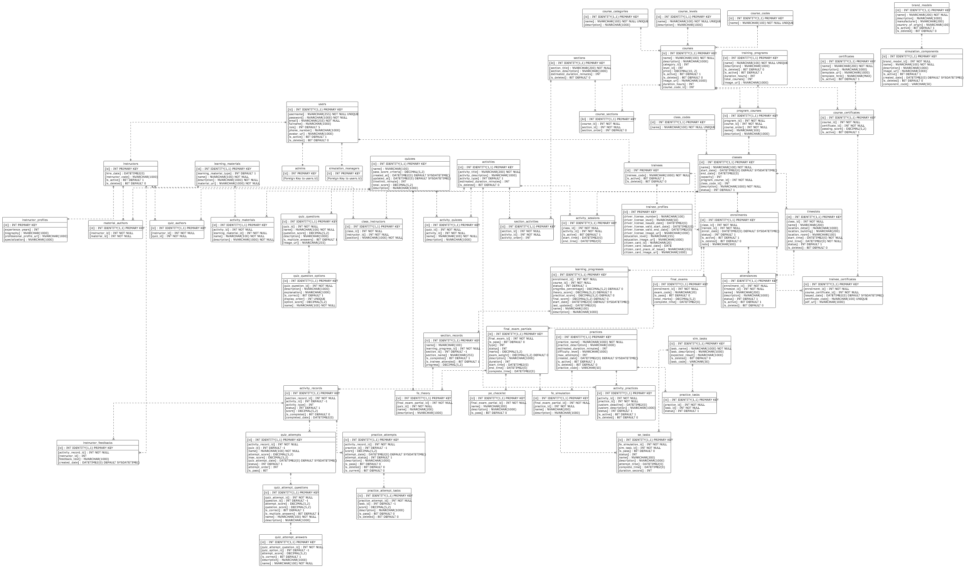

**Table Descriptions**

|  |  |  |
| --- | --- | --- |
| **No** | **Table** | **Description** |
| 1 | users | Stores the core account information for all system users including login credentials and contact info.  - Primary keys: id  - Foreign keys: None |
| 2 | admins | Stores specific information for users with the Admin role, linked to the main user record.  - Primary keys: id  - Foreign keys: id |
| 3 | simulation\_managers | Stores specific information for Simulation Managers, linked to the main user record.  - Primary keys: id  - Foreign keys: id |
| 4 | instructors | Stores specific information for Instructors, including employment details.  - Primary keys: id  - Foreign keys: id |
| 5 | trainees | Stores specific information for Trainees/Learners.  - Primary keys: id  - Foreign keys: id |
| 6 | instructor\_profiles | Contains detailed profile information for instructors such as experience and biography.  - Primary keys: id  - Foreign keys: id |
| 7 | trainee\_profiles | Contains detailed profile information for trainees, including driver license and citizen card details.  - Primary keys: id  - Foreign keys: id |
| 8 | course\_categories | Lookup table for defining different categories of courses.  - Primary keys: id  - Foreign keys: None |
| 9 | course\_levels | Lookup table for defining the difficulty or progression levels of courses.  - Primary keys: id  - Foreign keys: None |
| 10 | course\_codes | Lookup table for standardized course codes. - Primary keys: id - Foreign keys: None |
| 11 | courses | Stores the main course definitions including metadata like price and duration. - Primary keys: id  - Foreign keys: category\_id, level\_id, course\_code\_id |
| 12 | training\_programs | Defines high-level training programs that aggregate multiple courses.  - Primary keys: id  - Foreign keys: None |
| 13 | program\_courses | Junction table linking Courses to Training Programs, defining the order of courses within a program.  - Primary keys: id  - Foreign keys: program\_id, course\_id |
| 14 | sections | Defines content sections that organize activities within a course.  - Primary keys: Id  - Foreign keys: None |
| 15 | course\_sections | Junction table mapping sections to courses and defining their sequence.  - Primary keys: Id  - Foreign keys: course\_id, section\_id |
| 16 | activities | Stores individual learning activities (e.g., lessons, quizzes) that belong to sections. - Primary keys: id - Foreign keys: None |
| 17 | learning\_materials | Stores information about study materials like documents or videos.  - Primary keys: id  - Foreign keys: None |
| 18 | material\_authors | Links learning materials to the instructors who authored them.  - Primary keys: id  - Foreign keys: instructor\_id, material\_id |
| 19 | section\_activities | Junction table mapping activities to specific sections and defining their order.  - Primary keys: id - Foreign keys: section\_id, activity\_id |
| 20 | activity\_materials | Links learning materials to specific activities.  - Primary keys: id  - Foreign keys: activity\_id, learning\_material\_id |
| 21 | quizzes | Defines quiz assessments including time limits and passing criteria.  - Primary keys: id  - Foreign keys: None |
| 22 | quiz\_authors | Links quizzes to the instructors who created them.  - Primary keys: id  - Foreign keys: instructor\_id, quiz\_id |
| 23 | quiz\_questions | Stores questions belonging to a specific quiz.  - Primary keys: id  - Foreign keys: quiz\_id |
| 24 | quiz\_question\_options | Stores the possible answer options for a quiz question.  - Primary keys: id  - Foreign keys: quiz\_question\_id |
| 25 | activity\_quizzes | Junction table linking a Quiz to an Activity entity.  - Primary keys: id  - Foreign keys: quiz\_id, activity\_id |
| 26 | practices | Defines practical training exercises or simulation scenarios.  - Primary keys: id  - Foreign keys: None |
| 27 | sim\_tasks | Defines specific tasks or steps required within a simulation.  - Primary keys: id  - Foreign keys: None |
| 28 | practice\_tasks | Junction table linking simulation tasks to a practice scenario.  - Primary keys: id  - Foreign keys: practice\_id, task\_id |
| 29 | activity\_practices | Junction table linking a Practice to an Activity entity.  - Primary keys: id  - Foreign keys: activity\_id, practice\_id |
| 30 | brand\_models | Specific brand models of equipment (cranes) used in simulations.  - Primary keys: id  - Foreign keys: None |
| 31 | simulation\_components | Stores detailed components associated with specific brand models.  - Primary keys: id  - Foreign keys: brand\_model\_id |
| 32 | class\_codes | Lookup table for standardized class codes.  - Primary keys: id  - Foreign keys: None |
| 33 | classes | Represents a scheduled instance of a course (program course) with start/end dates.  - Primary keys: id  - Foreign keys: program\_course\_id, class\_code\_id |
| 34 | class\_instructors | Assigns instructors to specific classes with a designated position.  - Primary keys: id  - Foreign keys: class\_id, instructor\_id |
| 35 | enrollments | Records the registration of a trainee in a specific class.  - Primary keys: id  - Foreign keys: class\_id, trainee\_id |
| 36 | timeslots | Defines specific scheduling slots (date/time/location) for a class.  - Primary keys: id  - Foreign keys: class\_id |
| 37 | attendances | Tracks trainee attendance for specific timeslots.  - Primary keys: id  - Foreign keys: enrollment\_id, timeslot\_id |
| 38 | activity\_sessions | Schedules specific activities within a class timeframe.  - Primary keys: id  - Foreign keys: class\_id, activity\_id |
| 39 | final\_exams | Stores the overall record of a final exam for an enrollment.  - Primary keys: id  - Foreign keys: enrollment\_id |
| 40 | final\_exam\_partials | Stores specific parts (theory/practical) of a final exam.  - Primary keys: id  - Foreign keys: final\_exam\_id |
| 41 | pe\_checklist | Stores checklist items for grading practical final exams.  - Primary keys: id  - Foreign keys: final\_exam\_partial\_id |
| 42 | fe\_theory | Links a final exam partial to a specific theory quiz.  - Primary keys: id  - Foreign keys: final\_exam\_partial\_id, quiz\_id |
| 43 | fe\_simulation | Links a final exam partial to a specific simulation practice.  - Primary keys: id  - Foreign keys: final\_exam\_partial\_id, practice\_id |
| 44 | se\_tasks | Tracks the result of specific tasks within a simulation final exam.  - Primary keys: id  - Foreign keys: fe\_simulation\_id, sim\_task\_id |
| 45 | certificates | Defines certificate templates available in the system.  - Primary keys: id  - Foreign keys: None |
| 46 | course\_certificates | Links certificates to courses, defining passing requirements.  - Primary keys: id  - Foreign keys: course\_id, certificate\_id |
| 47 | trainee\_certificates | Records certificates issued to trainees upon course completion.  - Primary keys: id  - Foreign keys: enrollment\_id, course\_certificate\_id |
| 48 | learning\_progresses | Tracks the overall progress of a trainee within an enrollment.  - Primary keys: id  - Foreign keys: enrollment\_id |
| 49 | section\_records | Tracks a trainee's completion status for specific course sections.  - Primary keys: id  - Foreign keys: learning\_progress\_id |
| 50 | activity\_records | Tracks the detailed status and score of a trainee for specific activities.  - Primary keys: id  - Foreign keys: section\_record\_id |
| 51 | instructor\_feedbacks | Stores feedback provided by instructors on specific activity records.  - Primary keys: id  - Foreign keys: activity\_record\_id, instructor\_id |
| 52 | practice\_attempts | Records a specific attempt by a trainee to complete a practice activity.  - Primary keys: id  - Foreign keys: activity\_record\_id |
| 53 | practice\_attempt\_tasks | Records the result of individual tasks within a practice attempt.  - Primary keys: id  - Foreign keys: practice\_attempt\_id |
| 54 | quiz\_attempts | Records a specific attempt by a trainee to complete a quiz.  - Primary keys: id  - Foreign keys: activity\_record\_id |
| 55 | quiz\_attempt\_questions | Records the trainee's answer/score for a specific question in a quiz attempt.  - Primary keys: id  - Foreign keys: quiz\_attempt\_id |
| 56 | quiz\_attempt\_answers | Records the specific option selected by a trainee for a question.  - Primary keys: id  - Foreign keys: quiz\_attempt\_question\_id |

## 3. Detailed Design

### 3.1 Program & Course Management

#### 3.1.1 Class Diagram

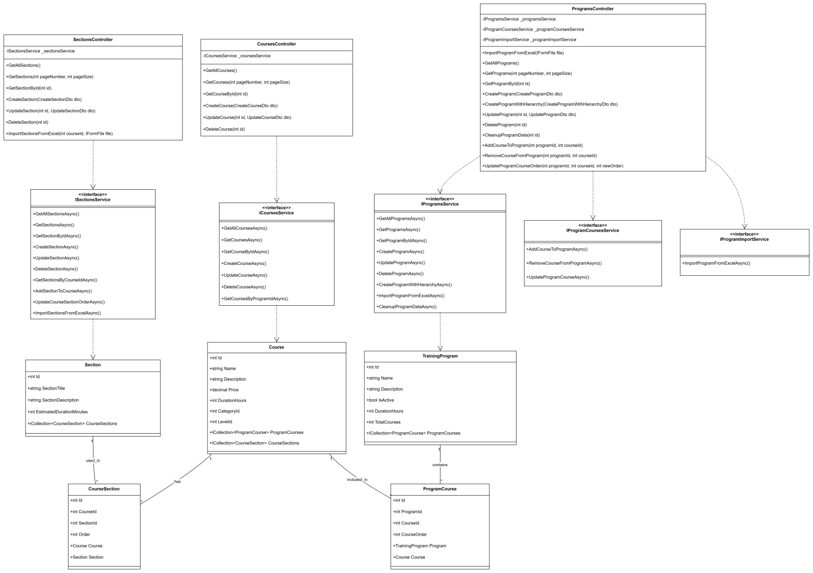

#### 3.1.2 Sequence Diagram - Admin Creates Program

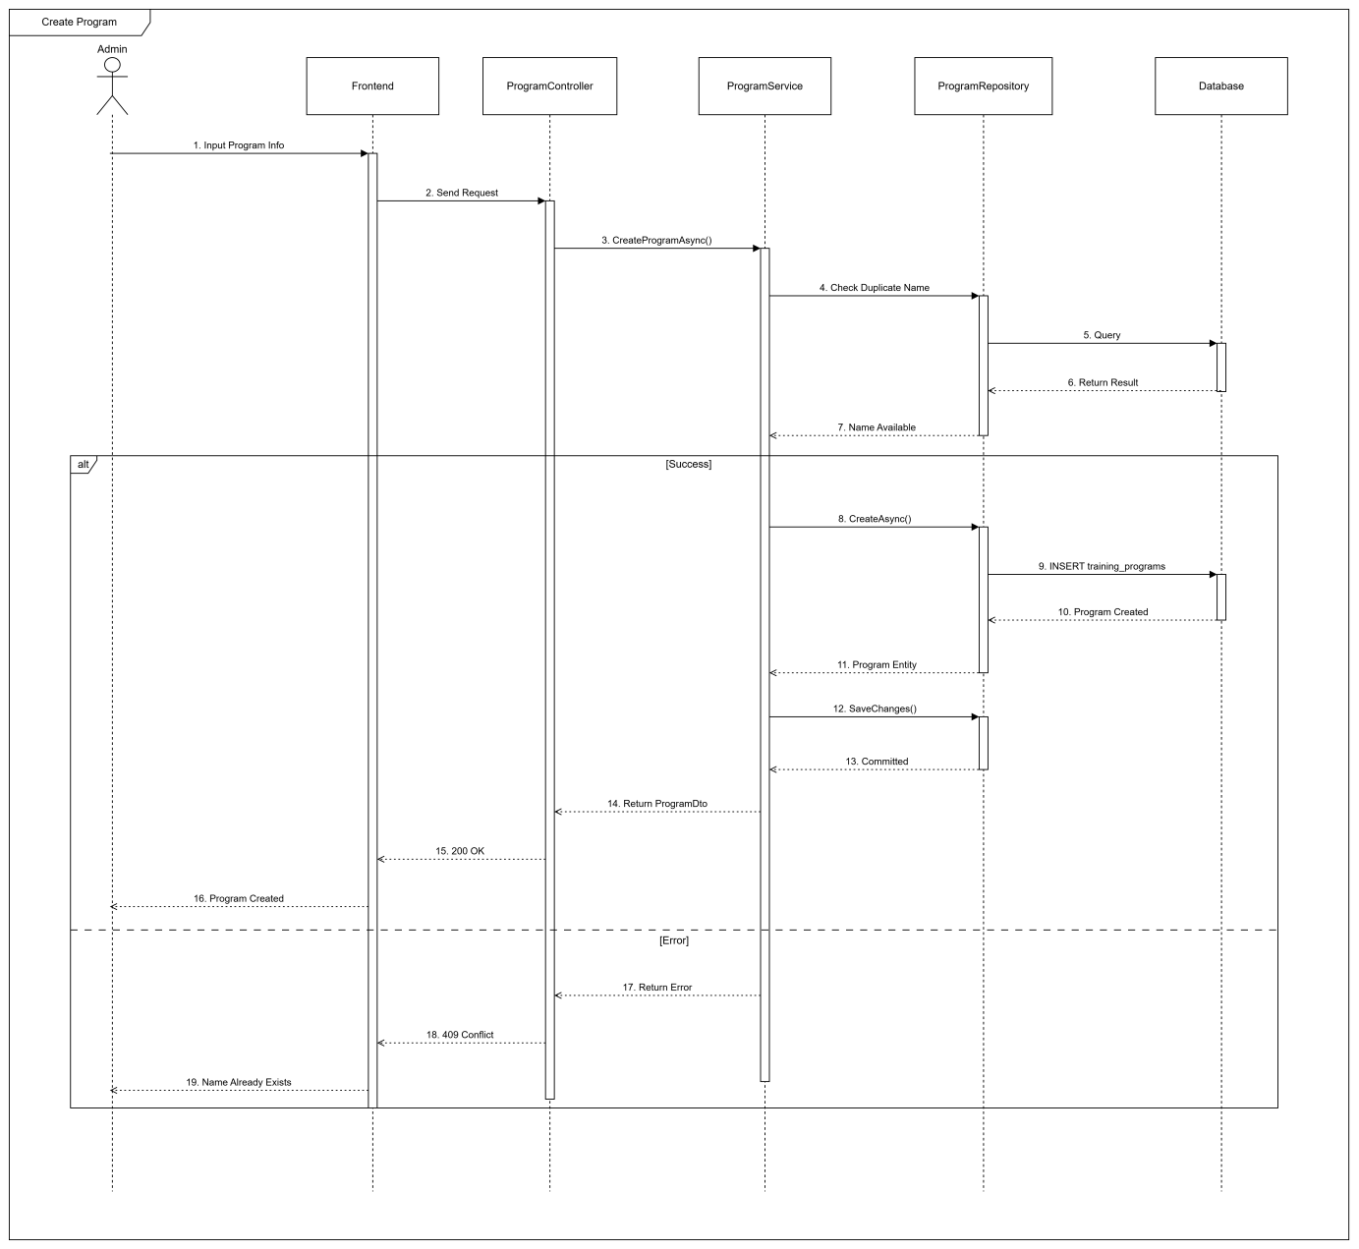

#### 3.1.3 Sequence Diagram - Admin Creates Course

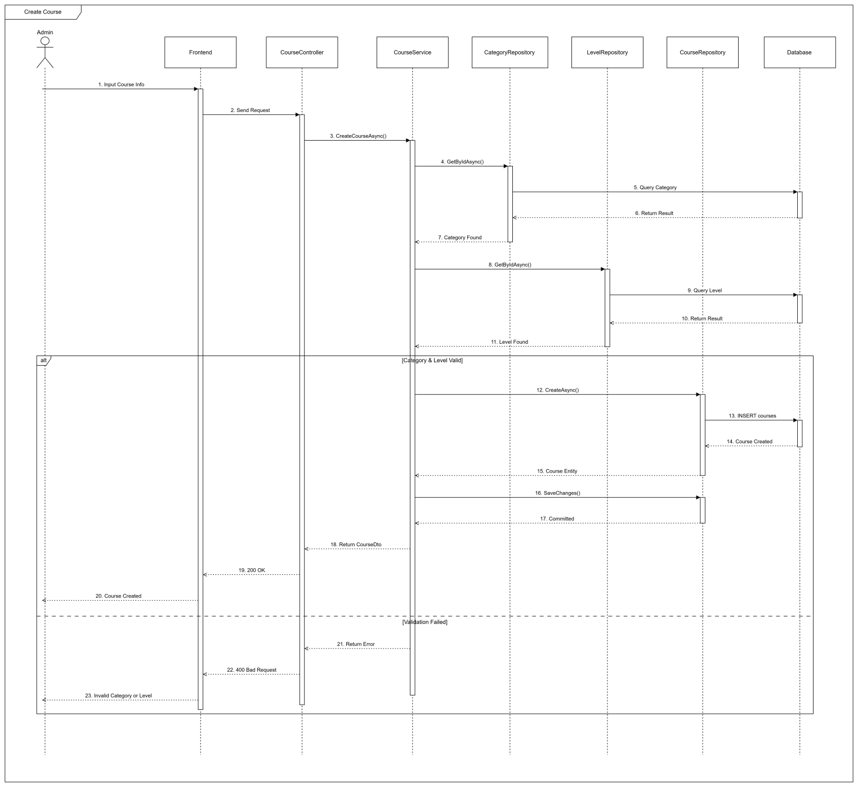

#### 3.1.4 Sequence Diagram - Admin Adds Course To Program

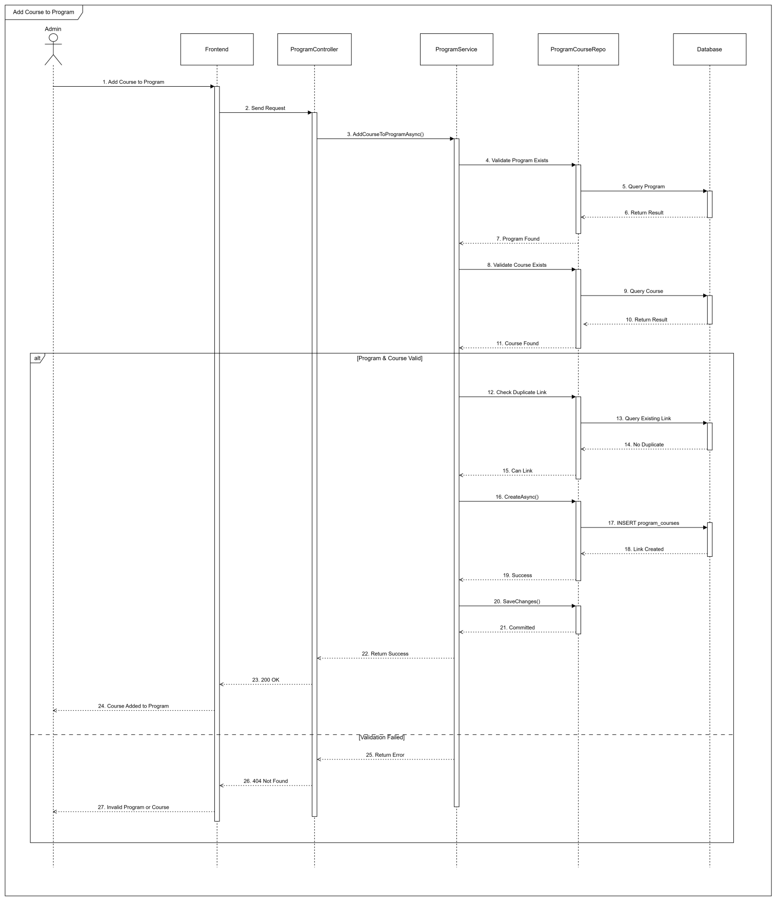

### 3.2 Class Management & Enrollment

#### 3.2.1 Class Diagram

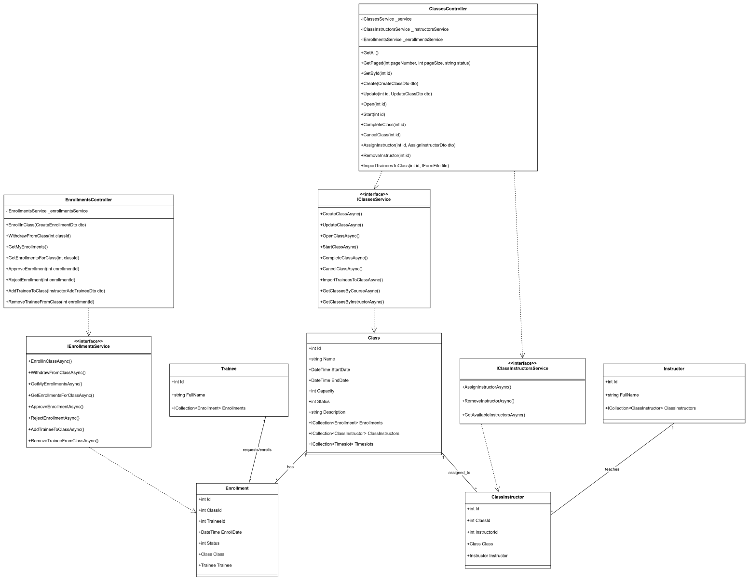

#### 3.2.2 Sequence Diagram - Trainee Enrolls to Class

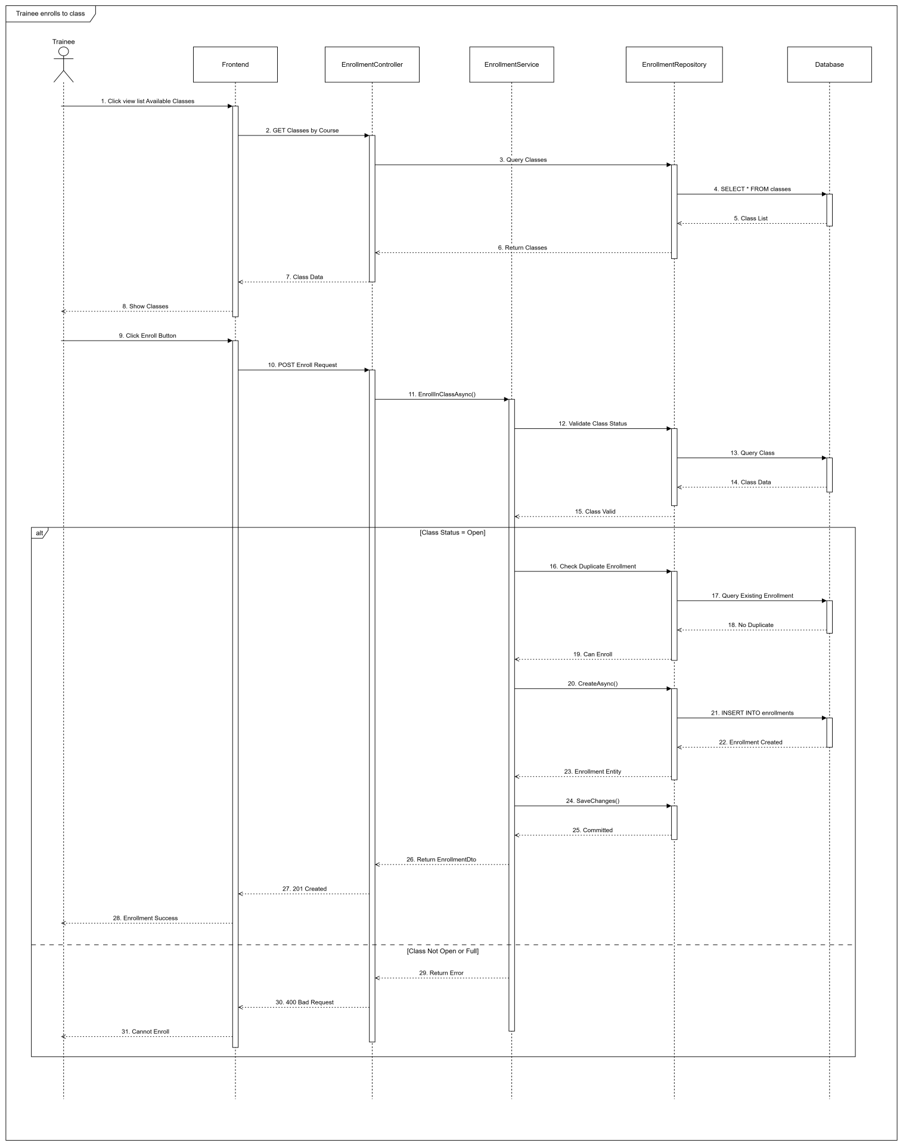

#### 3.2.3 Sequence Diagram - Admin Confirms Enrollment

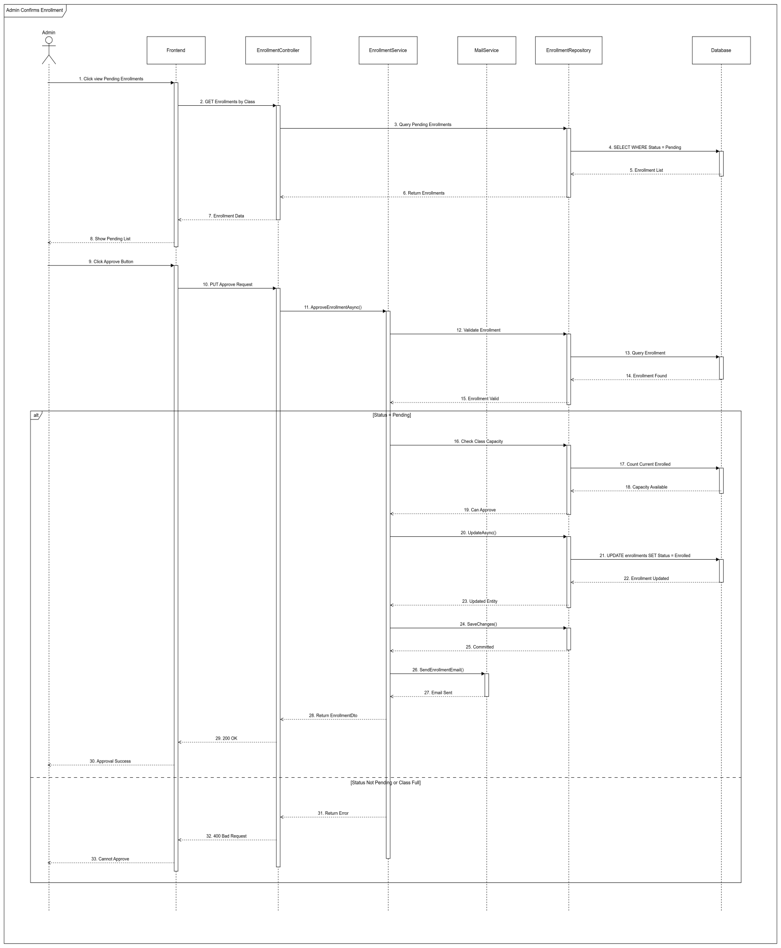

### 3.3 Simulation Practice Management

#### 3.3.1 Class Diagram

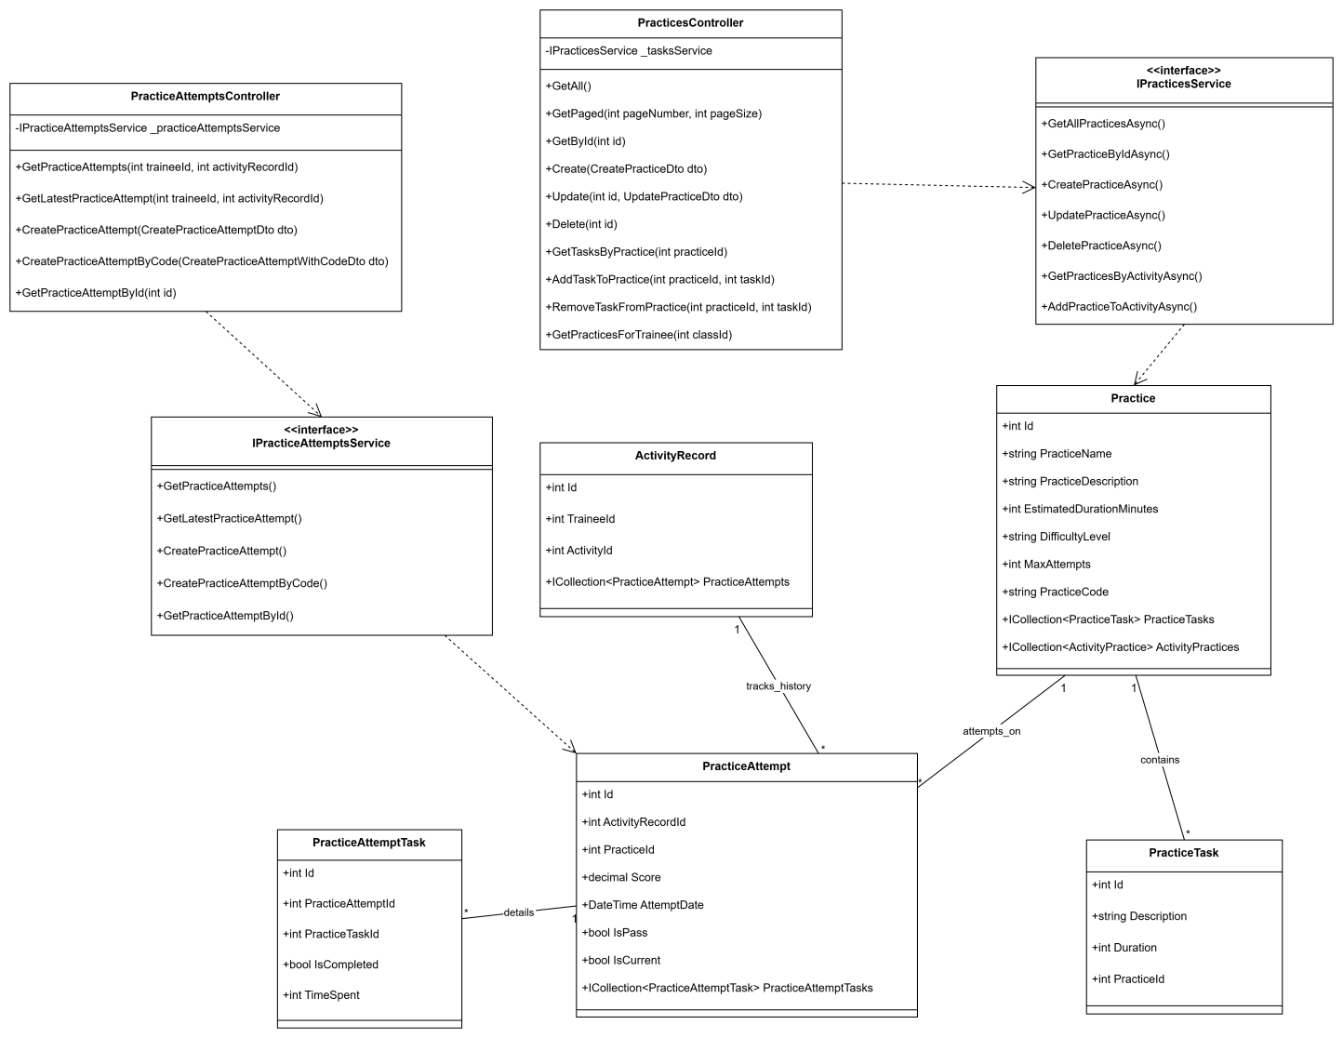

#### 3.3.2 Sequence Diagram - Simulation Manager Creates Practice

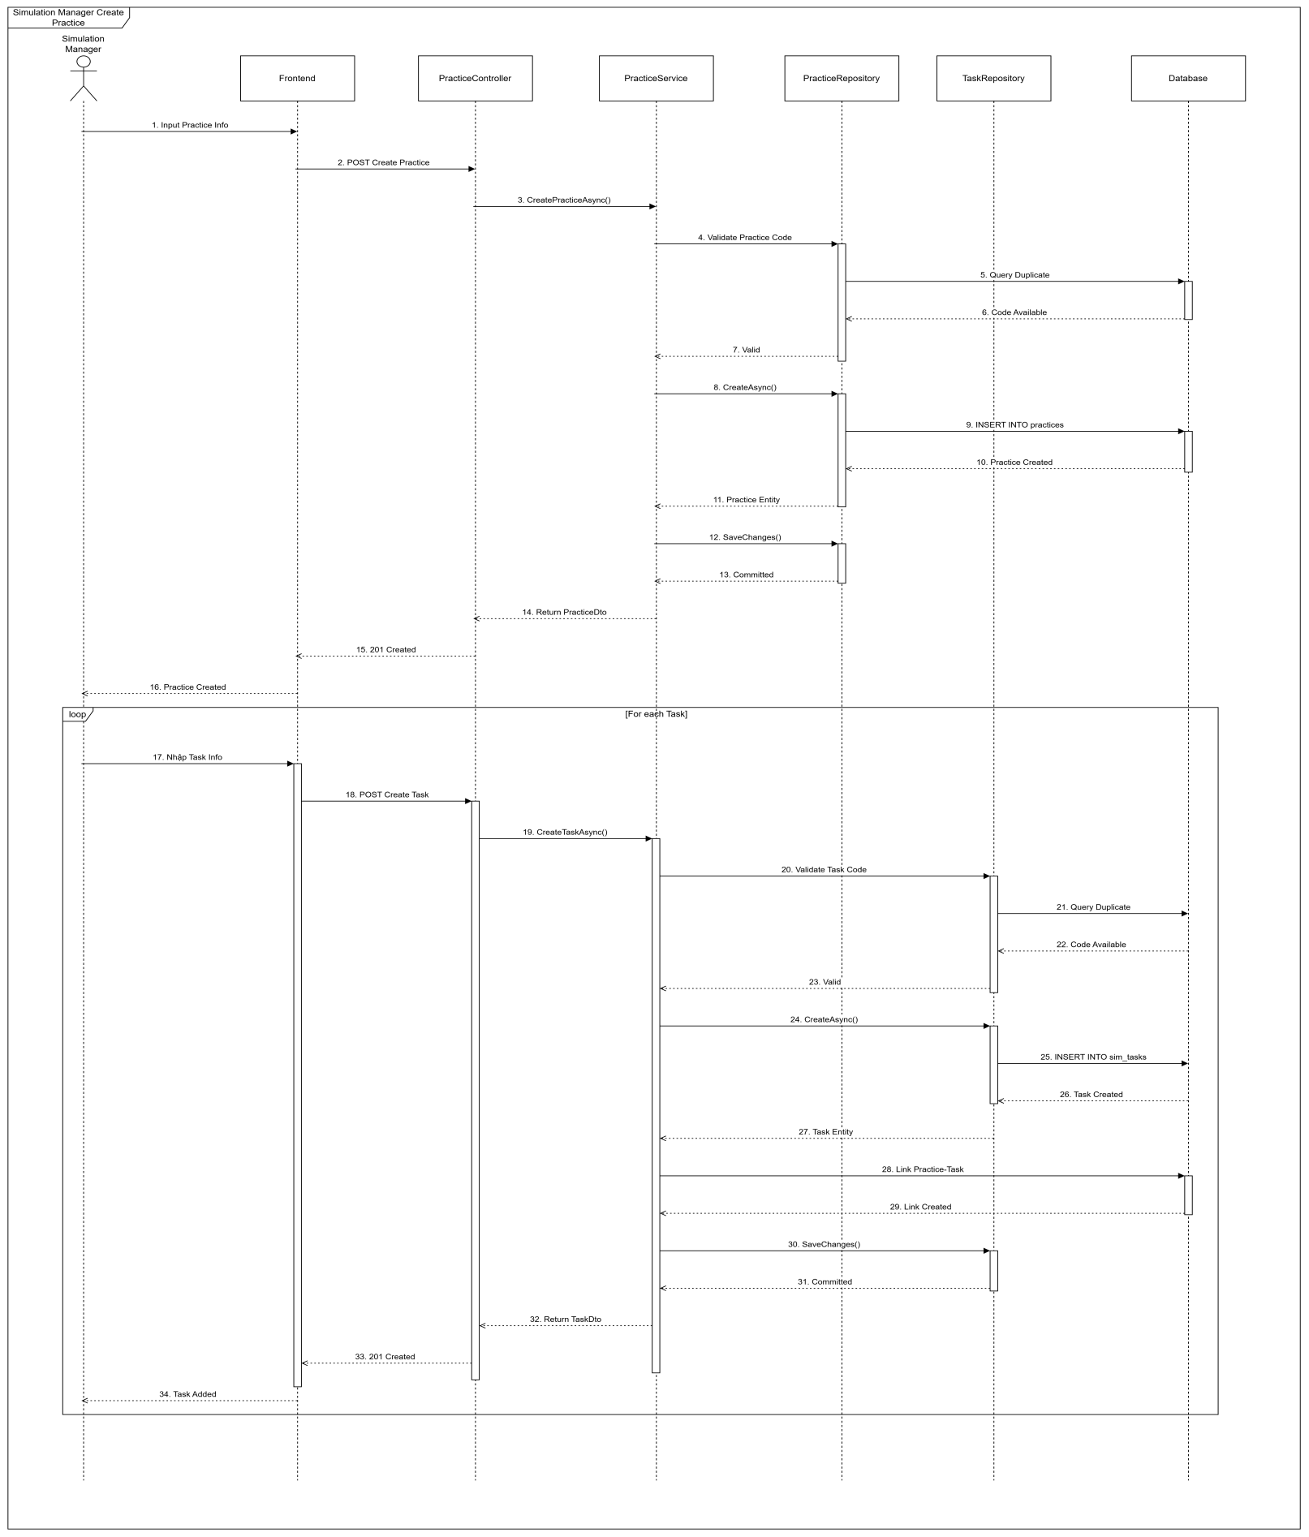

#### 3.3.3 Sequence Diagram - Trainees Attempt Practice

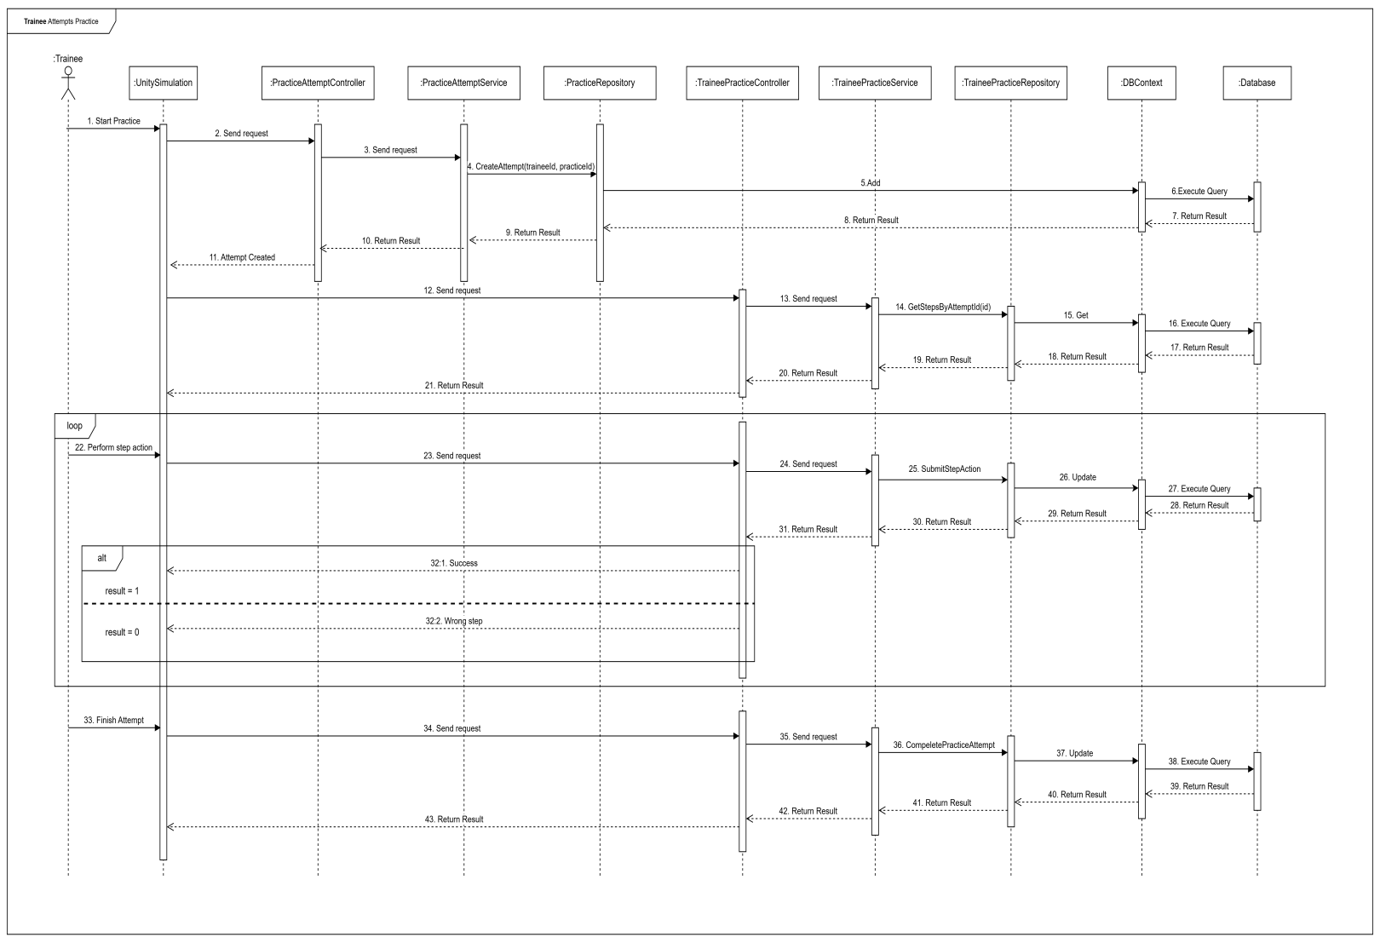

### 3.4 Final Exam Management

#### 3.4.1 Class Diagram

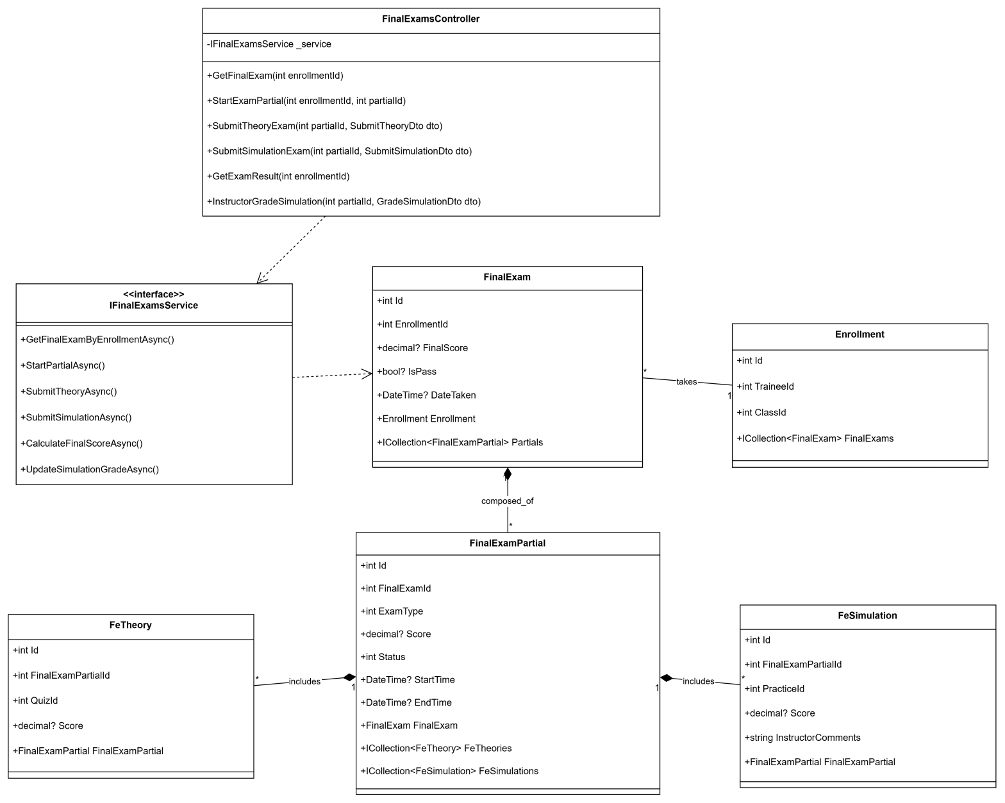

#### 3.4.2 Sequence Diagram - Final Exam Configuration

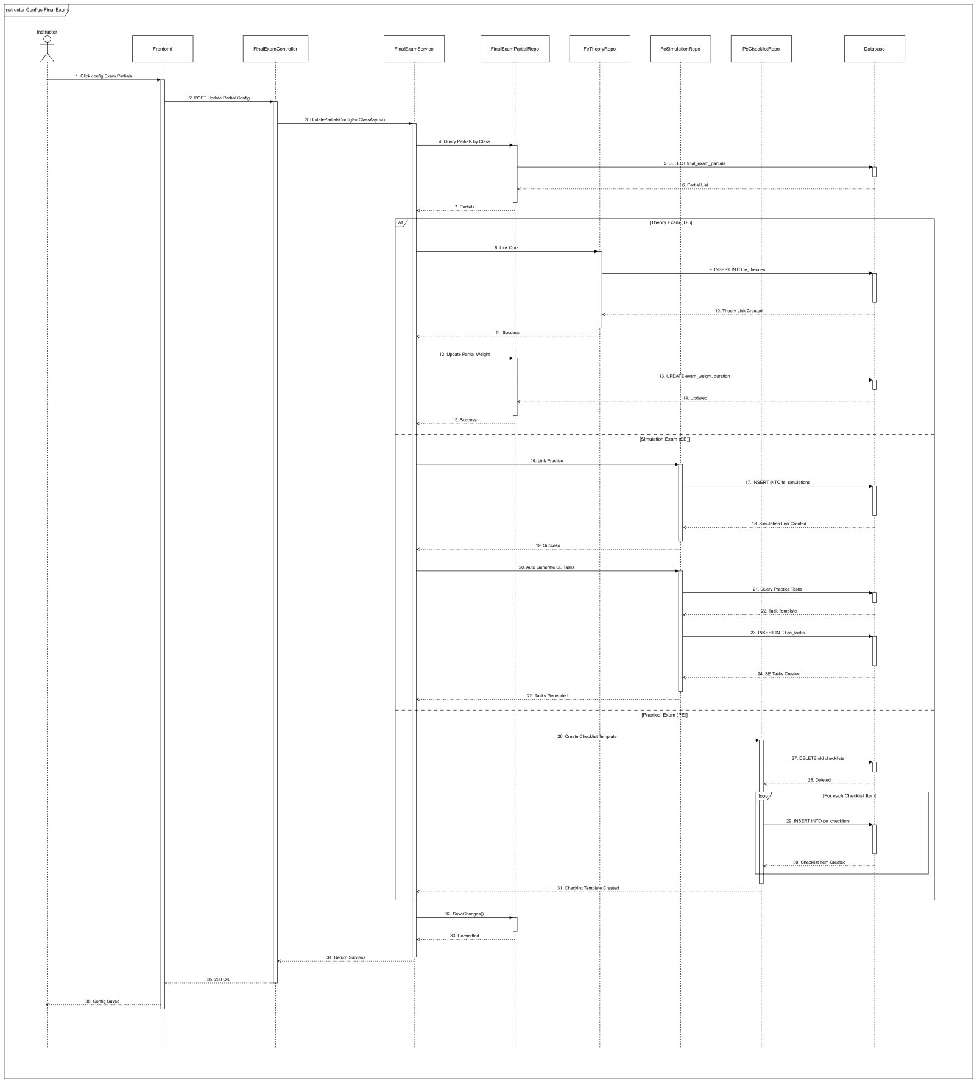

### 3.5 Dashboard & Reports

#### 3.5.1 Class Diagram

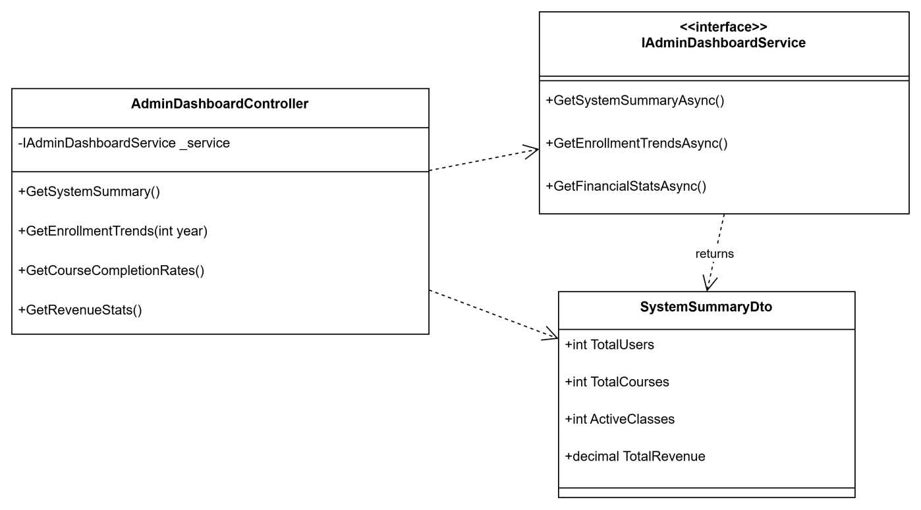

#### 3.5.2 Sequence Diagram - Admin Views Dashboard

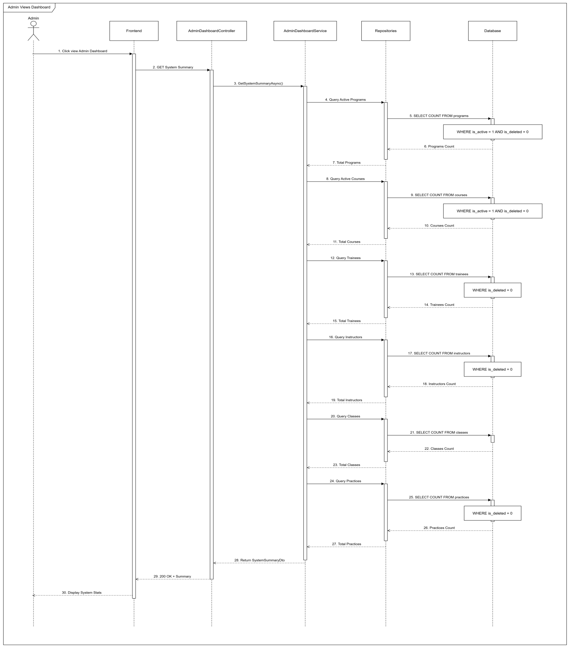

# V. Software Testing Documentation

## 1. Overall Description

### 1.1 Test Model

The project follows the Agile Testing Model. Testing is performed continuously alongside development sprints (Sprint 1 to Sprint 4).

* Requirement Analysis: Analyze SRS to identify test scenarios.
* Test Design: Create Test Cases (Excel).
* Test Execution: Execute Functional and Integration tests.
* Defect Tracking: Log issues on GitHub and re-test after fixing.

### 1.2 Testing Levels

* **Unit Testing:** Performed by Developers using xUnit (BE) and localized component testing (FE).
* **Integration Testing:** Verifying communication between React FE, .NET API, and the Simulation Client.
* **System Testing:** End-to-end testing of full workflows (e.g., Enrollment -> Learning -> Exam -> Certificate).
* **Acceptance Testing (UAT):** Validating the system against user requirements (Admin, Instructor, Trainee flows).

### 1.3 Testing Types

* **Functional Testing:** Verifying all features against SRS (CRUD, Workflows).
* **UI/UX Testing:** Ensuring responsiveness and usability (React components).
* **API Testing:** Validating data integrity using Postman.
* **Security Testing:** Verifying Role-based Access Control (RBAC) and JWT Authentication.

## 2. Test Plan

### 2.1 Test Stages

|  |  |  |  |  |
| --- | --- | --- | --- | --- |
| **Type of Test** | **Stage of Test** | | | |
| ***Unit*** | ***Integration*** | ***System*** | ***Acceptance*** |
| Function Test | X | X | X | X |
| User Interface Test |  |  | X | X |
| Performance Tests |  | X | X |  |
| Security Test |  | X | X |  |
| Data Integrity Test | X | X | X |  |

### 2.2 Resources

a. Human Resources (Refer to Team Involvements table in Section I.2)

b. Environment

|  |  |  |  |
| --- | --- | --- | --- |
| **Purpose** | **Tool** | **Provider** | **Version** |
| Backend Server | .NET 8 Web API | Microsoft | Hosted on Azure/Localhost |
| Frontend Client | ReactJS (Vite) | Open Source | Node.js v18+ |
| Database | SQL Server | Microsoft | Azure SQL / SQL Server 2019 |
| Simulation Client | Unity Build | Unity Tech | Windows Executable (.exe) |
| Browser | Google Chrome | Google | Latest Version |
| API Testing | Swagger / Swagger UI / Swagger Editor | OpenAPI Initiative | Latest Version |
| IDE | VS Code / Visual Studio | Microsoft | Code Editing |

### 2.3 Test Milestones

|  |  |  |  |
| --- | --- | --- | --- |
| **Milestone Task** | **Effort (md)** | **Start Date** | **End Date** |
| Test Planning | 2 | 10/11/2025 | 11/11/2025 |
| Test Case Design | 5 | 12/11/2025 | 18/11/2025 |
| Environment Setup | 1 | 19/11/2025 | 19/11/2025 |
| Test Execution (Round 1) | 5 | 20/11/2025 | 26/11/2025 |
| Bug Fixing & Retest | 3 | 27/11/2025 | 05/12/2025 |
| Final Report Generation | 1 | 06/12/2025 | 12/12/2025 |

### 2.4 Deliverables

|  |  |  |
| --- | --- | --- |
| **No** | **Deliverables** | **Due Date** |
| 1 | Report 5 - Test Documentation (This document) | 14/12/2025 |
| 2 | Report 5 - Test Cases (Excel File) | 14/12/2025 |
| 3 | Test Execution Reports (CSV/Excel) | 14/12/2025 |
| 4 | Bug Log / Defect List | 14/12/2025 |

## 3. Test Cases

Detailed test cases are provided in the attached file: Report5\_Test Report.xlsx. The test suite covers the following modules:

1. **Training Content & Curriculum Management:** Program, Course, Class, Section management.
2. **Trainee Enrollment & Learning Process:** Enrollment flow, "My Classes", learning materials.
3. **Simulation Integration:** Launching Sim client, syncing scores and results.
4. **Trainee Final Exam Module:** Theory and Simulation exams, grading logic.
5. **Dashboard Management:** Admin, Instructor, and Sim Manager analytics.

## 4. Test Reports

**Summary of Test Execution (Source: Test Statistics.csv):**

* **Total Test Cases:** 197
* **Passed:** 191
* **Failed:** 0
* **Pending/NA:** 6 (Skipped scenarios or future features)
* **Pass Rate:** ~96.95%

|  |  |  |  |  |  |  |
| --- | --- | --- | --- | --- | --- | --- |
| **No** | **Module Name** | **Passed** | **Failed** | **Pending** | **N/A** | **Total TCs** |
| *1* | *Training Content & Curriculum Management* | *50* | *0* | *0* | *0* | *56* |
| *2* | *Trainee Enrollment & Learning Process* | *73* | *0* | *0* | *0* | *73* |
| *3* | *Simulation Integration & Practice Session* | *9* | *0* | *0* | *0* | *9* |
| *4* | *Trainee Final Exam Module* | *36* | *0* | *0* | *0* | *36* |
| *5* | *Dashboard Management* | *23* | *0* | *0* | *0* | *23* |
| ***Total*** |  | ***191*** | ***0*** | ***0*** | ***0*** | ***197*** |

# VI. Release Package & User Guides

## 1. Deliverable Package

### 1.1 Source codes & documents

| **No.** | **Items** | **Sub-Items** | **Type** | **Version** |
| --- | --- | --- | --- | --- |
| **Code Package** | | | | |
| 1 | LSSCTC Backend API | Web Service | Modify | 10.5 |
| 2 | LSSCTC Frontend Web App | User Web Application | Modify | 9.3 |
| 3 | LSSCTC Simulator Desktop App | User Desktop Application | Modify | 3.0 |
| **Database** | | | | |
| 1 | Tables | lssctc\_db\_script.sql | Modify | N/A |
| **Documents** | | | | |
| 1 | Project  Introduction | Report1\_Project Introduction.docx | Modify | 1.0 |
| 2 | Project  Management  Plan | Report2\_Project Management Plan.docx | Modify | 1.0 |
| 3 | Software  Requirement  Specification | Report3\_Software Requirement Specification.docx | Modify | 1.0 |
| 4 | Software  Design  Document | Report4\_Software Design Document.docx | Modify | 1.0 |
| 5 | Test  Documentation | Report5\_Test Documentation.docx | Modify | 1.0 |
| 6 | Software User  Guides | Report6\_Software User Guides.docx | Modify | 1.0 |
| 7 | Final Project  Report | Report7\_FinalProjectReport.docx | Modify | 1.0 |

### 1.2 Known Issues, Limitations & Restrictions

* npm install fails: Delete the node\_modules folder and package-lock.json file, then run npm install again.
* Port 5173 already in use: Stop the process currently using the port or change the port number in the vite.config.js file.
* API calls fail with CORS error: Verify that the backend server is running and configured to accept requests from http://localhost:5173.
* Google OAuth not working: Ensure the Client ID in the .env file is correct and the Redirect URIs in the Google Cloud Console match your local URL.
* Blank page appears after loading: Open the browser developer tools console to check for JavaScript errors or missing environment variables.
* Module not found errors: Run npm install again to ensure all required dependencies are downloaded.

## 2. Installation Guides

### 2.1 System Requirements

#### 2.1.1 Hardware Requirements

|  |  |  |
| --- | --- | --- |
| **Component** | **Minimum** | **Recommended** |
| CPU | At least 2 GHz x64-bit CPU | Intel Core I5, 4GHz |
| Memory | At least 8GB RAM | 16GB RAM |
| Storage | 10GB SSD | 15GB SSD |
| Network | Internet Connection | 500 Mbps |

**Table 1: Hardware Requirements**

#### 2.1.2 Software Requirements

|  |  |  |
| --- | --- | --- |
| **Component** | **Software & Version** | **Description** |
| Operating System | Windows 10/11, macOS 10.15+, or Linux (Ubuntu 20.04+) | Operating system for running project |
| DBMS | SQL Server 2019 or Azure SQL Database | Database management system |
| Server Environment | .NET 8.0 SDK | Environment for running backend API |
| Frontend Environment | Node.js 18.17.0 or higher | Environment for running frontend application |
| Package Manager | NPM 9.x or higher | Package manager for frontend dependencies |
| IDE | Visual Studio Code 1.80+ or Visual Studio 2022 | Tool for viewing and editing code |
| VCS | Git 2.30+ | Tool for managing code version |
| Web Browser | Chrome 90+, Firefox 88+, Edge 90+, or Safari 14+ | Browser for accessing web application |
| Database Tool | SQL Server Management Studio (SSMS) 19+ or Azure Data Studio | Tool for database management |

**Table 2: Software Requirements**

### 2.2 Setup Files

#### 2.2.1 Database Files

* **lssctc\_db-script.sql**: Complete database schema script for SQL Server
* **seed-data.sql**: Initial seed data for system (users, roles, course categories, etc.)

#### 2.2.2 Backend Files

* **lssctc-api. zip**: Complete backend API solution
  + Contains: Controllers, Services, Models, Repositories, and Configuration files
  + Main project: Lssctc.ProgramManagement
  + Shared library: Lssctc.Share

#### 2.2.3 Frontend Files

* **lssctc-web.zip**: Complete frontend web application
  + Contains: React components, Pages, Routes, Layouts, and Assets
  + Main entry: src/main.jsx
  + Configuration: vite.config.js, package.json

#### 2.2.4 Configuration Files

* **appsettings.json**: Backend API configuration (connection strings, JWT settings)
* **appsettings.Development.json**: Development-specific settings
* **.env. example**: Frontend environment variables template

### 2.3 Installation Instruction

#### 2.3.1 Setup Environment

**Step 1: Install Required Software**

* **Download and Install .NET 8.0 SDK**
  + Visit: <https://dotnet.microsoft.com/download/dotnet/8.0>
  + Download .NET 8.0 SDK for your operating system
  + Run installer and follow installation wizard
* **Download and Install Node.js 18.17.0 or higher**
  + Visit: <https://nodejs.org/>
  + Download LTS version (18.17.0 or newer)
  + Run installer and follow installation wizard
* **Download and Install SQL Server 2019**
  + Visit: <https://www.microsoft.com/en-us/sql-server/sql-server-downloads>
  + Download SQL Server 2019 Developer Edition (free)
  + Run installer and follow installation wizard
  + Configure authentication mode: **Mixed Mode** (SQL Server and Windows Authentication)
  + Verify installation using SQL Server Configuration Manager
* **Download and Install SQL Server Management Studio (SSMS)**
  + Visit: <https://docs.microsoft.com/en-us/sql/ssms/download-sql-server-management-studio-ssms>
  + Download latest version
  + Run installer and follow installation wizard
  + Launch SSMS and connect to local SQL Server instance
* **Download and Install Visual Studio Code**
  + Visit: <https://code.visualstudio.com/>
  + Download for your operating system
  + Install recommended extensions
* **Download and Install Git**
  + Visit: <https://git-scm.com/downloads>
  + Download for your operating system
  + Run installer with default options

**Step 2: Configure Git**

* Set your name and email
* Verify configuration

**Step 3: Clone Repositories**

* Create project directory
* Clone backend repository
* Clone frontend repository
* Clone simulation application repository

#### 2.3.2 Setup Database

**Step 1: Create Database**

* Open **SQL Server Management Studio (SSMS)**
* Connect to your local SQL Server instance
* Right-click on **Databases** → Select **New Database**
* Database name: lssctc\_db
* Click **OK**

**Step 2: Execute Database Script**

* Open **lssctc\_db-script.sql** in SSMS
  + File → Open → File → Select lssctc\_db-script.sql
* Ensure lssctc\_db database is selected in database dropdown
* Click **Execute** button or press F5
* Wait for script execution to complete
* Verify tables are created:
* Expected output: 40+ tables including users, roles, courses, classes, quizzes, etc.

**Step 3: Execute Seed Data (Optional)**

* Open **seed-data.sql** in SSMS
* Execute script to populate initial data:
  + Default admin account
  + Course categories and levels
  + Course and class codes
  + Material types
* Verify seed data

**Step 4: Verify Database Connection String**

* Your server name
* Database name: lssctc\_db
* Authentication: SQL Server Authentication or Windows Authentication
* Example connection string:
  + Server=localhost;Database=LSSCTC\_DB;User Id=sa;Password=YourPassword;TrustServerCertificate=True

#### 2.3.3 Setup and Run Backend API

**Step 1: Navigate to Backend Project**

* cd lssctc-project/lssctc-api/Lssctc/Lssctc.ProgramManagement

**Step 2: Configure Application Settings**

* Open **appsettings.json** in text editor or VS Code
* Update your custom value for: "ConnectionStrings", "JwtConfig", "EmailSettings"
* **Generate JWT Secret Key** (recommended):
  + Generate random 32-character key using PowerShell (Windows)
  + Generate random 32-character key using openssl (macOS/Linux)
* **Configure Email Settings** (for OTP functionality):
  + Use Gmail account
  + Enable 2-Factor Authentication
  + Generate App Password: <https://myaccount.google.com/apppasswords>
  + Use App Password in configuration (not your Gmail password)

**Step 3: Restore NuGet Packages**

* Restore all dependencies
  + dotnet restore

**Step 4: Build Project**

* Build project
  + dotnet build
  + Expected output: Build succeeded.

**Step 5: Run Backend API**

* Run in development mode
  + dotnet run

**Step 6: Verify API is Running**

* Open web browser
* Navigate to default port
* If you setup the project to display the Swagger UI in production environment (recommend for testing only), you should see this page with all API endpoints

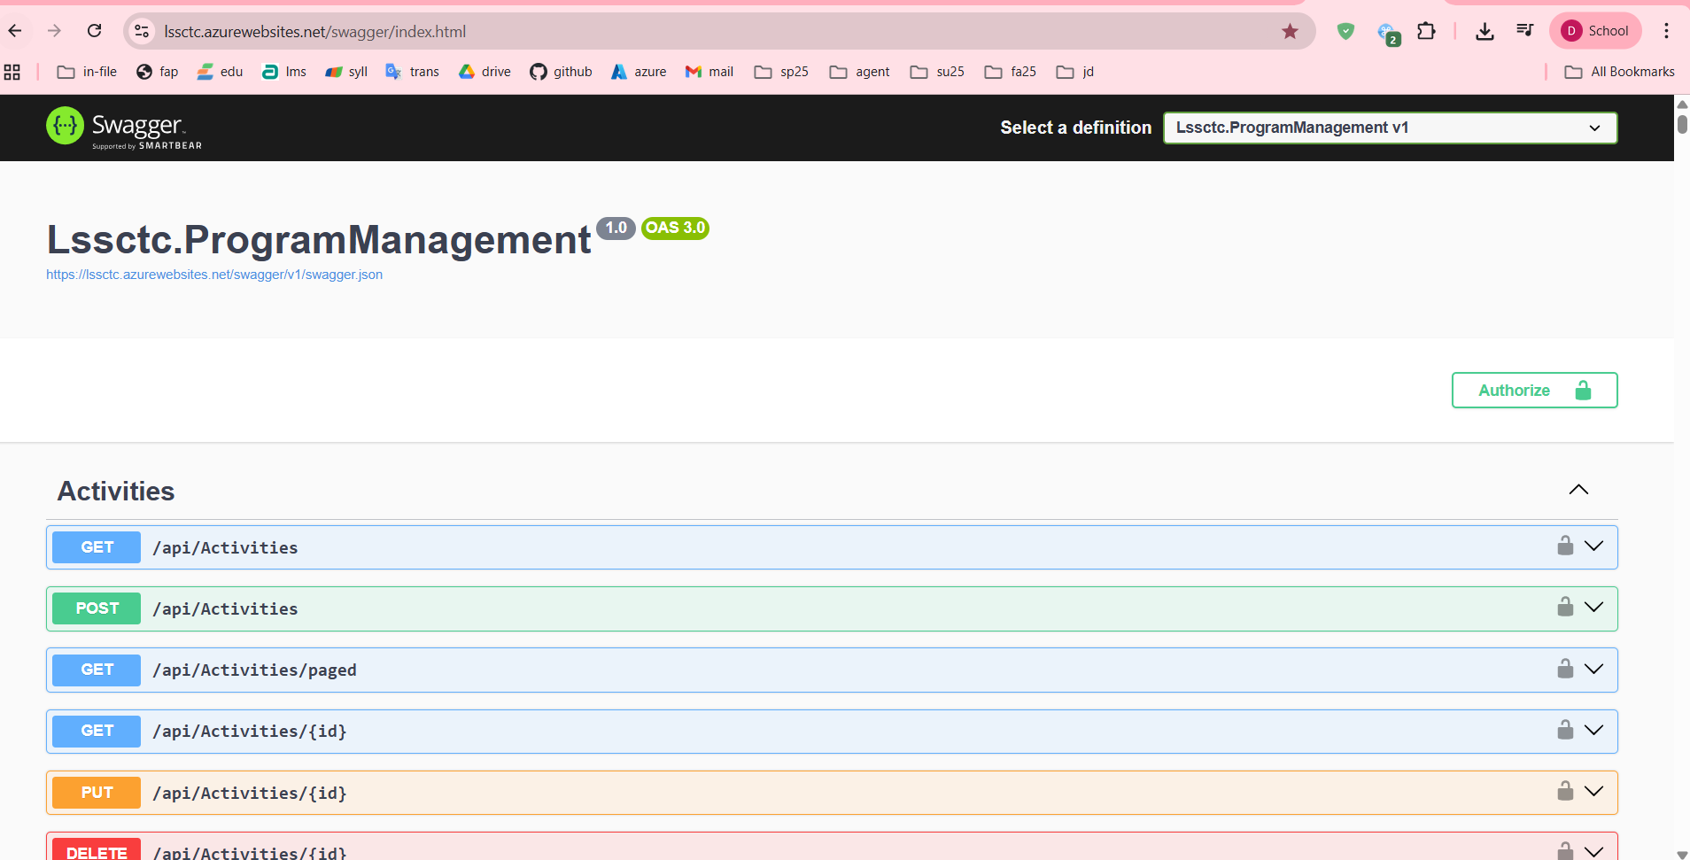

Or a json format:

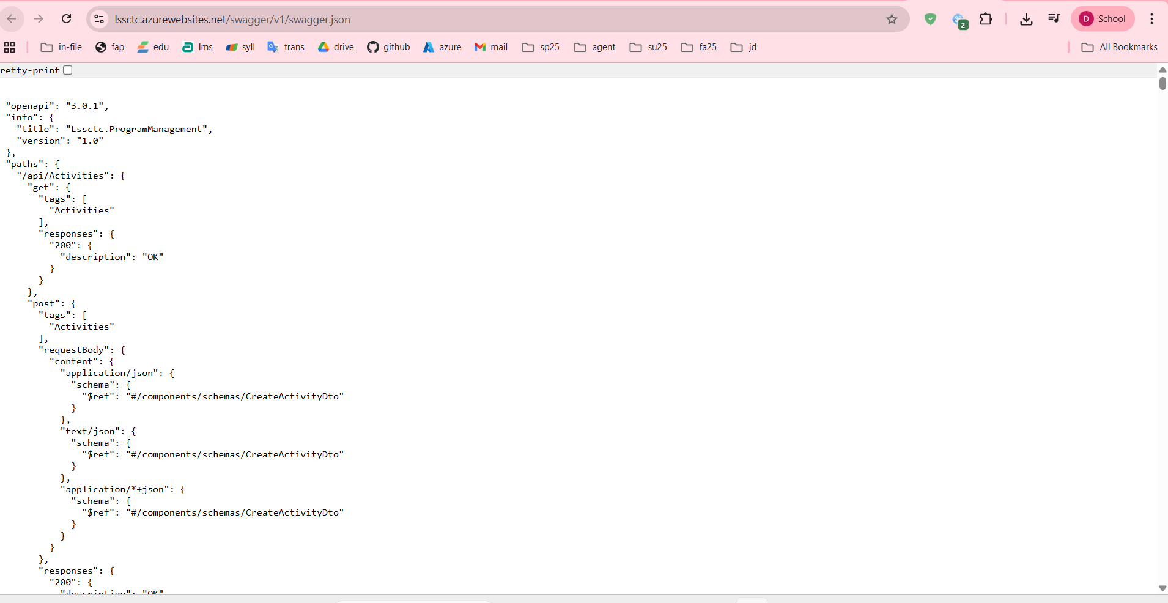

1. Test authentication endpoint:
   * Expand **POST /api/Authens/login-username**
   * Click **Try it out**
   * Enter test credentials (if seeded)
   * Click **Execute**
   * Verify 200 OK response with JWT token

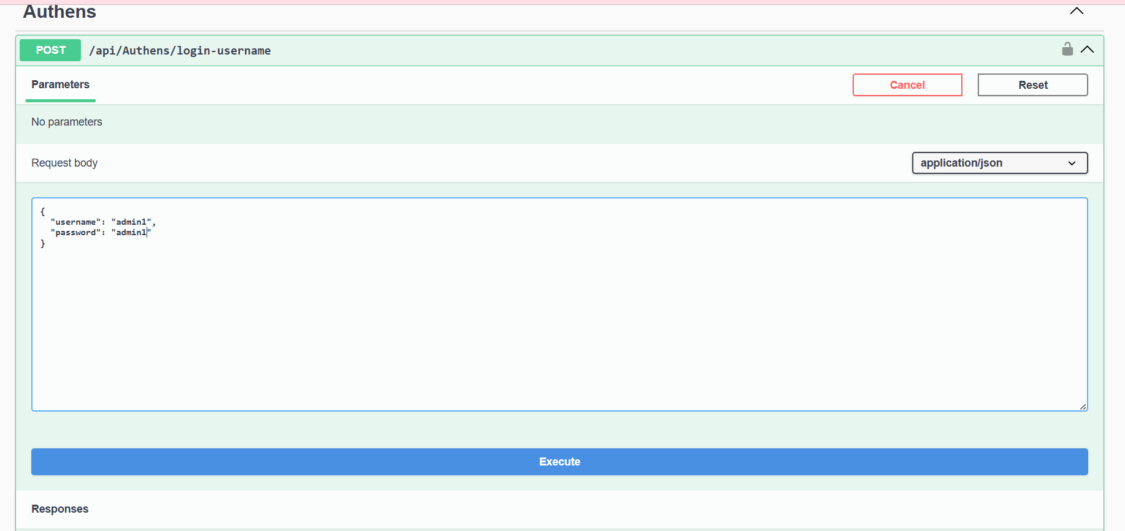

#### 2.3.4 Setup and Run Frontend Web Application

This section outlines how to configure, run, and verify the frontend client interface.

Step 1: Installation

* Navigate to the project directory and install the required dependencies.

Step 2: Environment Configuration

* Set up the connection to the backend and external services.
  + Create the configuration file (.env)
  + Edit the .env file with your own configuration (backend endpoints, service keys)
* Google OAuth Setup To enable "Sign in with Google," create a project in the Google Cloud Console:
  + Type: OAuth 2.0 Web Application
* Origin: http://localhost:5173
* RedirectURI: http://localhost:5173/auth/callback
* Paste the generated Client ID into your .env file.

Step 5: Production Build (Optional)

* To prepare the application for final deployment:
* Build: Run npm run build to generate the dist/ folder.
* Preview: Run npm run preview to test the build at http://localhost:5173.

#### 2.3.5 Deployment to Production

**Backend Deployment Options:**

**Option 1: Deploy to Azure App Service**

1. Install Azure CLI
2. Login to Azure
3. Create App Service:
4. Deploy with dotnet publish option
5. Access Azure Portal and navigate to your app service
6. Configure connection string in Azure Portal
7. Update environment variable settings

**Option 2: Deploy to Docker Container**

1. Create Dockerfile in backend project root with publish option
2. Build and run
3. Access Docker application to view your running projects.

**Frontend Deployment Options:**

**Option 1: Deploy to Vercel**

1. Create an account in vercel.com (or using an existed one)
2. Connect your Vercel account with github repository
3. Create a new Vercel project
4. Setup deployment configuration
5. Configure environment variables in Vercel dashboard
6. Confirm deployment and view the project in Vercel dashboard
7. Vercel project will automatically update after change in github repository

**Option 2: Deploy to Azure Static Web Apps**

1. Create a Azure account in Azure Portal (or using an existed one)
2. In Azure Portal, create a new resource
3. Select Static Web App
4. Setup your github repository of frontend project (or using a zip file)
5. Azure will automatically build and deploy your web app

**Database Deployment:**

**Deploy to Azure SQL Database**

1. Create Azure SQL Database in Azure Portal
2. Connect to Azure SQL Database using SSMS
3. Execute script to create tables and seed data
4. Update backend environment variables to match your database

## 3. User Manual

### 3.1 Terms and definitions

|  |  |
| --- | --- |
| **Term** | **Definition** |
| LSSCTC | Learner Management and 3D Simulation System for Crane Training Center |
| Admin | System administrator with full access to all features and user management |
| Instructor | Teacher/trainer who creates course content, quizzes, and evaluates trainees |
| Trainee | Student enrolled in crane operation training courses |
| Program Manager | Role responsible for curriculum design and course orchestration |
| Simulation Manager | Role responsible for managing 3D simulation components and scenarios |
| Training Program | Complete curriculum consisting of multiple courses leading to certification |
| Course | Individual training module covering specific crane operation topics |
| Section | Subdivision within a course containing organized activities |
| Activity | Learning task within a section (material, quiz, or practice) |
| Learning Material | Educational content (PDF, video, image, URL) provided to trainees |
| Quiz | Assessment containing multiple-choice or single-choice questions |
| Practice | Hands-on simulation task for skill development and evaluation |
| Class | Group of trainees enrolled in a program with scheduled sessions |
| Timeslot | Scheduled session for class instruction with date, time, and instructor |
| Enrollment | Trainee's registration and participation in a specific class |
| Activity Record | Trainee's progress and completion status for an activity |
| Quiz Attempt | Trainee's submission of a quiz with scored results |
| Practice Attempt | Trainee's completion of a practice session with performance metrics |
| Simulation Component | 3D model or asset used in crane operation simulation environment |
| Brand Model | Specific crane manufacturer and model configuration |
| JWT | JSON Web Token - authentication token for API access |
| OTP | One-Time Password - 6-digit code for password reset verification |
| WebGL | Web Graphics Library - browser technology for 3D rendering |

### 3.2 System requirements

For End Users (Trainees, Instructors):

* Operating System:
  + Windows 10/11 (64-bit)
  + macOS 10.15 (Catalina) or later
  + Linux (Ubuntu 20.04+ or equivalent)
* Web Browser:
  + Google Chrome 90+ (Recommended)
  + Mozilla Firefox 88+
  + Safari 14+ (macOS only)
  + Microsoft Edge 90+
* Internet Connection:
  + Minimum: 5 Mbps (for video streaming and general use)
  + Recommended: 10 Mbps (for 3D simulation)
* Display Resolution:
  + Minimum: 1366x768
  + Recommended: 1920x1080 or higher
* Input Devices:
  + Mouse and keyboard (required)
  + Trackpad supported but not recommended for simulation

For Simulation Features:

* RAM:
  + Minimum: 8GB
  + Recommended: 16GB
* Graphics Card:
  + Dedicated GPU with WebGL 2.0 support
  + NVIDIA GTX 1050 or equivalent
  + AMD Radeon RX 560 or equivalent
* Storage:
  + 2GB free space for cached 3D models and textures
* CPU:
  + Minimum: Intel Core i5 or AMD Ryzen 5
  + Recommended: Intel Core i7 or AMD Ryzen 7

For System Administrators:

* All of the above, plus:
* Access to SQL Server Management Studio or Azure Data Studio
* Network access to application server and database server

Remote desktop or SSH access to servers (for on-premise deployment)

### 3.3 Application Usage

#### 3.3.1 Overview

The LSSCTC system is a web-based Learning Management System integrated with 3D crane operation simulation capabilities. It consists of:

1. Frontend (Web Application): React-based single-page application
2. Backend (API): .NET 8 RESTful API with JWT authentication
3. Database: SQL Server relational database
4. 3D Engine: Desktop application (.exe file) or WebGL-based environment

#### 3.3.2 Feature 1: Authentication & User Management

Purpose: Secured user authentication with multiple login methods and role-based access control

Available Functions:

1. Login with Username/Password
2. Login with Google account
3. Password Reset
4. Logout
5. Manage Personal Profile
6. Manage User (Admin role)
   1. Add User
   2. Edit User information

#### 3.3.3 Feature 2: Program & Course Management

Purpose: Create, organize, and manage training program and courses

Available Functions:

1. View all Training Programs

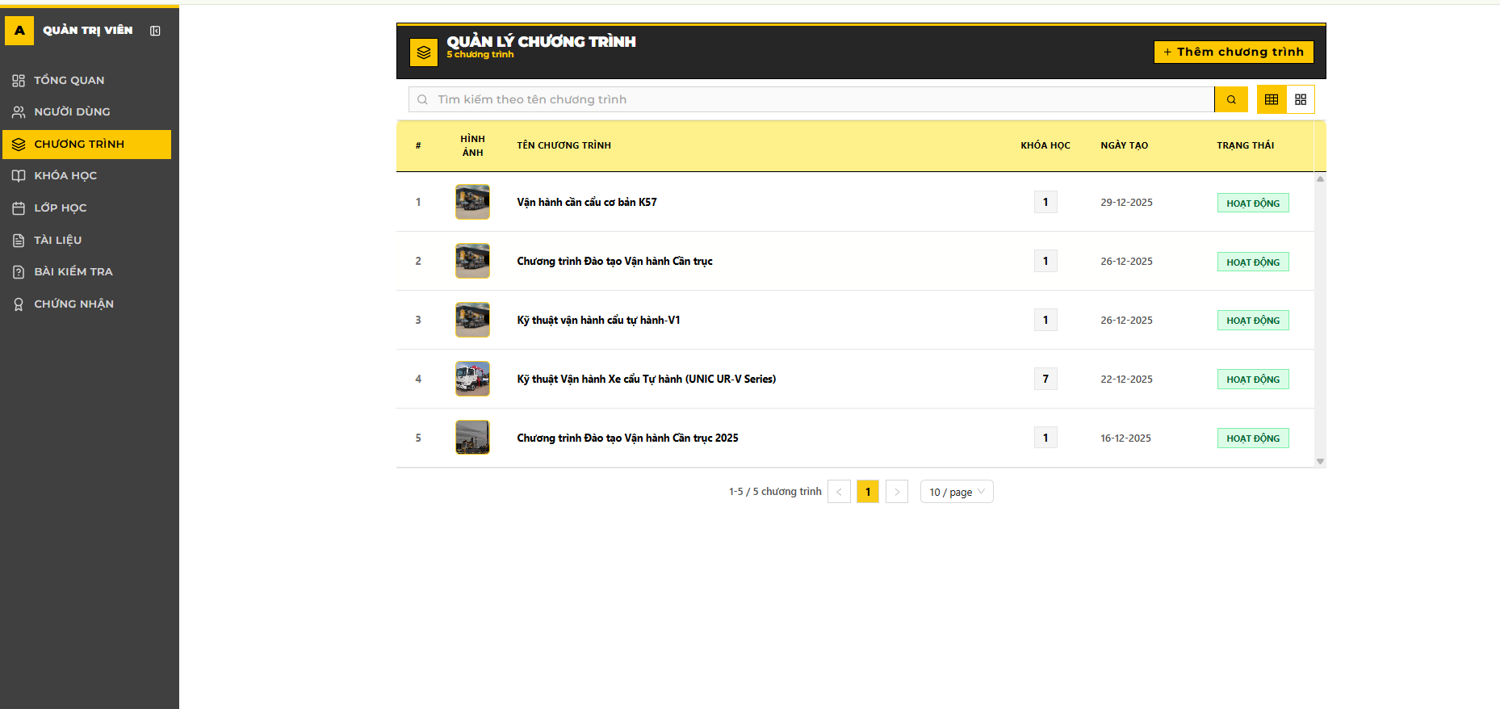

1. Create Training Program

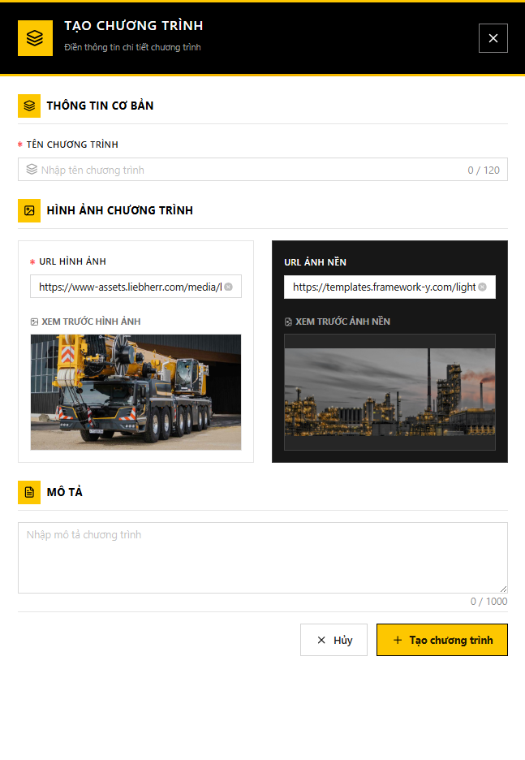

1. Edit Training Program details

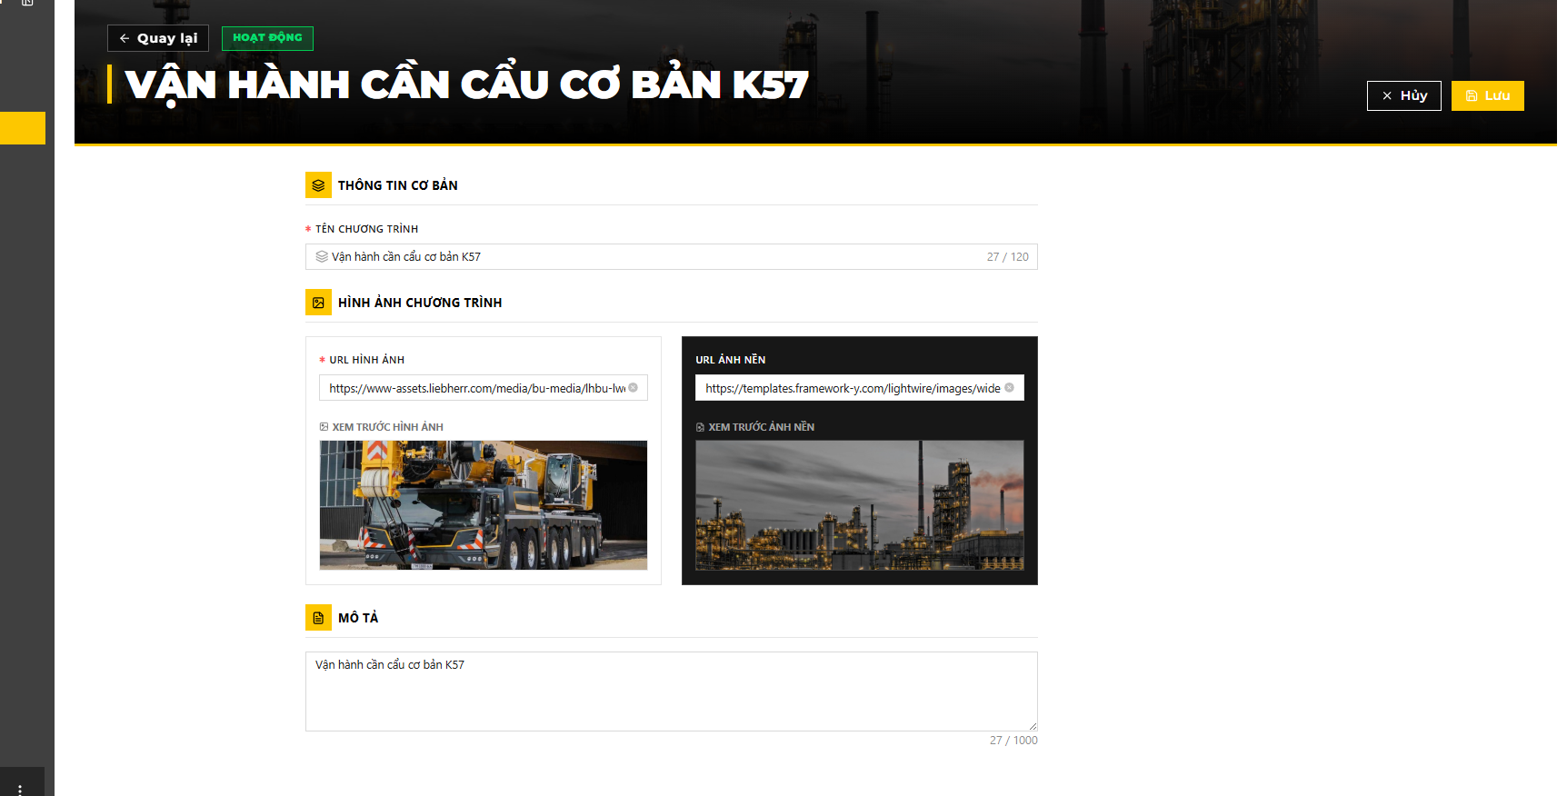

1. Delete Training Program

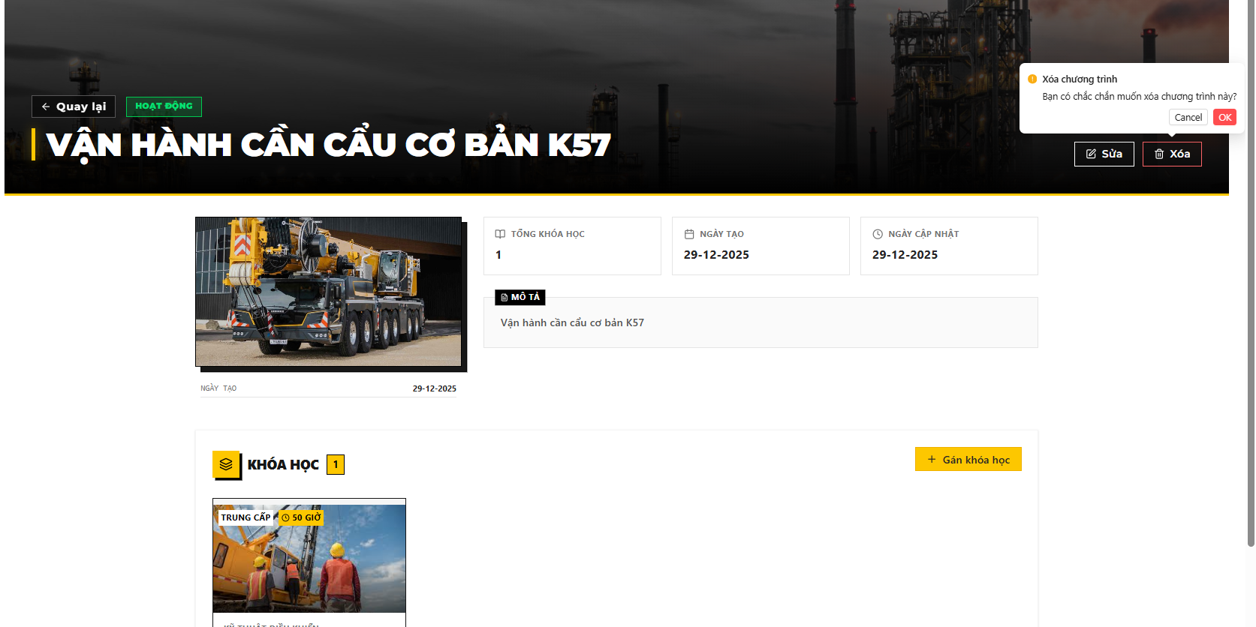

1. View All Courses

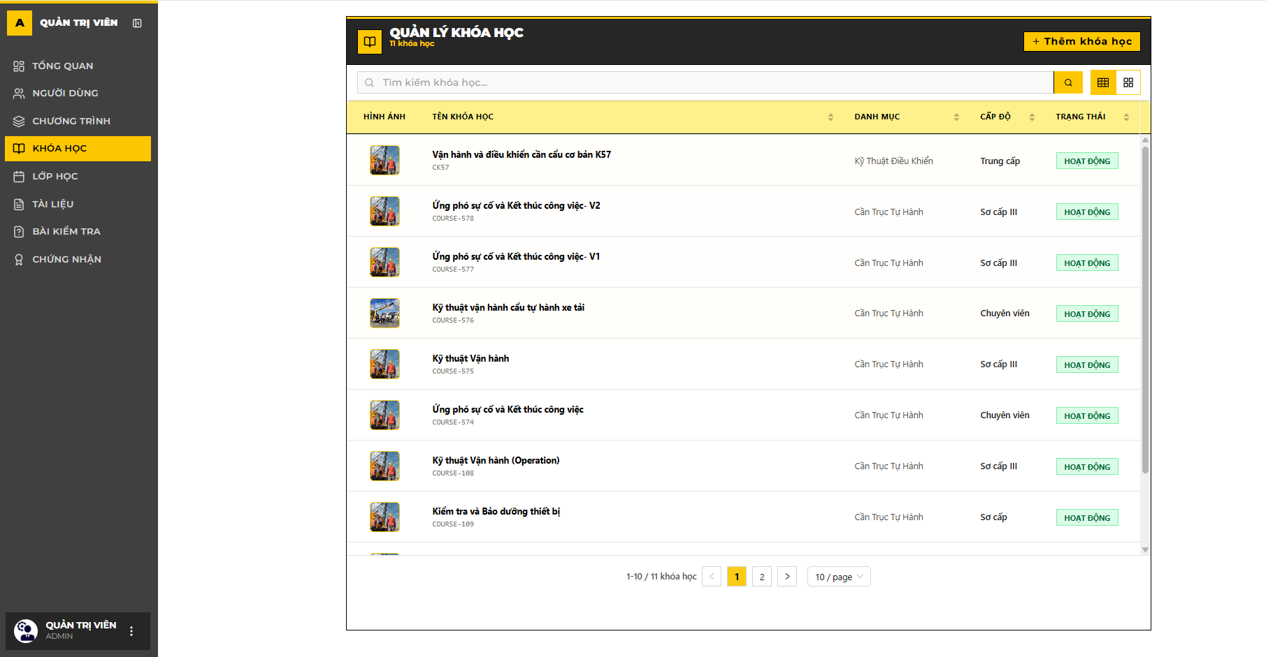

1. Create Course

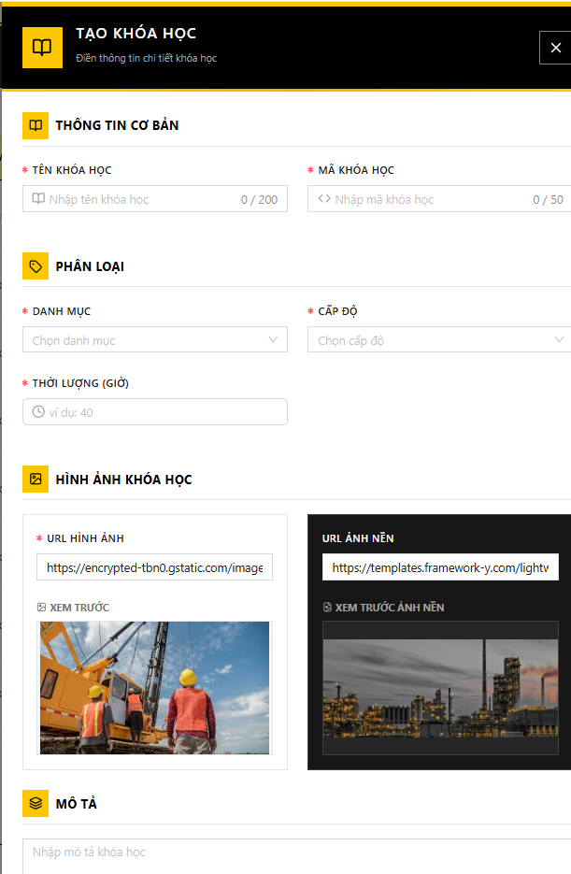

1. Edit Course details

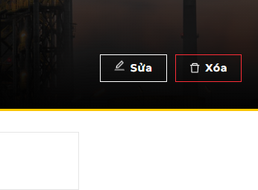

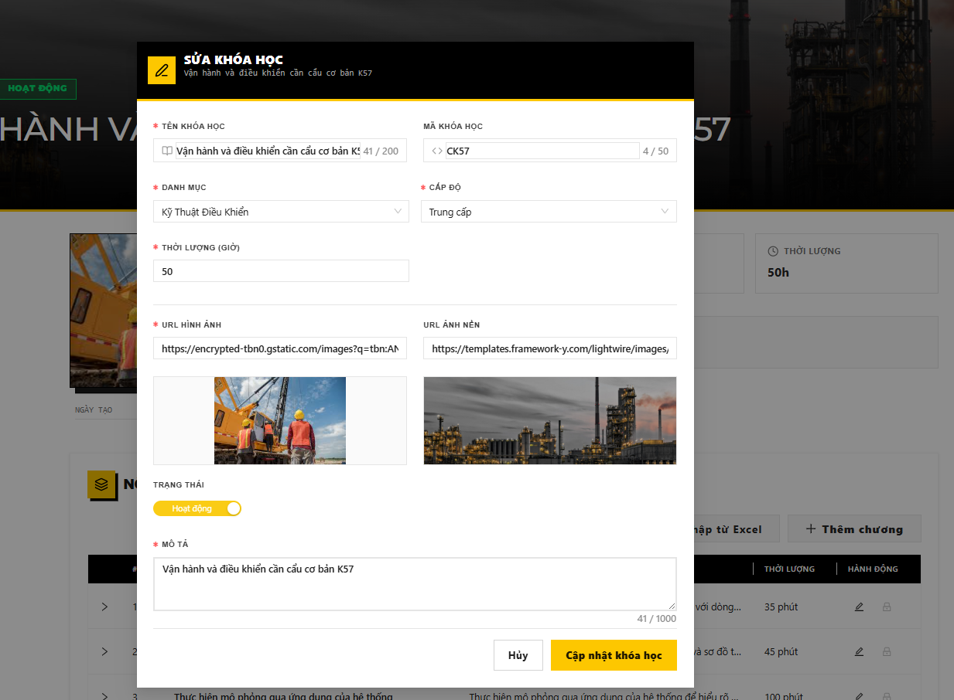

1. Delete Course

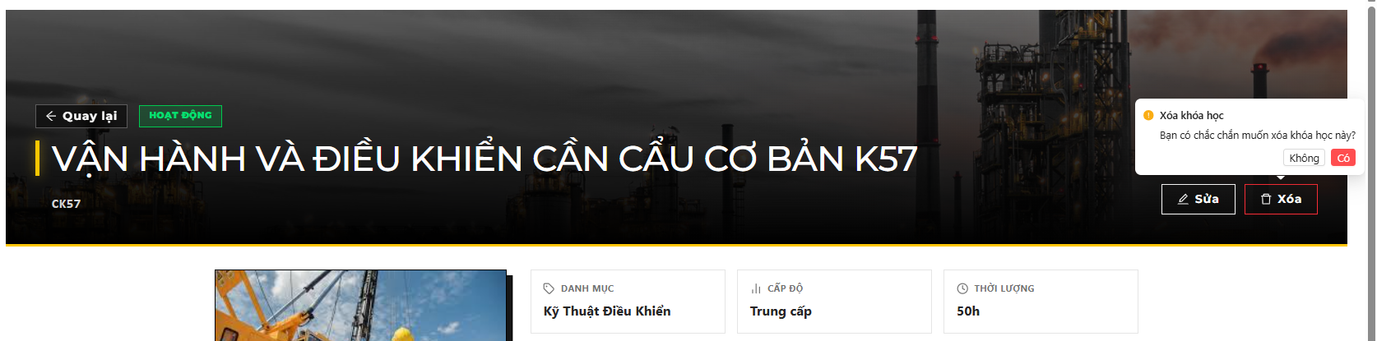

1. Assign Course to Programs

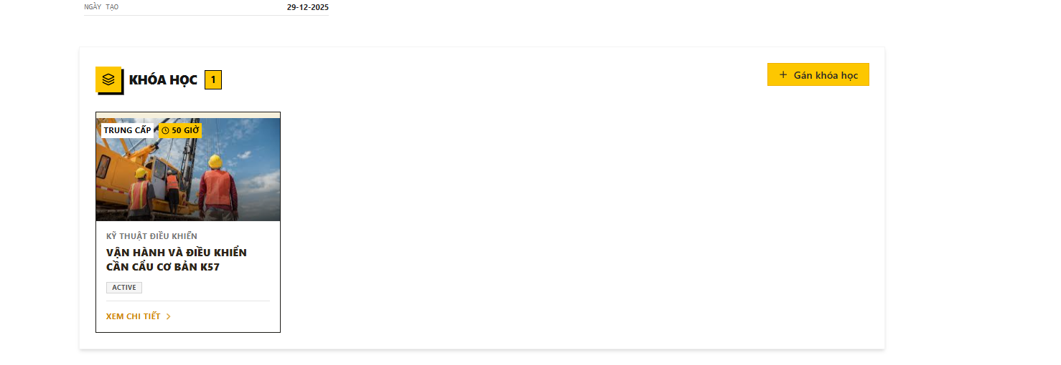

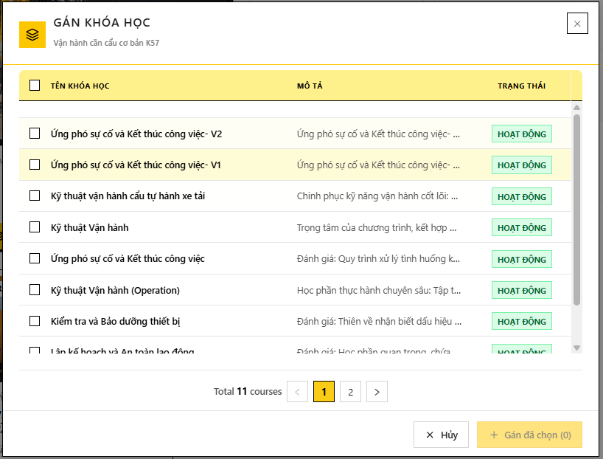

10. Add new section

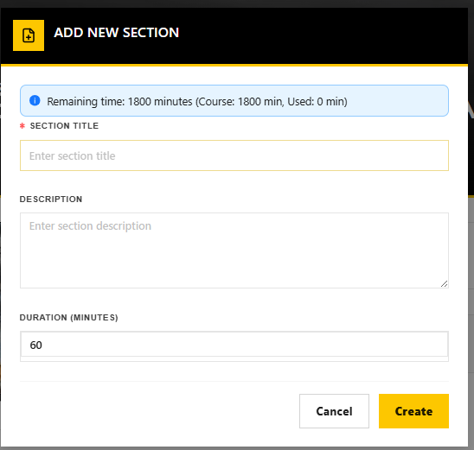

11. Import Sections and Activity from Excel

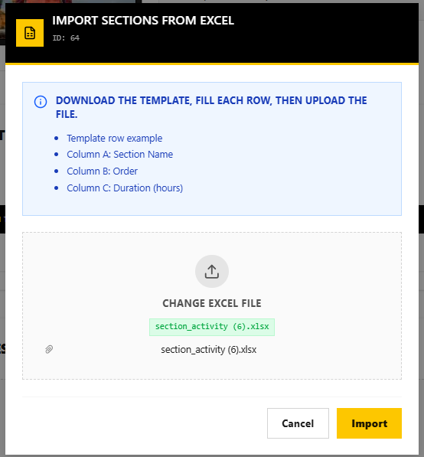

12. Add New Activity

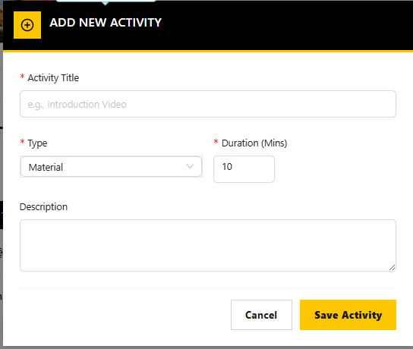

12. Assign the Materialto activity.

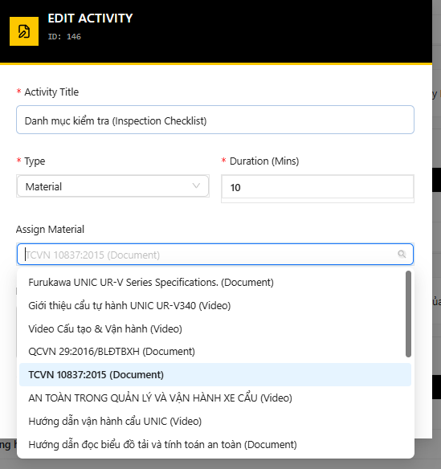

13. Assign the Practice activity.

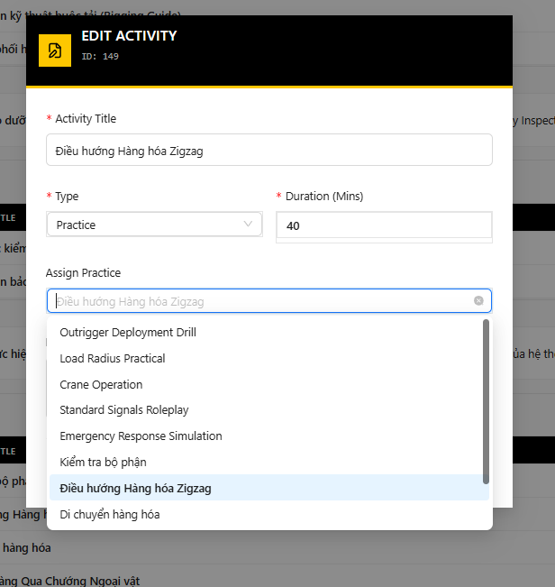

14. Assign the quiz to activity.

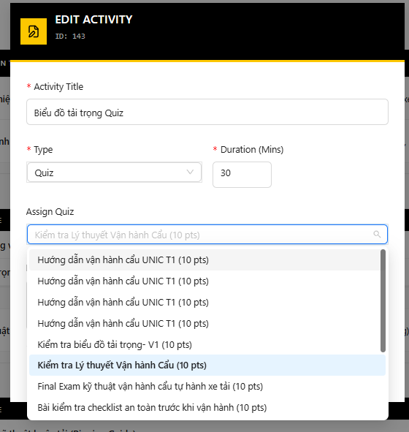

15. Add Quiz to Theory Exam( Final Exam)

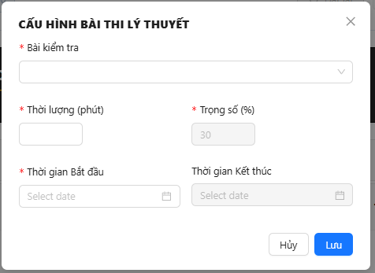

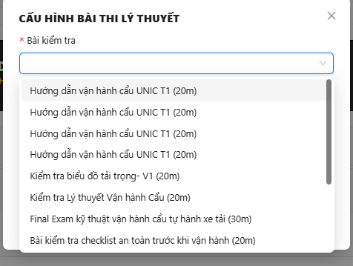

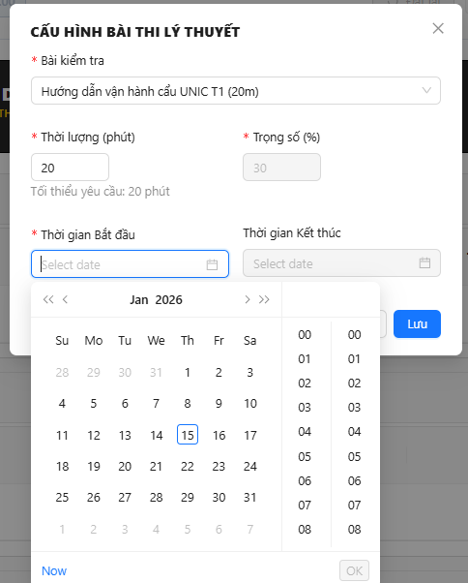

16. Add Practice to Simulation Exam( Final Exam)

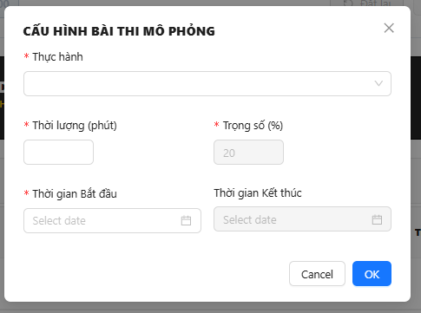

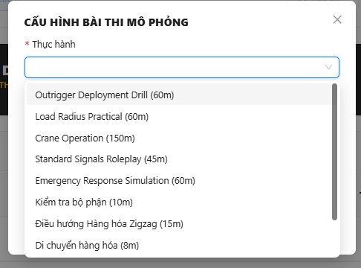

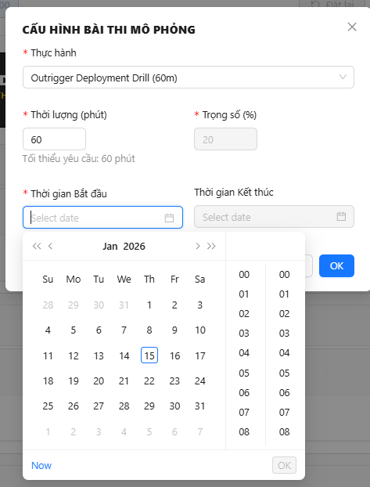

17. Add Practical to Practical Exam( Final Exam)

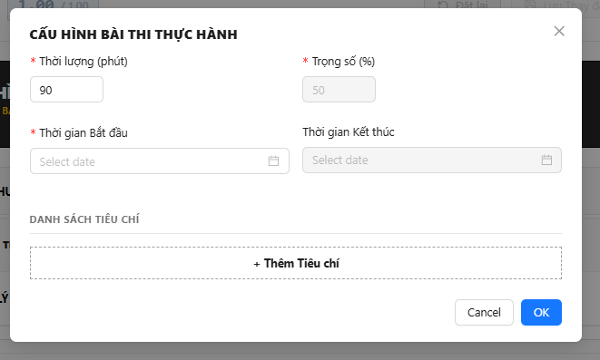

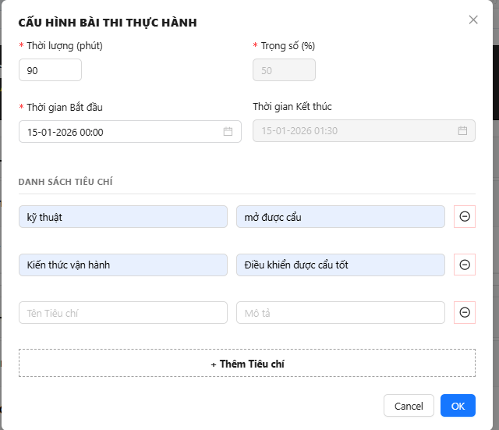

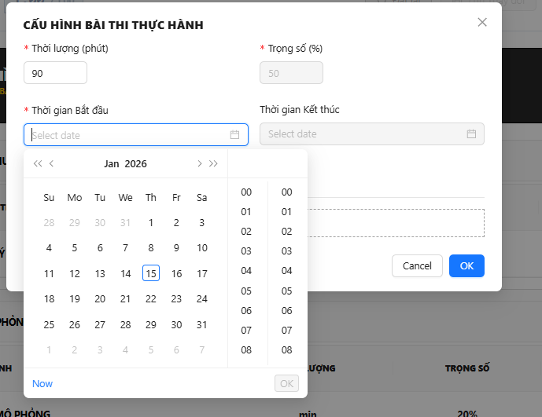

#### 3.3.4 Feature 3: Class Management

Purpose: Create and edit learning classes (organize trainees into classes, assign instructors, and manage schedules)

Available Functions:

1. View All Classes
   1. Navigate to Class management / Quản lý lớp học (Admin portal)
   2. A table of all classes shall be displayed in the page

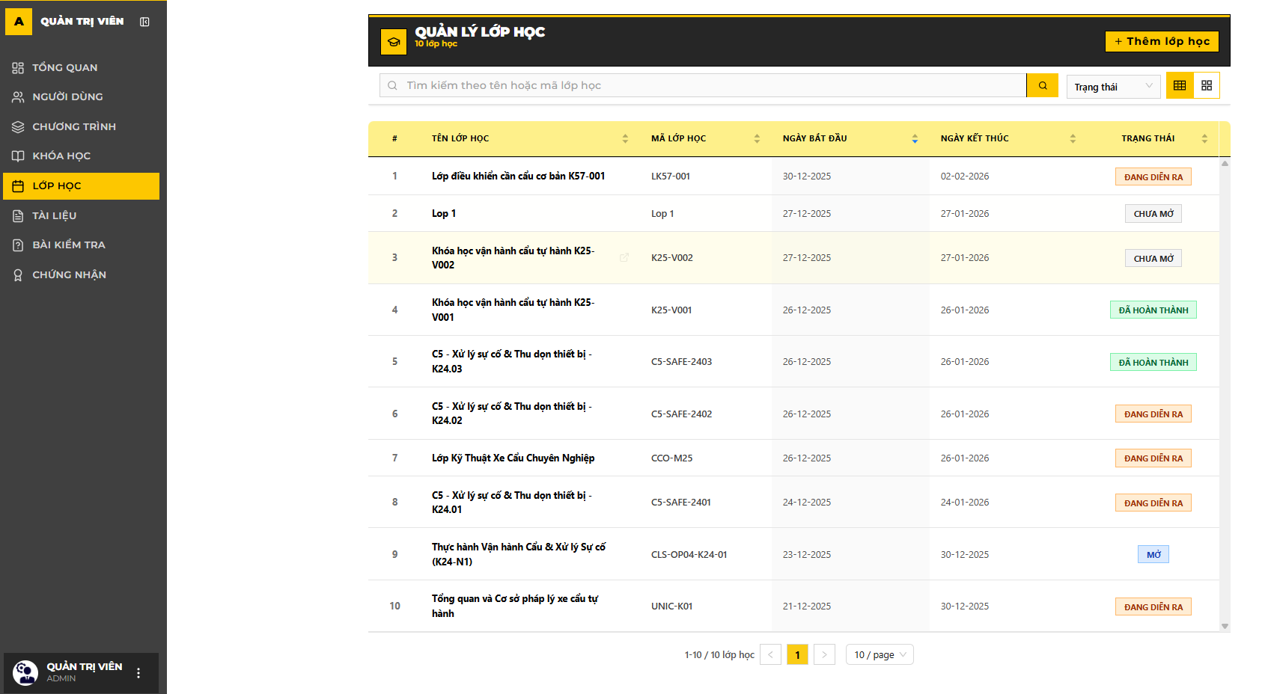

* 1. There is a search bar at the top of the page (search by name and by code)
  2. There is a filter by class status next to search bar.



1. Create New Class
   1. Click Create / Thêm lớp học

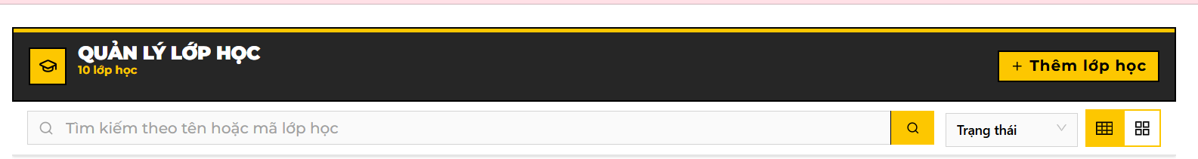

* 1. Fill the class information in the popup screen

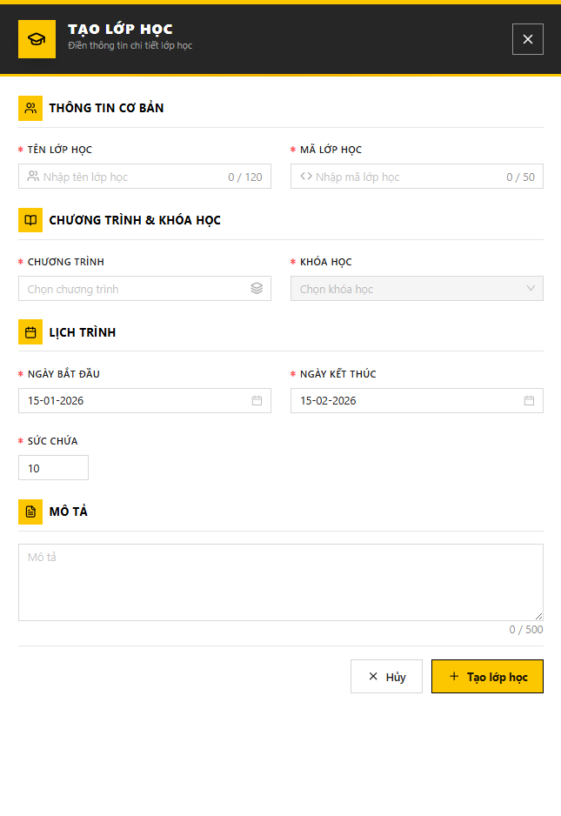

* 1. We shall select program and course from existed list.

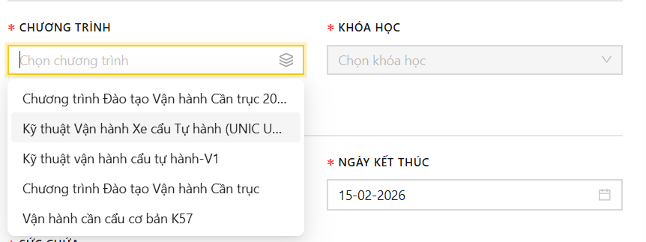

* 1. No duplicated class code or class name
  2. Confirm the process by clicking Create / Tạo
  3. Any violation of the system rules shall cancel the process

1. Edit Class Details
   1. Click onto a target class in the table to view its details.

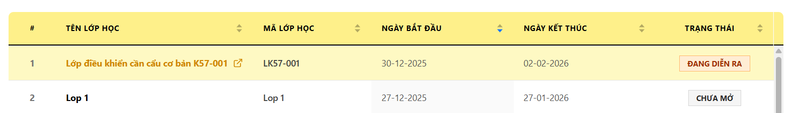

* 1. In the class detail page, click Edit / Sửa



* 1. Change the editable information (with blocked information printed gray)

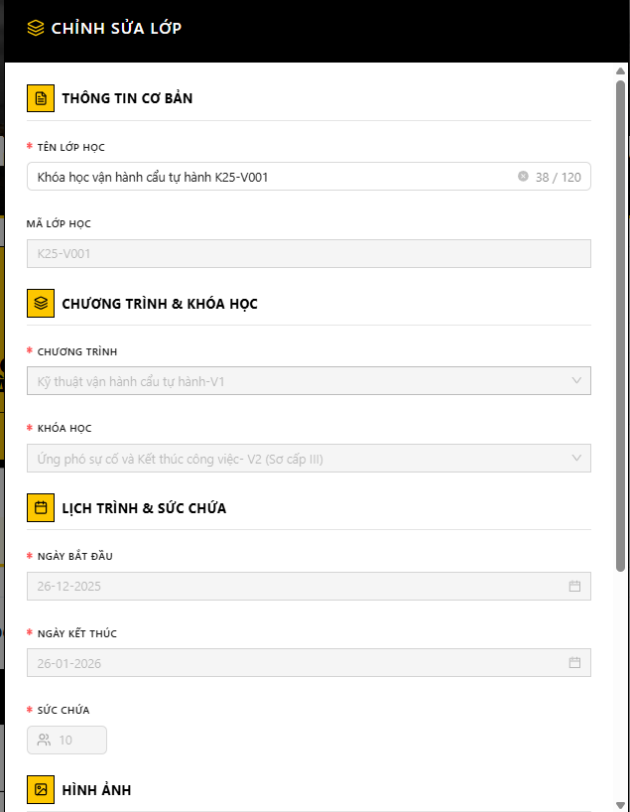

* 1. Confirm the change by clicking Save / Cập nhật

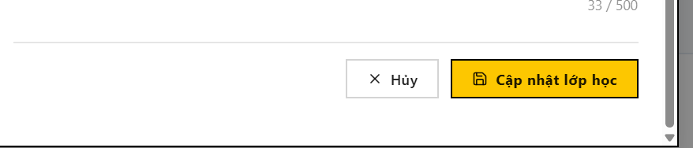

1. Manage Class Enrollments

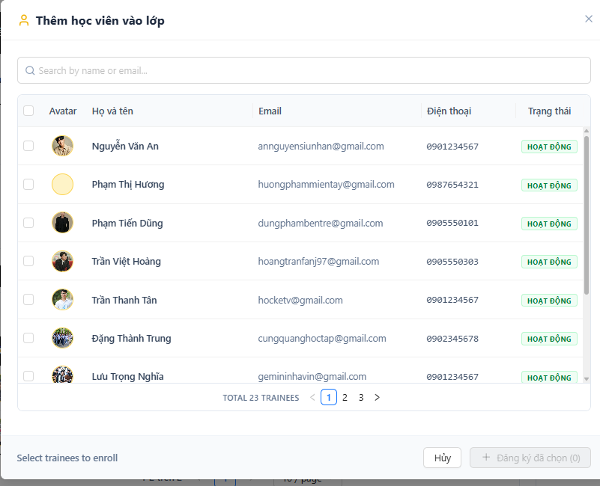

1. Manage Class Instructor

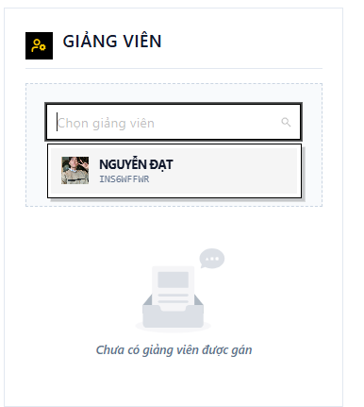

1. Manage Class Timeslots (Schedule)

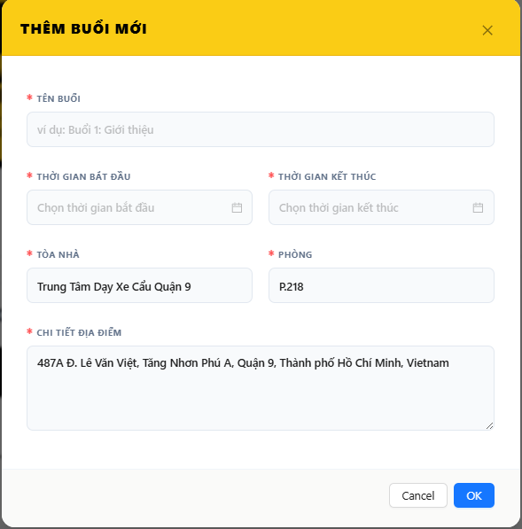

1. Manage Class Final Exam

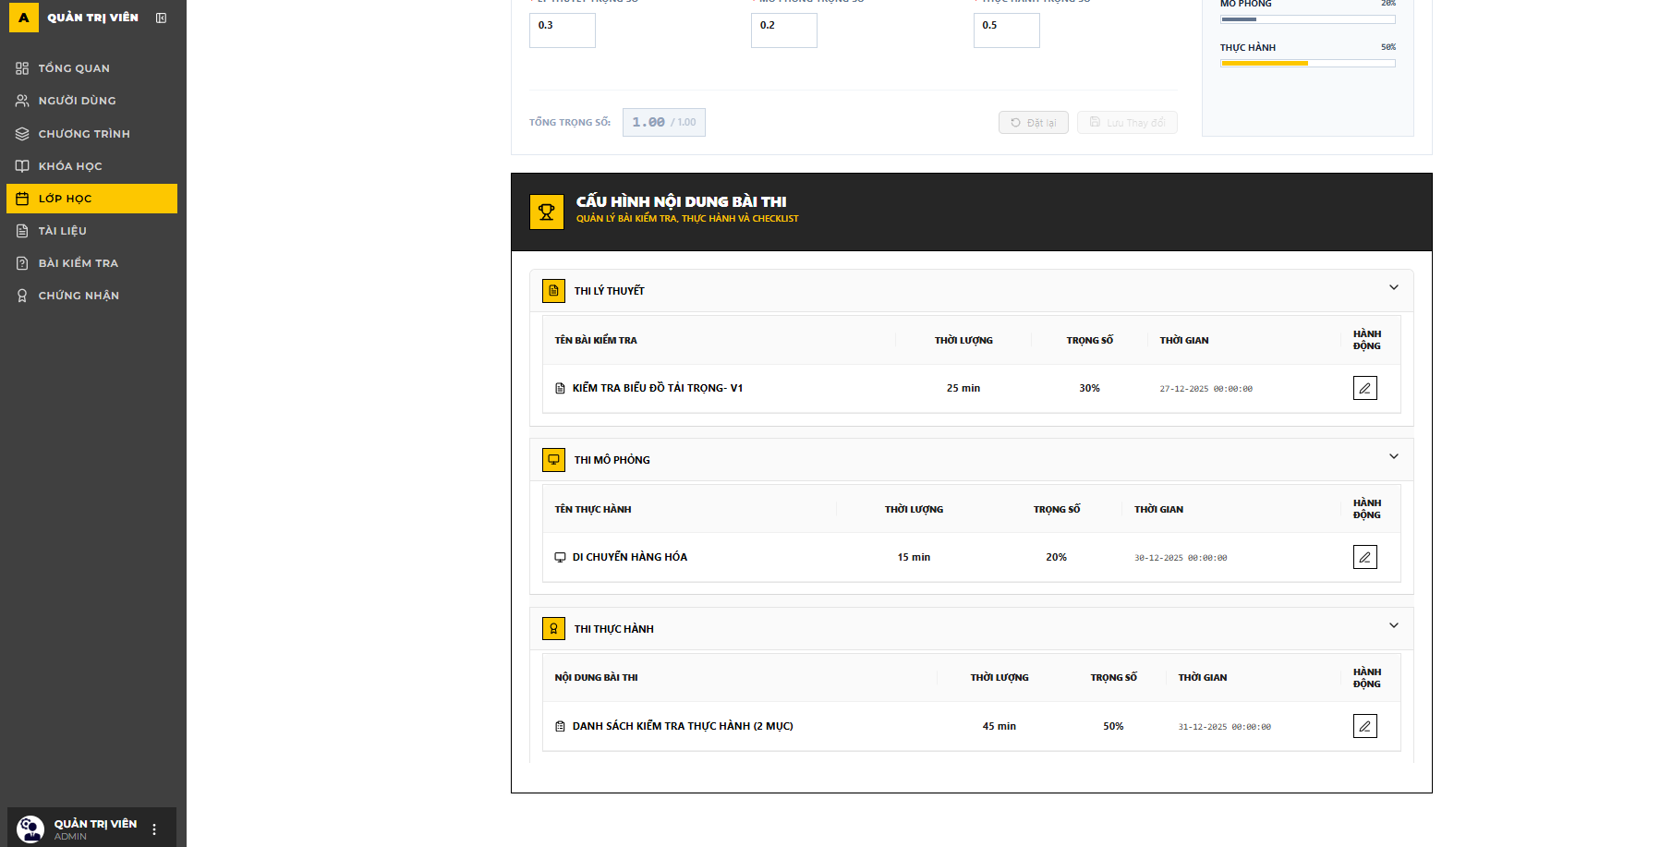

1. View issued certificates (for class completion)

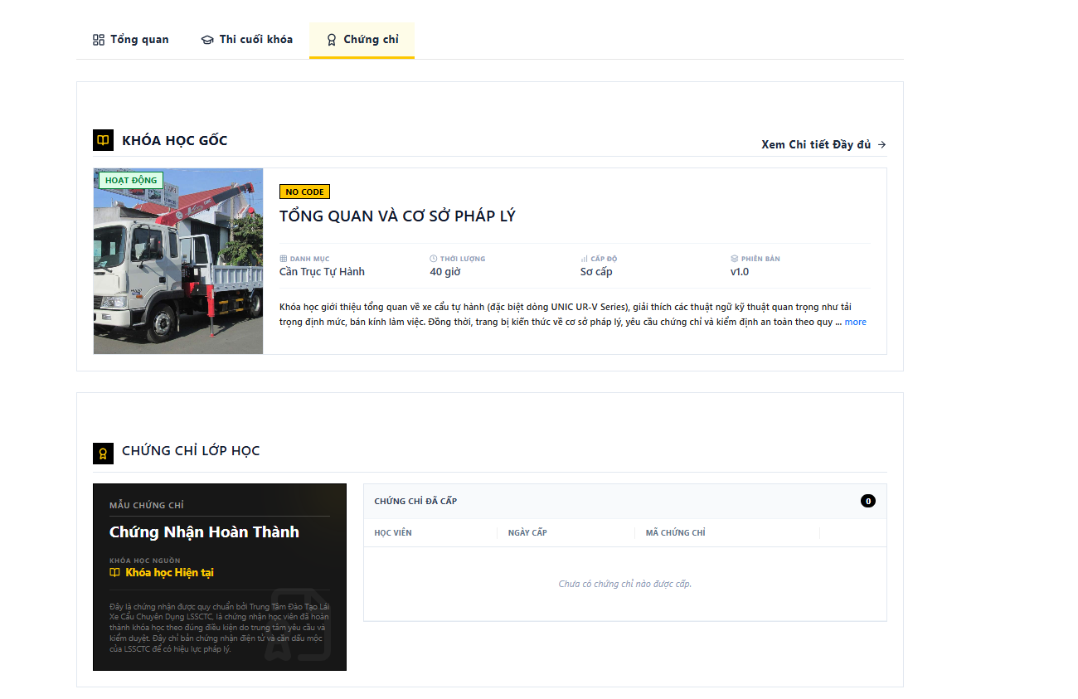

#### 3.3.5 Feature 4: Learning Content Management

Purpose: Create assessments to evaluate trainee knowledge and understanding

Available Functions:

1. Create Quiz (Tạo bài kiểm tra)
2. Import Quiz (Nhập file bài kiểm tra)
   1. Click Import / Nhập Bài kiểm tra button on the task bar

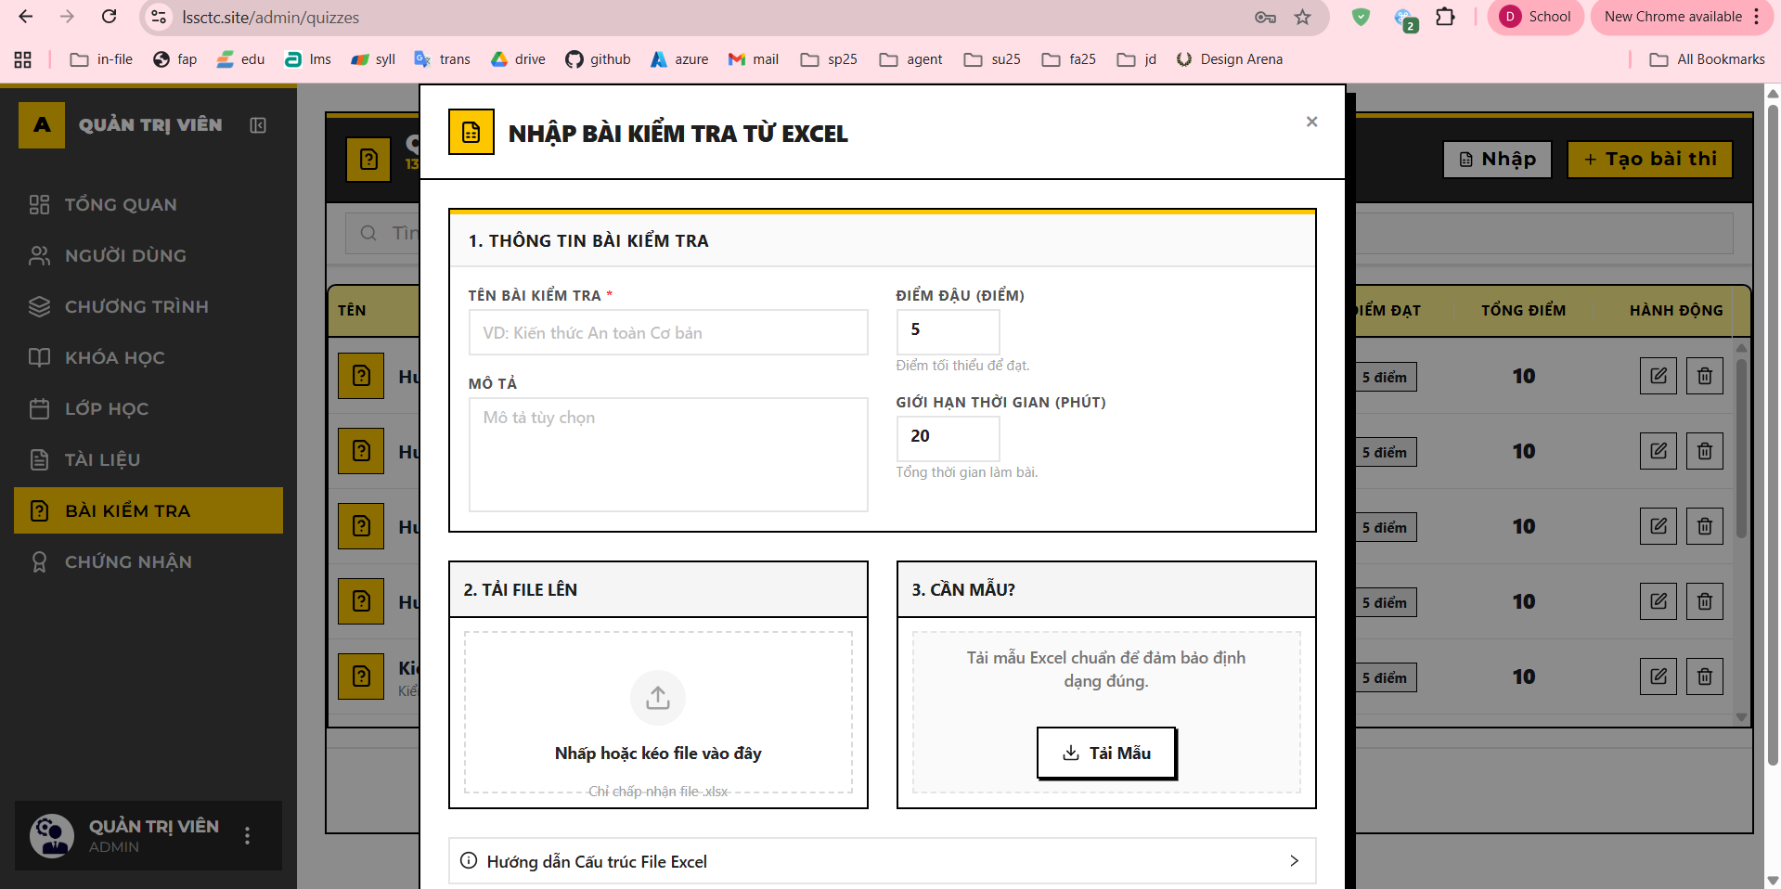

* 1. The import file should follow system provided format (you can download the template to see detail)

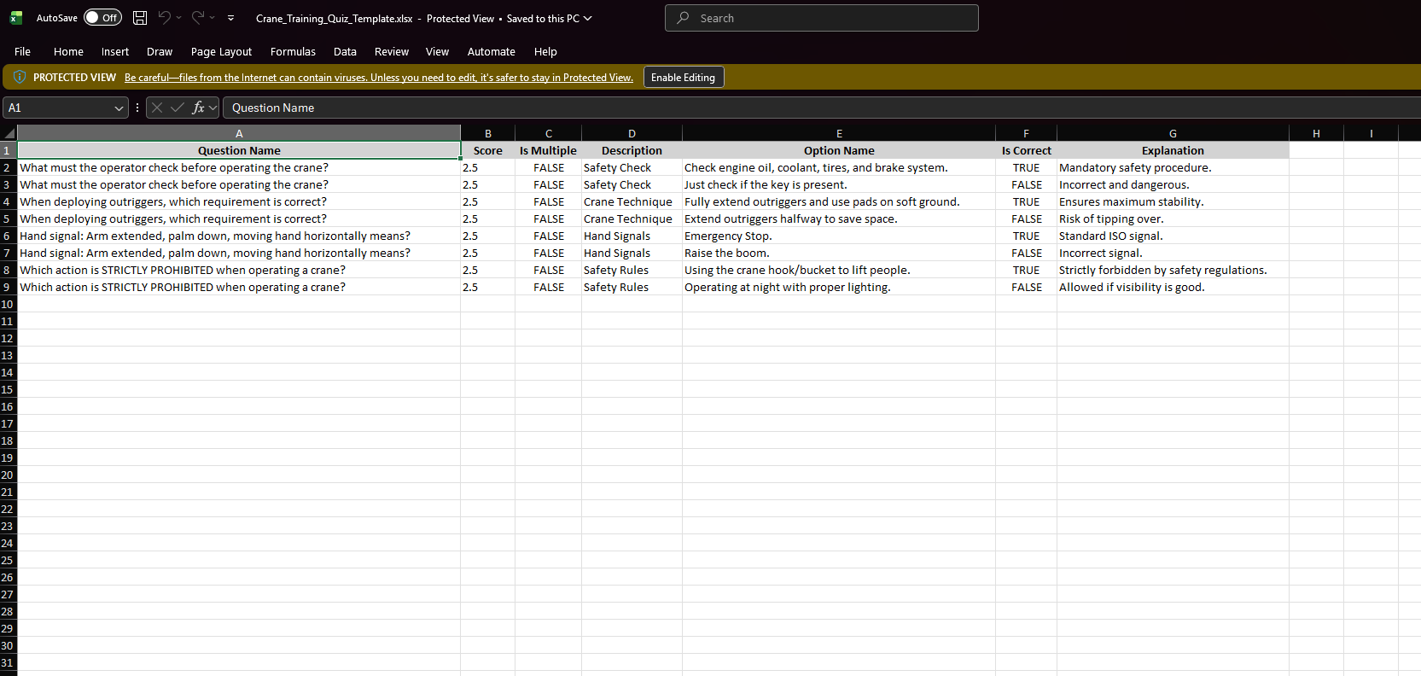

1. Edit Quiz (Sửa Bài kiểm tra)
   1. Click Edit / Sửa on a specific quiz in the table
   2. Change the quiz content which includes questions and answers
   3. Confirm the change by clicking Save / Lưu

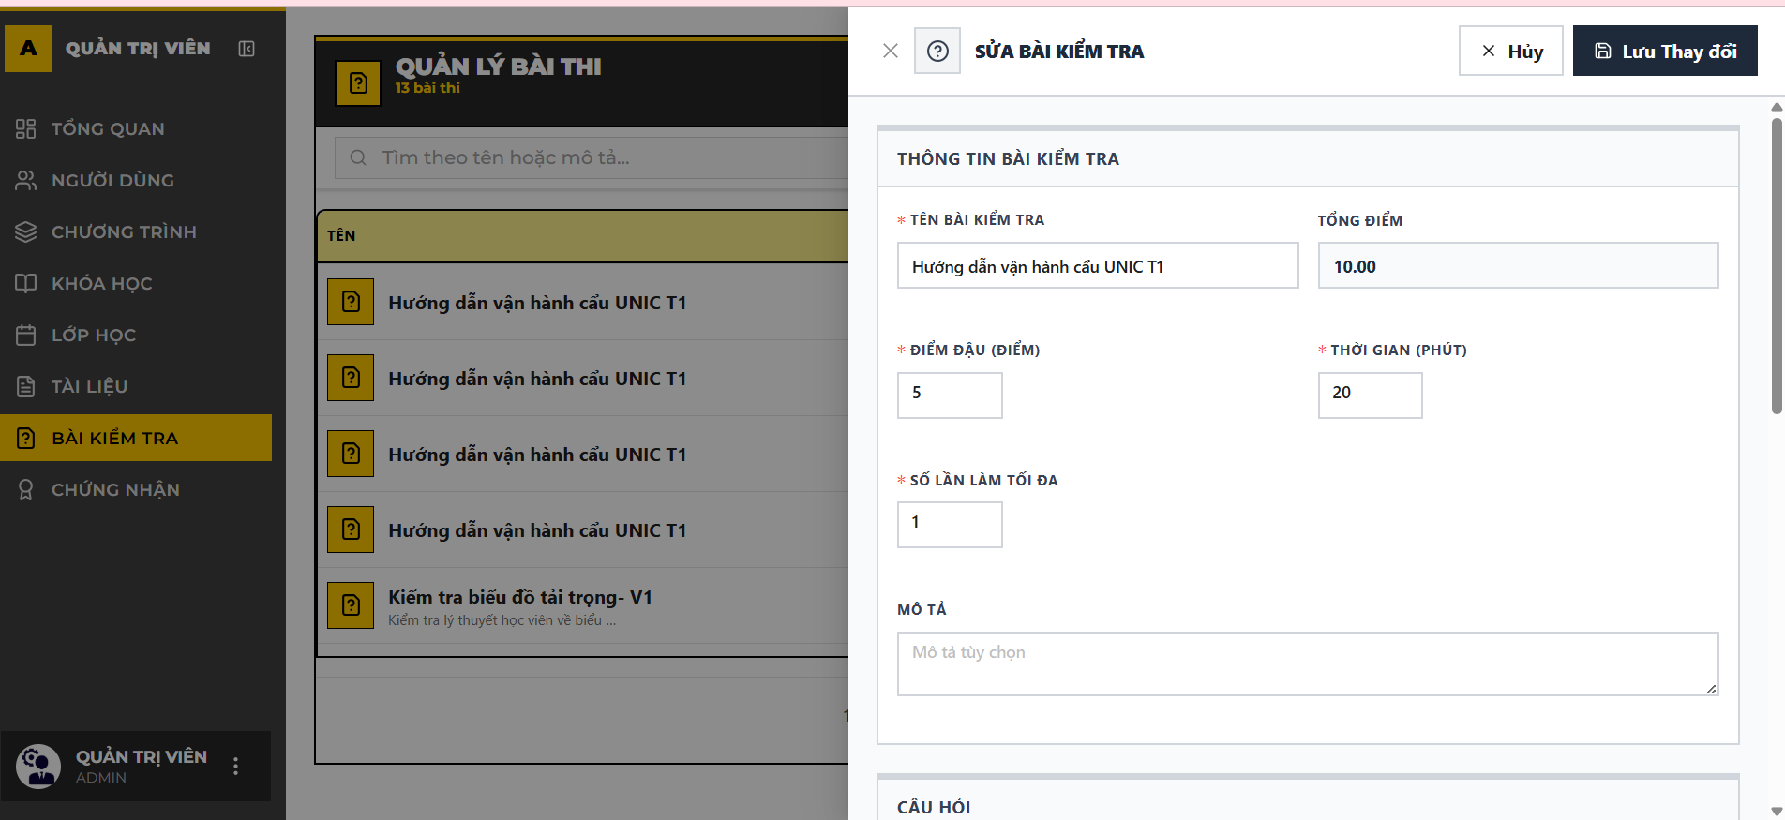

* 1. Any violation of the system rules will make this progress cancelled.

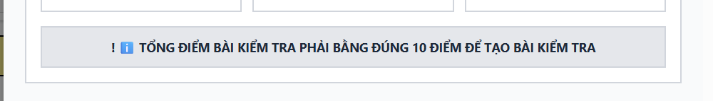

1. Delete Quiz (Xóa Bài kiểm tra)
   1. Click Delete / Xóa button on a specific quiz in the table
   2. Confirm deletion
   3. Any violation of the system rules shall block this progress

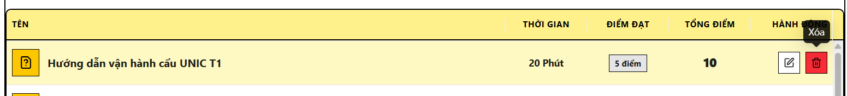

1. Create Learning Material (Tạo Tài liệu học tập)
   1. Navigate to Material Management / Quản lý tài liệu (Admin role)

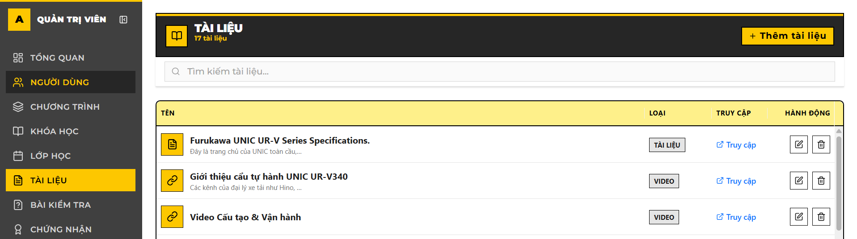

* 1. Click Create / Thêm Tài liệu on the task bar in the top of the page

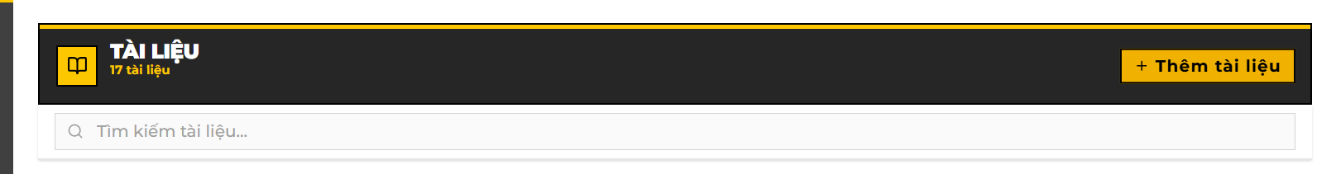

* 1. Fill details for the new learning material.

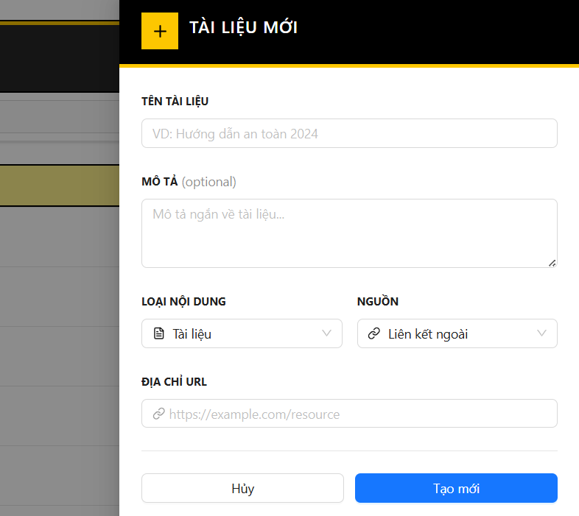

* 1. For material source, there are two options, which are Link / File

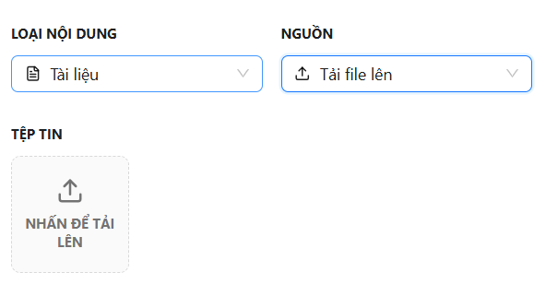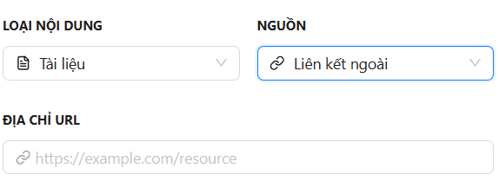

* 1. Confirm the creating by clicking Save / Tạo mới
  2. Any violation of the system rules shall cancel this process.

1. Edit Learning Material (Sửa Tài liệu học tập)
   1. Click Edit icon on a specific learning material in the table.

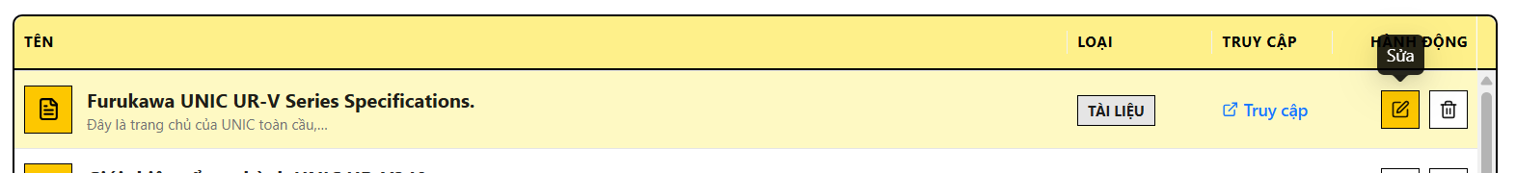

* 1. A editable screen shall display after the previous step. You can now change the material details such as name, description, type and source.

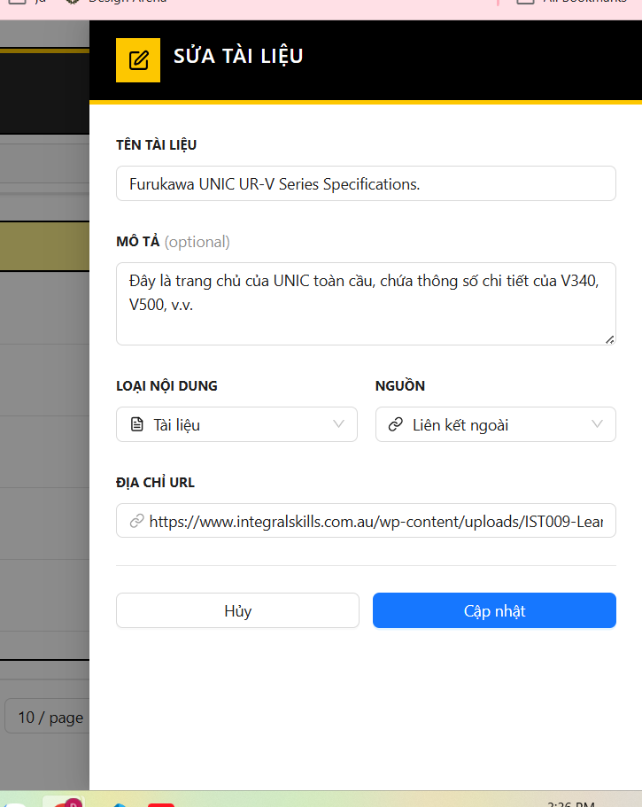

* 1. There are two available types: Video and PDF (Đoạn ghi hình và tài liệu đọc)

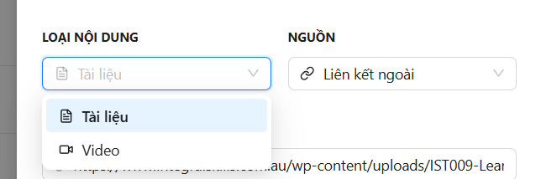

* 1. There are two available sources: Link and File (Đường dẫn và tài liệu gốc)
  2. Confirm the process by clicking Save / Cập nhật
  3. Any violation of the system rules shall cancel the process.

1. Delete Learning Material (Xóa Tài liệu học tập)
   1. Click Delete icon on a specific learning material in the table.

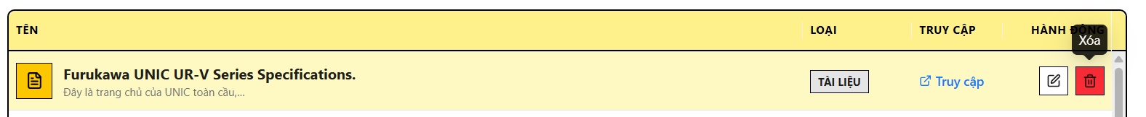

* 1. Confirm the deletion by clicking Delete / Xóa or cancel the deletion by clicking Cancel / Hủy

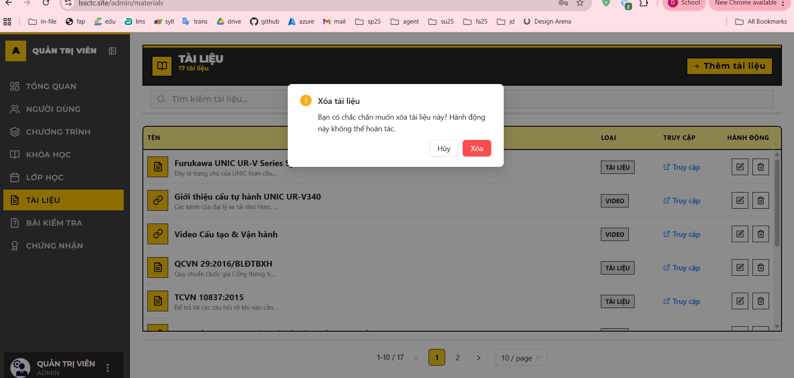

* 1. Any violation of the system rules shall cancel the process

#### 3.3.6 Feature 5: Simulation Practice

1. Download file exe

* Navigate to Simulation page by selecting Simulation / Mô phỏng in the web task bar.

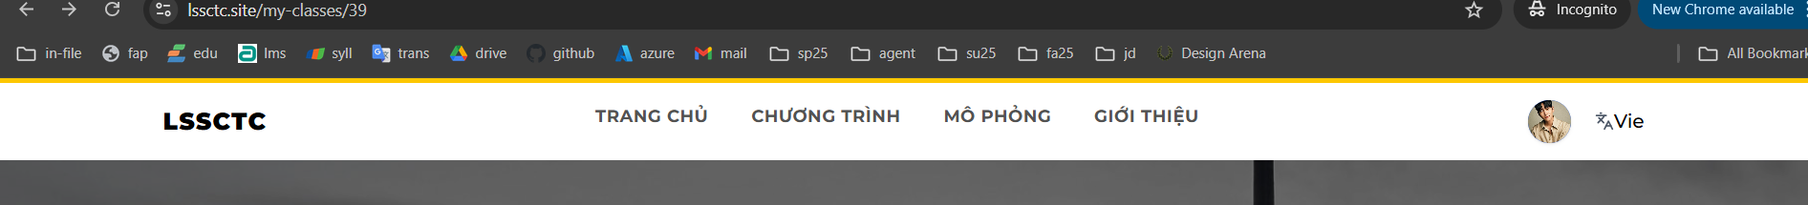

* The simulation engine provided by the center shall be listed in the simulation page

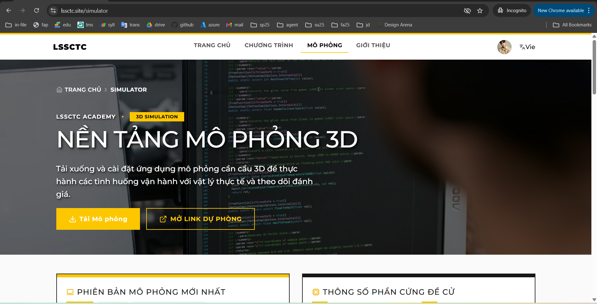

* Read all the details about hardware requirements and implementation guide.

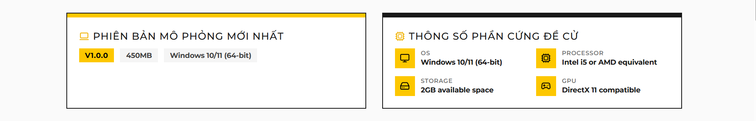

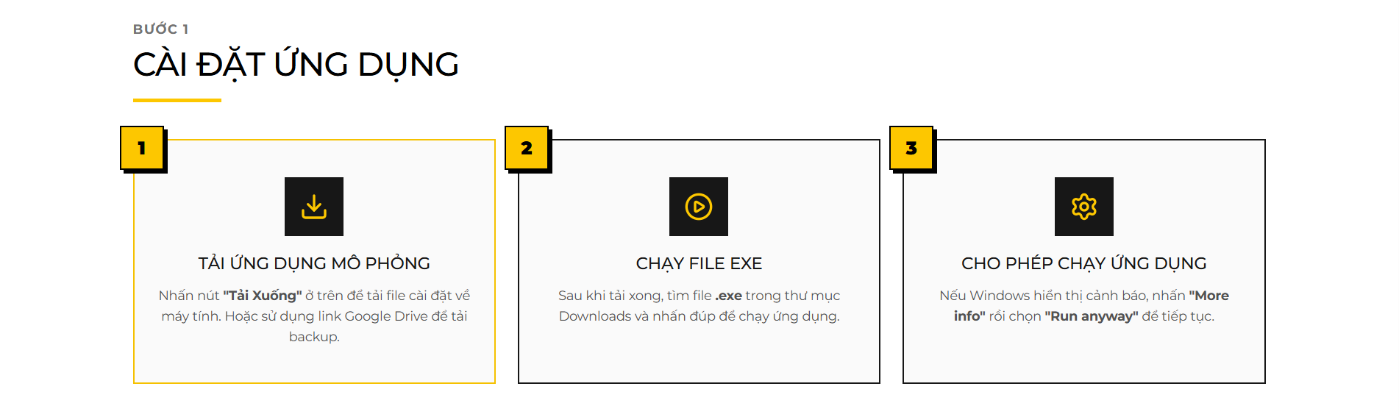

* Downloading the File: Click the "Tải Mô phỏng" (Download Simulator) button to download the .exe installer.
* Connection Stability: Ensure you have a stable internet connection (at least 100 Mbps recommended) throughout the download process to avoid file corruption.

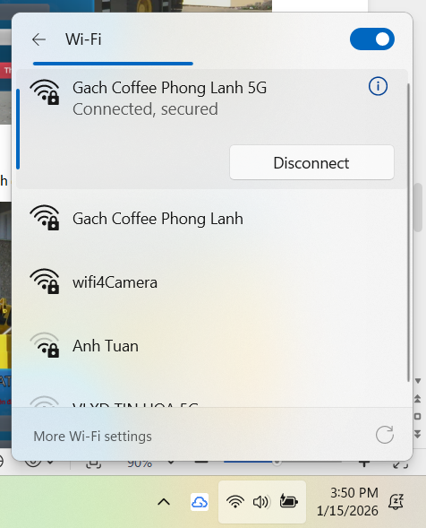

* Download Failure: If the download fails or the file does not open, delete the partial file and restart the download from the beginning.
* There is a contact information for troubleshooting or feedback about the engine at the bottom of the page.



2. Open CraneSimulator.exe file

* Security Warnings: When launching the application, your operating system (Windows) may display a security alert such as "Windows protected your PC" or "Unknown Publisher." \* Action: Click "More info" and select "Run anyway" to bypass the warning.

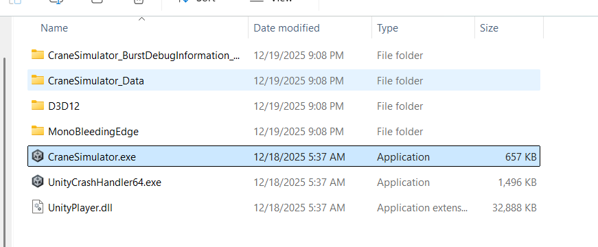

3. Login with username and password of an active trainee account

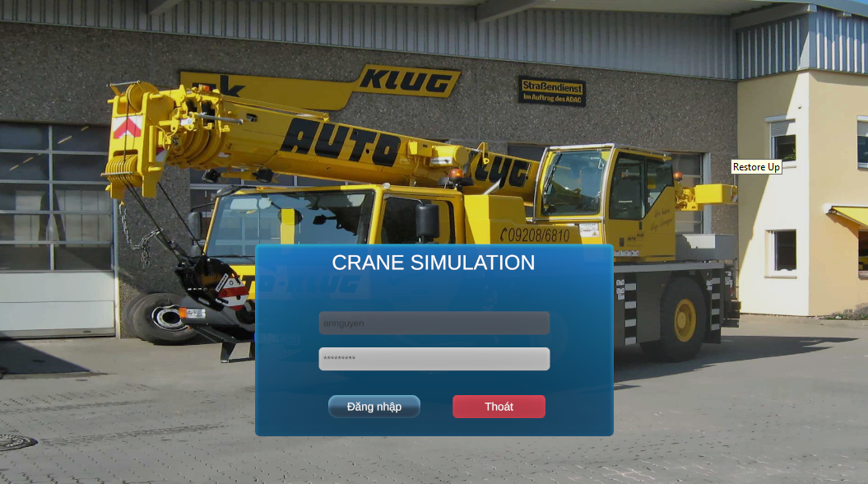

Login problems:

* If the login fails, please try to login again in website to make sure the credentials are correct
* In case you do not remmember your login information, use your assigned email to renew the credentials in student portal website.
* Contact center hotline number or email to gain better help.

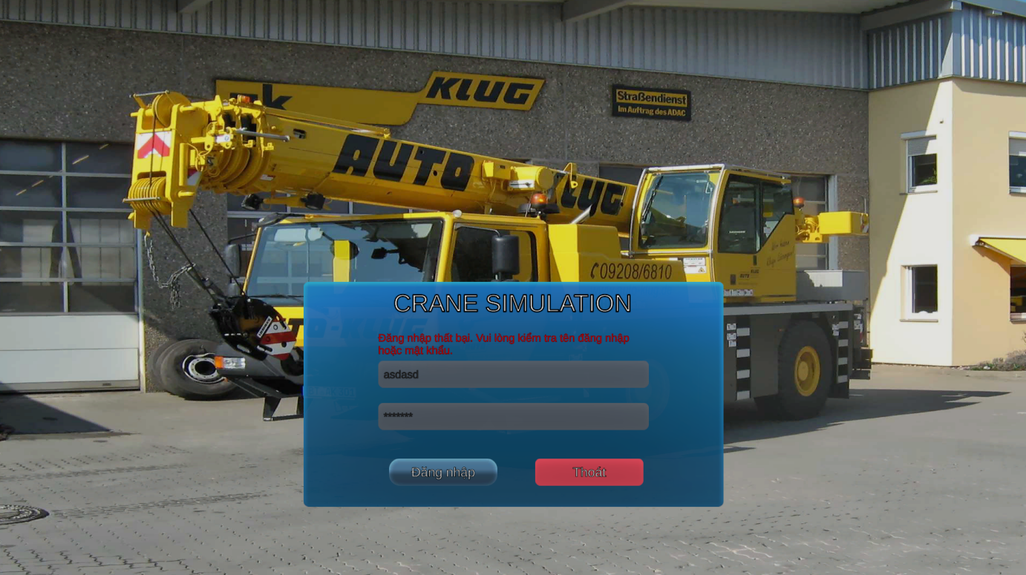

4. Select practice mode.

* Once logged into the LSSCTC Simulator, you will be presented with two distinct modes. The availability of these modes depends on your current enrollment status and the permissions granted by your Instructor.

4.1. "Bài Tập" (Practice) Mode

* **Purpose:** To allow trainees to familiarize themselves with the crane controls without the pressure of a final score.
* Accessibility: This mode is usually unlocked automatically once you are assigned to a class.
* Repetition: You can restart this mode as many times as needed to perfect your practice.

4.1. "Kiểm Tra" (Exam) Mode

* Access Requirements:
  + Instructor Activation: This mode will only be visible if an Instructor or Admin has scheduled and activated an exam for your specific class.
  + Access Code (Security): To enter the exam, you must provide a unique Access Code. This code is provided only by your Instructor or the Program Manager at the beginning of the testing session.
* Limit Attempt: Unlike Practice Mode, Exam Mode may limit the number of attempts you can make, and your performance metrics (score and time) are sent directly to the Instructor's dashboard.
* Technical Safety: Ensure you have a stable connection before starting; if the application crashes or you lose internet, you must immediately contact your Instructor to reset your session.

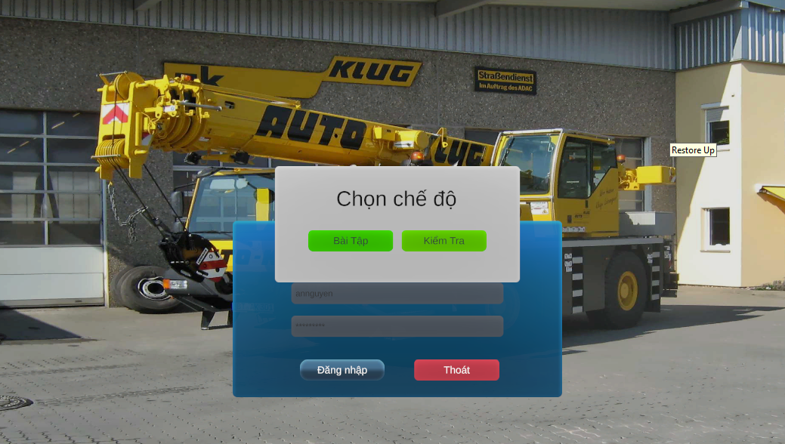

5. Select Class.

After choosing your desired mode (Practice or Exam), you must specify the training group you are participating in to ensure your progress is recorded correctly.

* Class Selection Logic: The system will display a dropdown list of Classes that you are currently enrolled in.
* Enrollment Requirement: A class will only appear in this list if your Enrollment has been officially Approved by the Admin or Instructor.
* Course Coordination: Each class is tied to a specific Training Program or Course; ensure you select the one corresponding to your current curriculum.

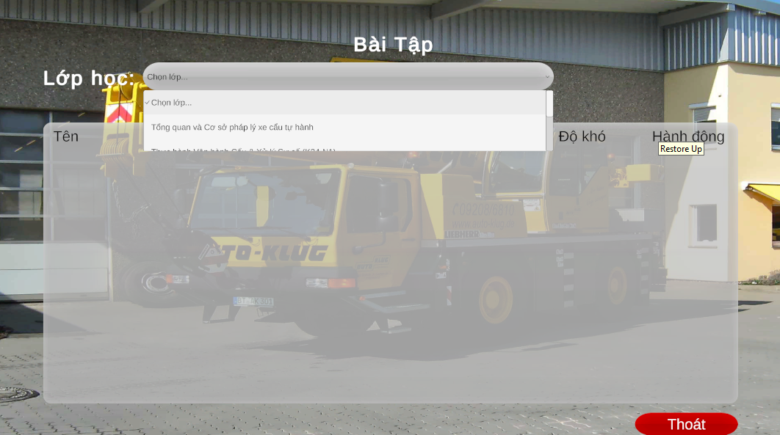

6. Select practice to start.

After selecting the correct class, the system will display the list of available simulation scenarios assigned to that specific group. This step ensures you are entering the correct training environment for your current module.

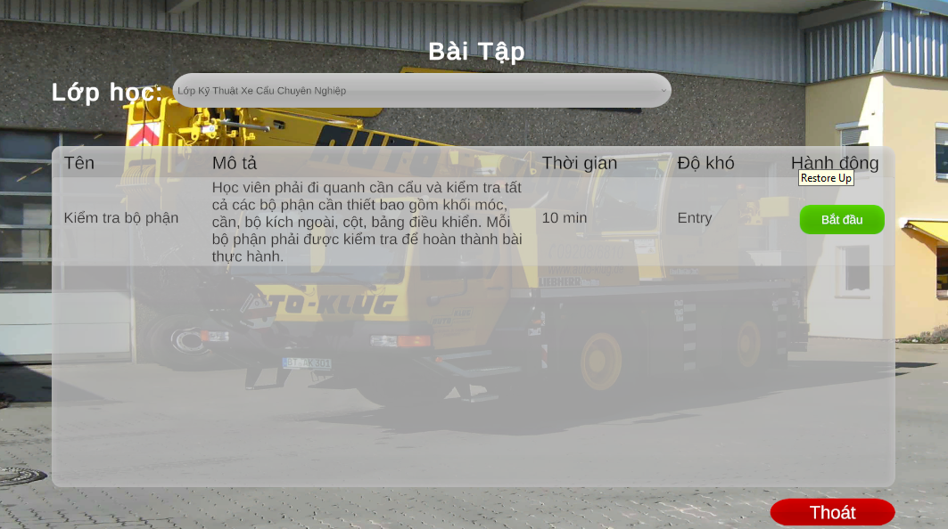

7. Read practice guide before doing the practice.

Once you select a scenario, a Practice Guide overlay will appear. This is a critical preparation phase—do not skip it, as it contains the specific rules for the simulation environment.

7.1 Key Information to Review

* Operational Objectives: Understand the exact start and end points of the cargo (e.g., from the ground to the truck bed).
* Safety Constraints: Review the "ZigZac" path requirements; the system will not count progress if you deviate from this specific path.
* Penalty Rules: Be aware that every time the cargo or hook touches a pole, your score will be automatically reduced by 0.5 points.

7.2 Understanding Phase Transitions

* Phase 1: Focuses on navigating the obstacle course (the ZigZac poles).
* Phase 2: Activates only after Phase 1 is completed successfully; the target text will change, signaling you to move the cargo to the final drop-off point (the truck).

7.3 Operational Tips

* Lever Identification: Use the guide to familiarize yourself with which levers control the boom, the winch, and the rotation before you engage them with the "F" key.
* Visual Cues: Look for "Target Point" in the 3D world which indicate where the cargo needs to be positioned next.

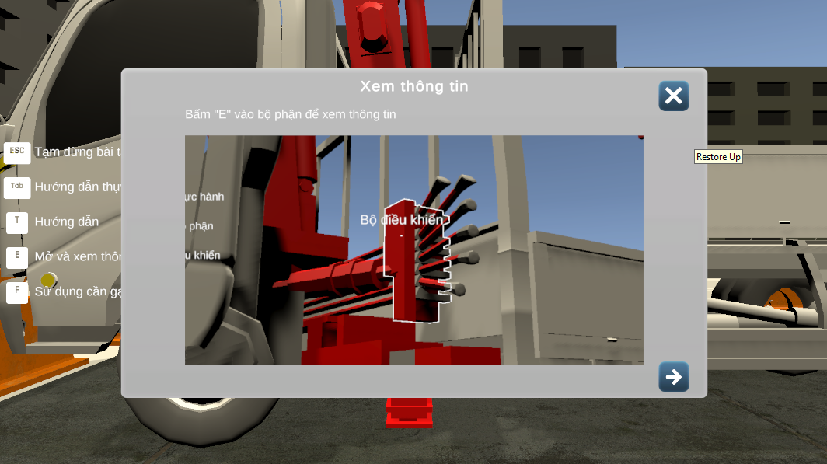

8. Important key when doing practice.

Operating the crane simulator requires precise coordination between keyboard inputs and visual cues. Familiarize yourself with these essential controls before engaging the crane components.

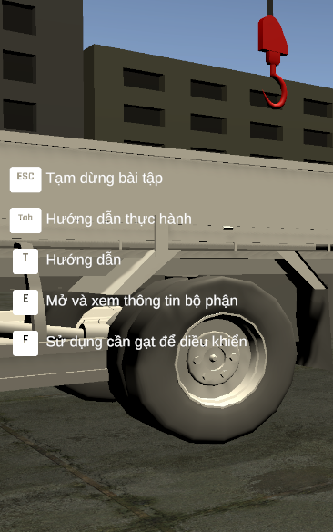

9. Lever Identification and Focus.

Before engaging the crane, you must identify which control component you wish to operate. The simulator uses a proximity-based "Focus" system to prevent accidental movements.

* First-Person Interaction: Use your mouse to look around the crane cabin or control station.
* Visual Hover: Move your crosshair (reticle) directly over a specific crane lever.
* Name Recognition: Wait for the Lever Name to appear on your screen (e.g., "Main Hoist," "Boom Luffing," or "Swing Control").
* Contextual Awareness: Different levers correspond to different 3D components of the crane; always verify the lever name matches your intended action before pressing the interaction key.

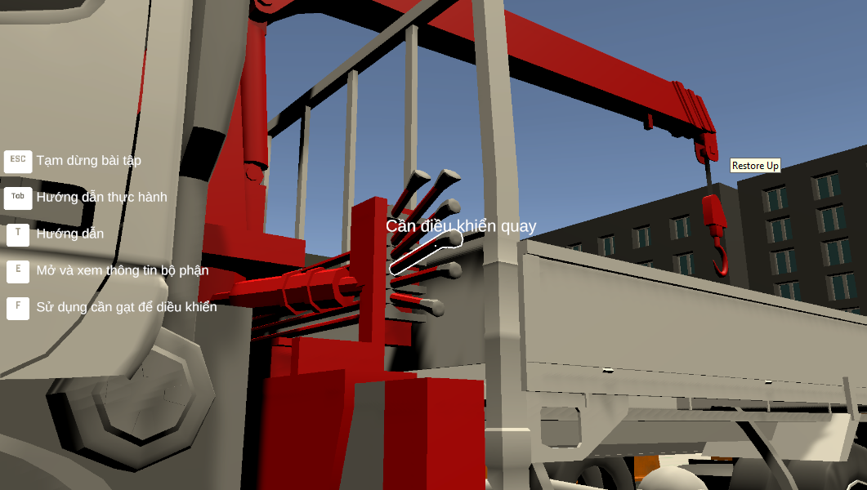

10. Press “F” to the lever to control the Crane with Corresponding components.

Once the name of the lever is visible, you are ready to begin the operation.

* Engage: Press the "F" key to lock your focus onto that specific lever
* Dynamic Controls: As soon as you engage a lever, the Hint Keys at the bottom right will update to show you the movement controls for that specific part of the crane (e.g., Forward/Backward or Left/Right).
* Switching Controls: To move to a different lever, press "F" again to release the current one, then repeat the hover process for the next control.

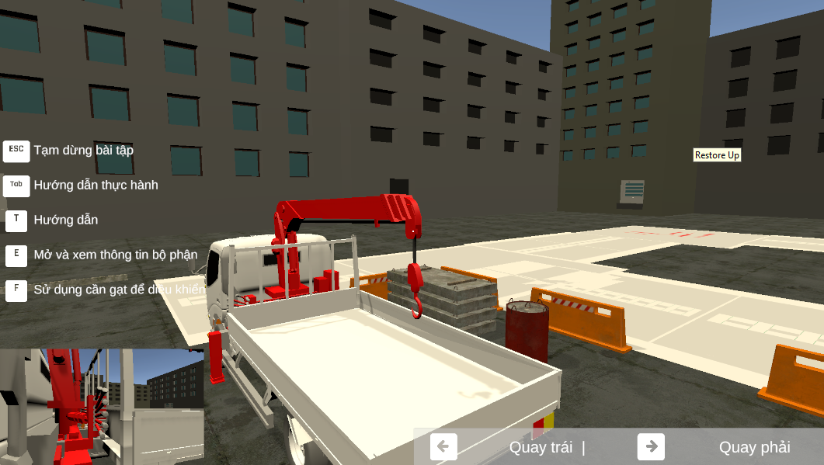

11. Hints.

* Control Labels: Use the hint key display on the bottom right of your screen as a constant reference for operating the crane's components.
* Real-time Guidance: These hint keys will change dynamically based on which lever you have selected, helping you move the crane accurately toward the target cargo.

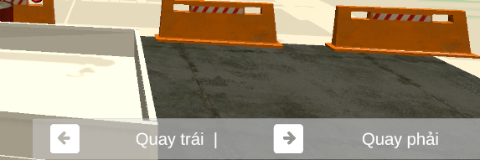

12. Operating the Crane Using Dynamic Hints

The simulator provides real-time guidance to help you master the crane's complex movements. The hint system ensures you always know which keys correspond to your current lever selection.

* Dynamic Mapping: Once you have engaged a lever with the "F" key, look at the bottom right corner of your screen.
* Contextual Control: The hint panel will update instantly to show you the specific keys (e.g., Arrow Keys or W/A/S/D) required to move the current component (Boom, Swing, or Hoist).
* Precision Movement:
  + Tap vs. Hold: For fine adjustments when approaching a target, tap the keys lightly.
  + Coordinated Control: While only one lever is controlled at a time, you must sequence your movements (lifting, then swinging, then luffing) to maintain a smooth path.

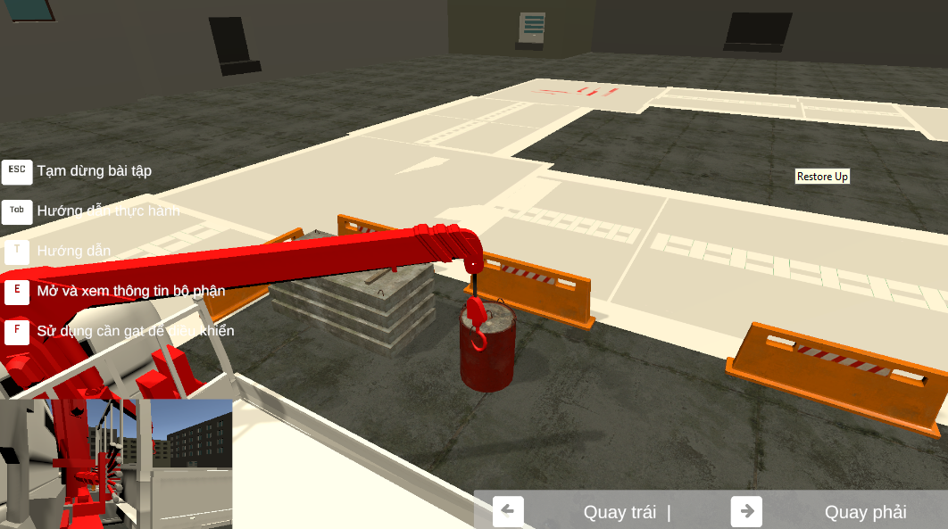

13. Monitoring Performance Metrics.

As you use the hint keys to move the crane, stay aware of your operational status:

* Score and Timer: These are visible at the top right of the screen.
* Penalty Awareness: Remember that jerky movements or over-swinging can lead to collisions with the ZigZac poles, resulting in a 0.5 point deduction per hit.

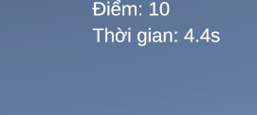

14. Move the crane to the target cargo.

* Identify Destination: Use the camera to locate the Target Cargo in the simulation area.
* Approach: Move the crane steadily until the hook block is centered over the load, preparing for the attachment phase.

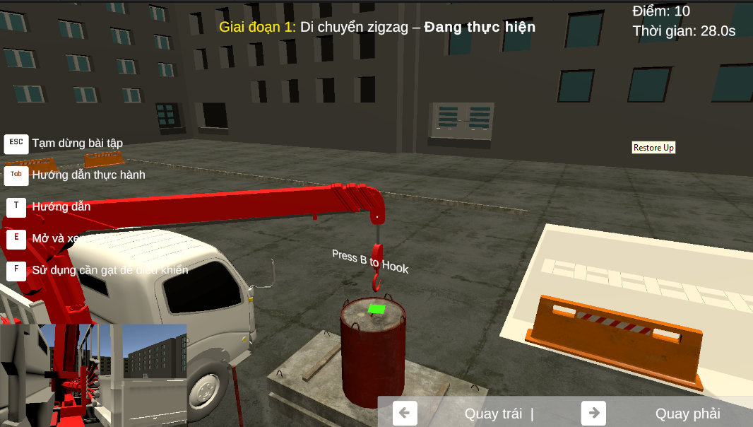

15.Press “B’ to attach the cargo to the hook block.

* Attachment Protocol: Lower the hook block until it is within the attachment radius of the cargo.
* Locking: Press "B" to secure the cargo to the hook.

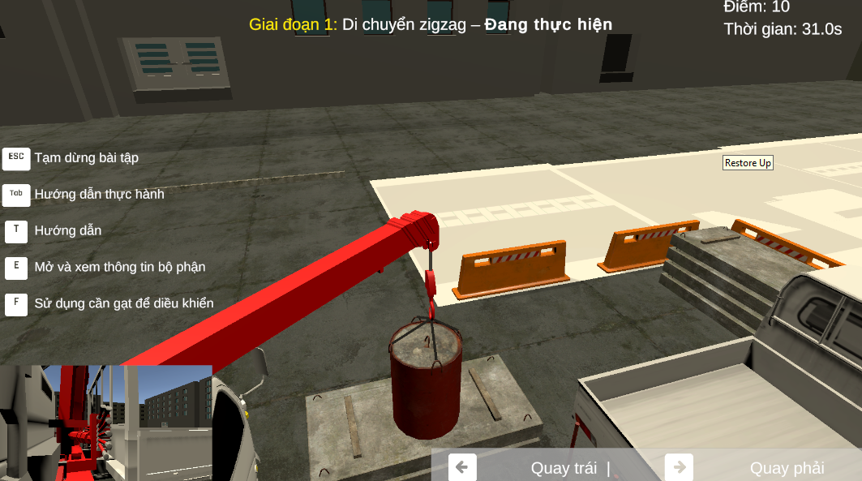

16.Lift the cargo up and doing the practice.

Once the cargo is securely attached using the "B" key, you must perform a controlled lift to begin the maneuver.

* Vertical Control: Use the Hoist/Winch lever to lift the cargo vertically.
* Safety Clearance: Lift the cargo to a height that clears ground obstacles but remains low enough to maintain a low center of gravity.
* Swing Dampening: Wait for any initial pendulum swing to settle before starting horizontal movement to avoid immediate collisions with the first set of poles.
* Telemetry Monitoring: Check the top right of the screen to ensure the weight load is balanced and the timer has officially started for the practice session.

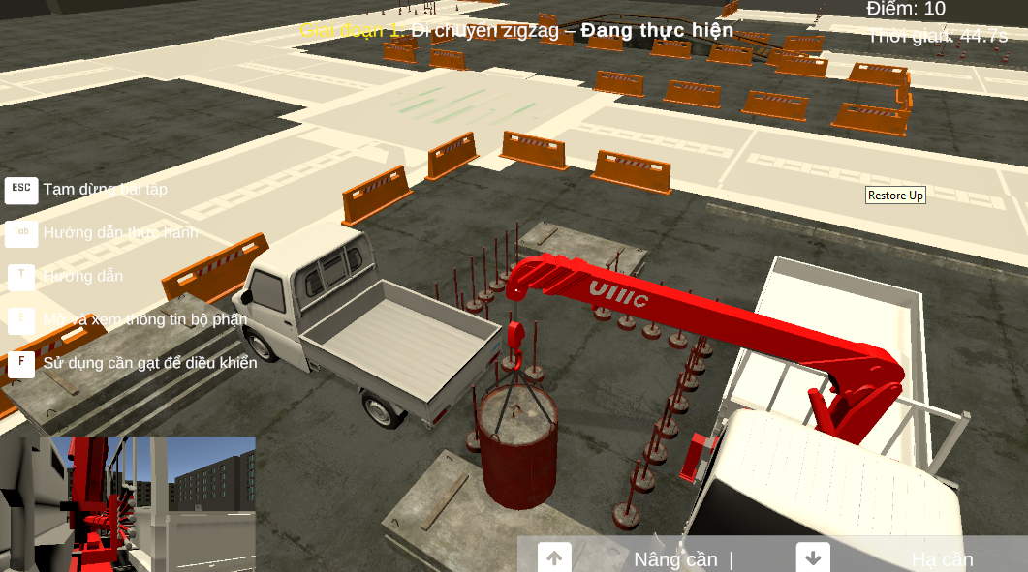

17. Move the Cargo to the target point.

The ZigZac practice is divided into two distinct phases. You must complete the objective of Phase 1 before the system will allow you to proceed to Phase 2.

17.1. “Zigzac” practice target.

“Zigzac” practice phase 1 target.

* Primary Goal: You must navigate the suspended cargo through the pole course following the designated zigzag trajectory.
* Path Accuracy: The cargo must stay within the zigzag boundary; if you skip a section of the path, the maneuver will not be counted as valid.
* Landing Zone: Phase 1 concludes when you move the cargo to the first target point and lower it to the designated surface.
* Collision Monitoring: Throughout this phase, ensure the cargo does not touch the poles, as each contact results in a 0.5 point deduction from your score.



“Zigzac” practice phase 2 target.

* Transition: Once Phase 1 is completed, the objective text on your screen will update, signaling the start of Phase 2.
* Primary Goal: Move the cargo from the Phase 1 landing zone to the back of the transport truck (Target 2).
* Precision Control: Carefully align the cargo over the truck bed using the hint keys to coordinate swing and boom movements.
* Completion: Lower the cargo onto the truck bed before opening the menu to submit your results.

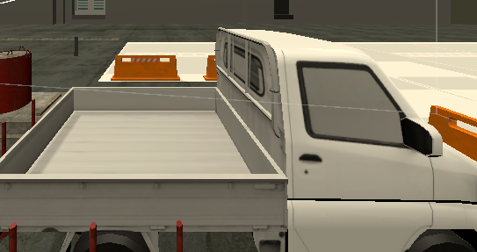

17.2. Cargo positioning practice target.

This scenario focuses exclusively on your ability to perform precise vertical and horizontal adjustments to center a load.

* Primary Goal: Move the cargo from its starting position and land it directly in the center of the target circle.
* Accuracy Metrics: The system calculates your final score based on how close the center of the cargo is to the center point of the circle.
* Vertical Control: Use the Hoist/Winch lever to ensure the cargo does not sway as you lower it toward the ground.

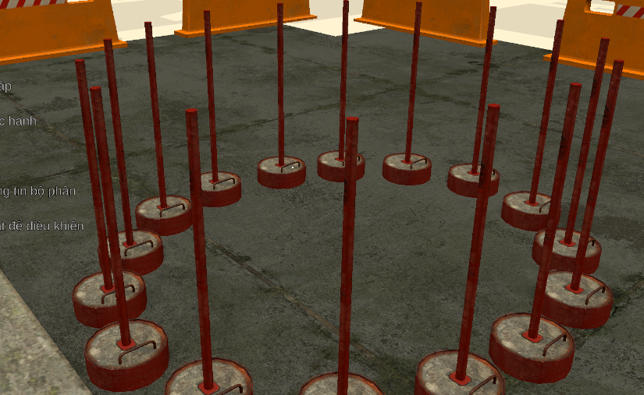

18. The path must be in the zigzag, if it's not it won’t be counted.

The simulator is programmed with a strict path-tracking algorithm. To pass the evaluation, you must adhere to the designated route.

* Non-Negotiable Trajectory: The cargo must pass between every set of poles in the specific "ZigZac" sequence.
* Checkpoint System: The system utilizes invisible checkpoints; if you attempt to "shortcut" the course by bypassing a pole, the maneuver will not be recognized, and the task will not be marked as complete.
* Validation Logic: Progress is only recorded when the cargo centers through each gap; failing to follow the sequence means the final phase will not trigger.

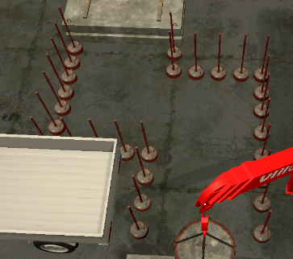

19. Precision Handling and Penalty System

Safety is the highest priority in crane operation. The simulator enforces this through a real-time scoring deduction system.

* Collision Detection: The physics engine detects any contact between the cargo, the hook block, or the crane’s boom and the boundary poles.
* Scoring Penalties: Each instance of contact results in an immediate -0.5 point deduction from your total performance score.
* Swing Control: You must manage the "pendulum effect" by making small, counter-movements with the levers; excessive cargo swaying is the primary cause of pole collisions.
* Monitoring: Keep a constant eye on the top-right HUD to track your current score during the maneuver.

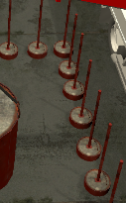

20. Objective Transition: Phase 1 to Phase 2.

The simulator provides clear visual and textual feedback when a major milestone is reached.

* State Change: Once the cargo successfully clears the final "ZigZac" checkpoint, the system will automatically transition to Phase 2.
* Visual Notification: The instruction text on your screen will update to reflect the new objective.

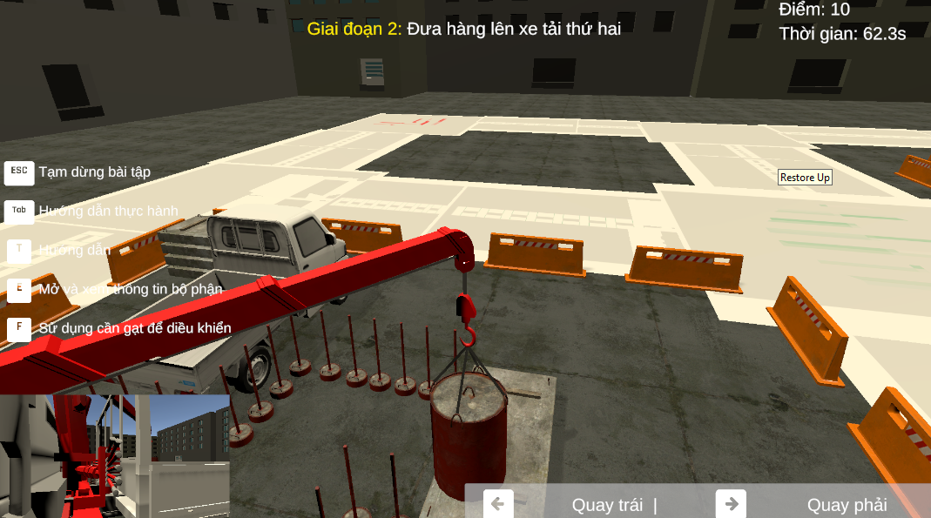

21. Move the cargo to the back of the truck to finish the practice.

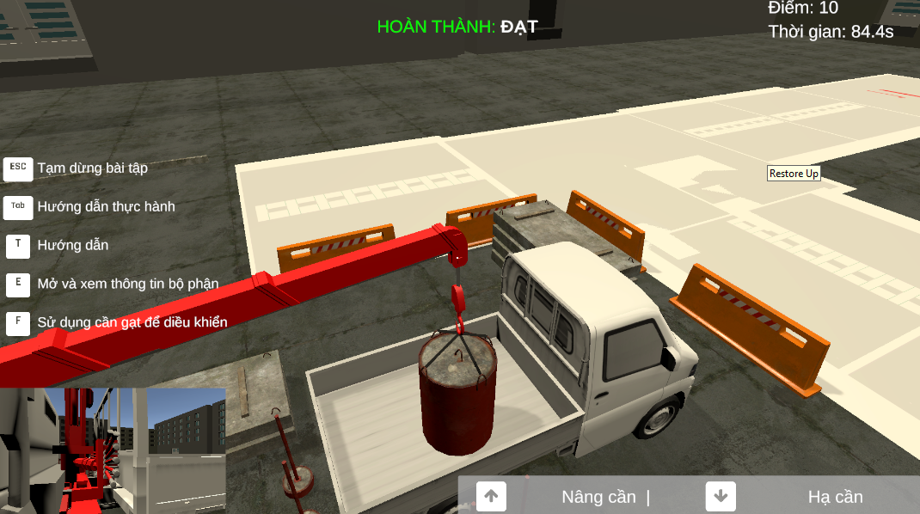

22. Final Review and Process Completion.

* Opening the Menu: After placing the cargo, press "ESC" on your keyboard to pause the simulation and open the settings/submission menu.
* Submission ("Nộp bài"): Click the "Nộp bài" button to finalize your attempt and transmit your score, time, and penalty data to the instructor's dashboard.

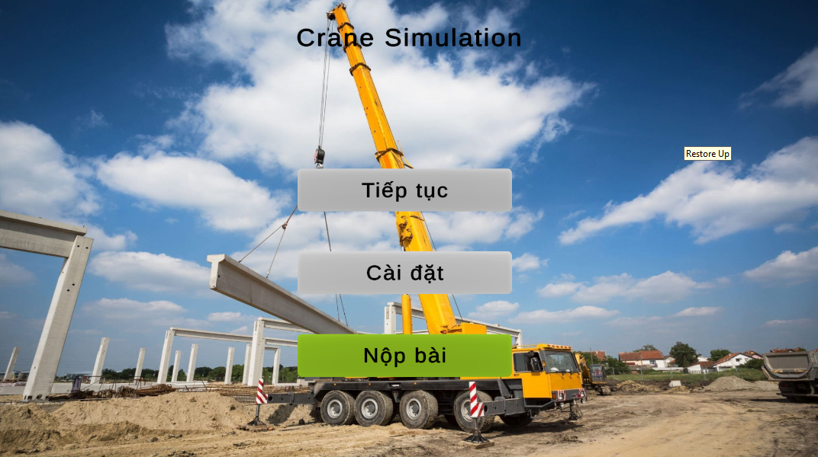

#### 3.3.7 Feature 6: Simulation Management

**Overview:** This feature is the control center for the simulation ecosystem. It allows the **Simulation Manager** to configure physics parameters, manage 3D assets, and design training scenarios. These configurations directly synchronize with the Desktop Client to ensure accurate simulation behavior.

**Actor:** Simulation Manager **Pre-condition:** User must be logged in successfully with the Simulation Manager role.

**Manage Brand Models (Quản lý Thương hiệu & Model)**

* **Description:** Defines the technical specifications (physics profiles) of different crane models. The Unity Client uses these parameters to calculate real-time physics limits.
* **Trigger:** Select **"Thương hiệu và model"** (Brand Models) from the Sidebar.
* **URL:** /simulation-manager/brand-model

**Usage Steps:**

1. **View List:** The interface displays a table of registered crane models.
2. **Create New Model:**
   * Click the **"Tạo mới"** (Create) button on the top right.
   * **[Action]:** A drawer form appears.
   * Input the required fields:
     + **Tên Model** (Model Name): e.g., *SCC550A*.
     + **Tải trọng tối đa** (Max Lifting Capacity): e.g., *55 tons*.
     + **Bán kính tối đa** (Max Radius): e.g., *40m*.
   * Click **"Lưu"** (Save) or **"Xác nhận"** (Submit) to finish.
3. **Edit/Delete:** Click the **"Chỉnh sửa"** (Edit icon) or **"Xóa"** (Delete icon) on specific rows.

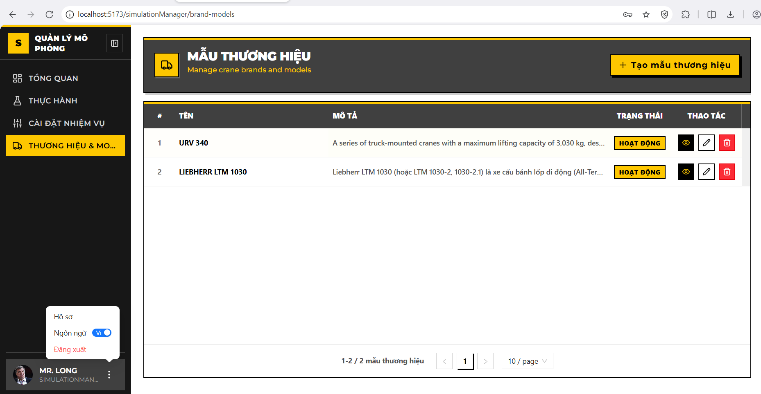

**Create New Brand Model (Tạo mới Thương hiệu & Model)**

**Description:** Provides a drawer interface for Simulation Managers to register a new crane model identity (e.g., KATO, SANY) into the system. This establishes the brand profile before physical parameters are configured.

**Trigger:** Click the **"Thêm mới"** (Create) button (icon dấu cộng **+**) located at the top-right corner of the management table.

**Usage Steps:**

1. **[Action]:** A drawer form slides in from the right side of the screen titled **"THÊM MỚI THƯƠNG HIỆU"** (Create Brand Model).
2. **Input the required fields:**
   * **Tên thương hiệu (Brand Name):**
     + *Input:* Text field.
     + *Validation:* Required, unique in the system (Duplicate Check).
     + *Example:* "SANY SCC550A".
   * **Mô tả (Description):**
     + *Input:* Text Area.
     + *Validation:* Optional, max 500 characters.
     + *Example:* "Cẩu bánh xích 55 tấn - Model tiêu chuẩn 2024".
   * **Trạng thái (Status):**
     + *Input:* Toggle Switch.
     + *Default:* Active (Hoạt động).
3. **Submission:** Click **"Lưu"** (Save) to submit the data to the server (POST /api/BrandModels).

**System Logic (Backend Verification):**

* **Name Normalization:** The system automatically trims whitespace (e.g., " KATO ") before saving.
* **Integrity Check:** If the entered name already exists, the system returns a 400 Bad Request: *"Tên thương hiệu đã tồn tại"* (Brand name already exists).

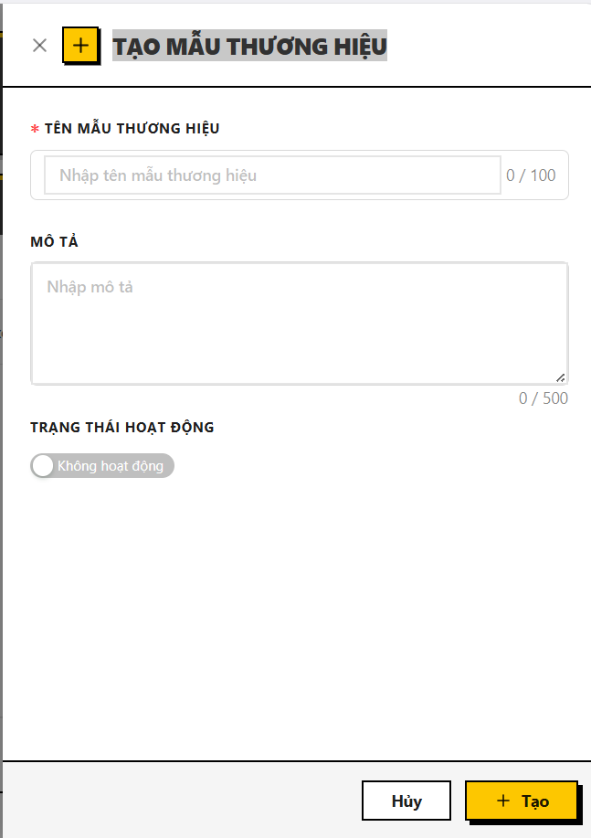

**Edit Brand Model (Sửa mẫu thương hiệu)**

**Description:** Allows authorized users to modify the details of an existing crane model. This function ensures that any updates to the brand identity (Name, Description) do not violate system integrity rules.

**Trigger:** Click the **"Chỉnh sửa"** (Edit - icon bút chì) button on a specific row in the Brand Model list.

**Usage Steps:**

1. **[Action]:** The drawer form slides in from the right, titled **"CẬP NHẬT THƯƠNG HIỆU"** (Edit Brand Model).
2. **Data Population:** The form automatically pre-fills with the selected model's current information:
   * **Tên thương hiệu (Brand Name):** Displays current name (e.g., "SANY SCC550A").
   * **Mô tả (Description):** Displays current description.
   * **Trạng thái (Status):** Shows the current Active/Inactive switch state.
3. **Modification:** User updates the desired fields.
   * *Input:* Text field / Text Area / Switch.
   * *Validation:* Standard validation rules apply (Required, Max length).
4. **Submission:** Click **"Cập nhật"** (Save/Update) to commit changes to the server (PUT /api/BrandModels/{id}).

**System Logic (Backend Verification):**

* **Existence Check:** The system verifies if the record exists and has not been deleted.
* **Self-Exclusion Duplicate Check:** The system checks if the new name exists in the database *excluding the current record itself*.
  + *Logic:* if (Name == NewName AND Id != CurrentId) -> Error.
  + *Purpose:* Allows the user to keep the same name while updating the description, but prevents renaming the model to a name that belongs to another brand.

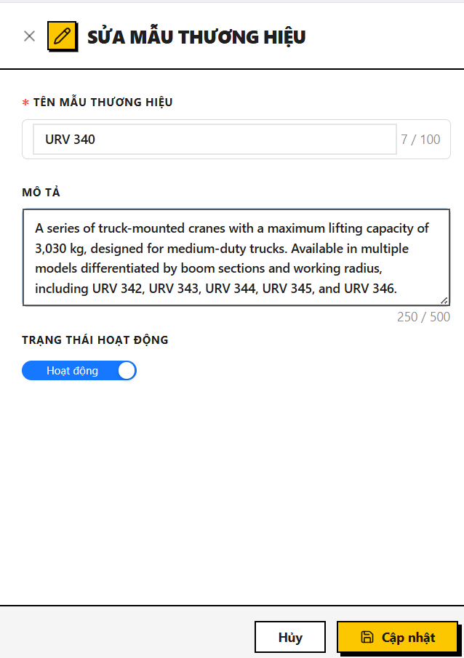

**Delete Brand Model (Xóa mẫu thương hiệu)**

**Description:** Allows the removal of a crane model from the active system. This action is protected by strict dependency checks to prevent breaking simulation configurations.

**Trigger:** Click the **"Xóa"** (Delete - icon thùng rác) button on a specific row.

**Usage Steps:**

1. **[Action]:** A confirmation dialog appears asking the user to confirm the deletion.
2. **Confirmation:** Click **"Xóa"** (Confirm) to proceed.
3. **Result:** The record is removed from the table view.

**System Logic (Critical Integrity Rule):**

* **Dependency Check:** Before deletion, the backend scans the SimulationComponents table.
* **Blocking Rule:** If this Brand Model is currently linked to any Simulation Component (used in physics calculations), the system **BLOCKS** the deletion and returns an error: *"Cannot delete brand model that has simulation components."*.
* **Soft Delete:** If no dependencies exist, the system performs a "Soft Delete" (sets IsDeleted = true) to preserve historical data integrity.

**Manage Simulation Tasks (Quản lý Nhiệm vụ Mô phỏng)**

**Description:** Allows the Simulation Manager to define a library of atomic tasks (objectives) such as "Lift Cargo", "Navigate Zigzag", or "Emergency Stop". These tasks serve as building blocks that are later assigned to specific Practice Sessions.

**Trigger:** Select **"Nhiệm vụ thực hành"** (Task Practice) from the Simulation Manager Sidebar.

**View Task List (Xem Nhiệm vụ Mô Phỏng)**

**Usage Steps:**

1. **Access:** The page loads the list of existing tasks via API GET /api/Tasks/paged.
2. **View Modes:** Users can toggle between **Table View** and **Card View** using the toggle button at the top right.
3. **Display Data:**
   * **Task Name:** Descriptive name (e.g., "Nâng hàng an toàn").
   * **Task Code:** Unique identifier (e.g., "TASK-001").
   * **Description:** Operational details.
   * **Expected Result:** The criterion for success (e.g., "Cargo placed within 5cm of target").

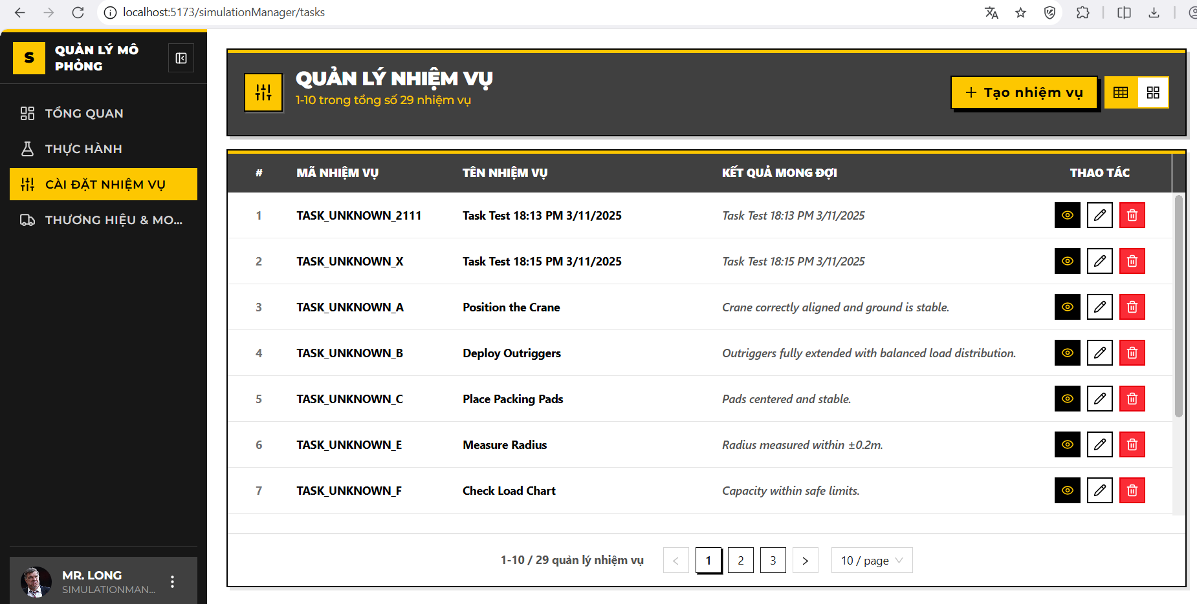

**Create New Task (Tạo mới Nhiệm vụ)**

**Usage Steps:**

1. **Trigger:** Click the **"CREATE TASK"** button (or icon **+**) at the top right.
2. **Action:** A drawer form slides in titled **"CREATE NEW TASK"**.
3. **Input the required fields** :
   * **Tên nhiệm vụ (Task Name):**
     + *Validation:* Required, Max 100 chars.
   * **Mã nhiệm vụ (Task Code):**
     + *Validation:* Required, Max 50 chars, Must be unique.
     + *Example:* "LIFT-OP-01".
   * **Mô tả (Description):**
     + *Validation:* Optional, Max 500 chars.
   * **Kết quả mong đợi (Expected Result):**
     + *Validation:* Optional, Max 100 chars.
4. **Submission:** Click **"Create"** (Tạo ) to submit to POST /api/Tasks.

**System Logic (Backend Verification - TasksService.cs):**

* **Uniqueness Check:** The system verifies if TaskCode already exists (case-insensitive). If duplicated, it throws an error: *"Task code '{code}' already exists."*
* **Data Cleaning:** Automatically trims whitespace from all text inputs.

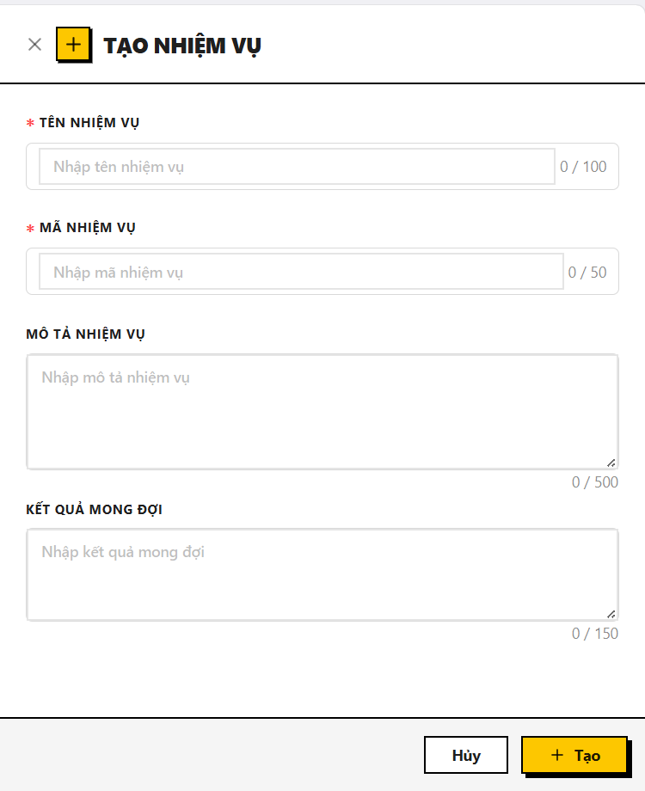

**Edit Task (Cập nhật Nhiệm vụ)**

**Usage Steps:**

1. **Trigger:** Click the **"Edit"** (Pencil icon) on a task card or table row.
2. **Action:** The drawer opens with title **"EDIT TASK"**, pre-filled with current data.
3. **Modification:** Update fields as needed. Note that TaskCode can be changed but must remain unique across the system.
4. **Submission:** Click **"Update"** to save changes (PUT /api/Tasks/{id}).

**Business Rules:**

* **Self-Exclusion Check:** When checking for duplicate TaskCode, the system ignores the current task being edited.

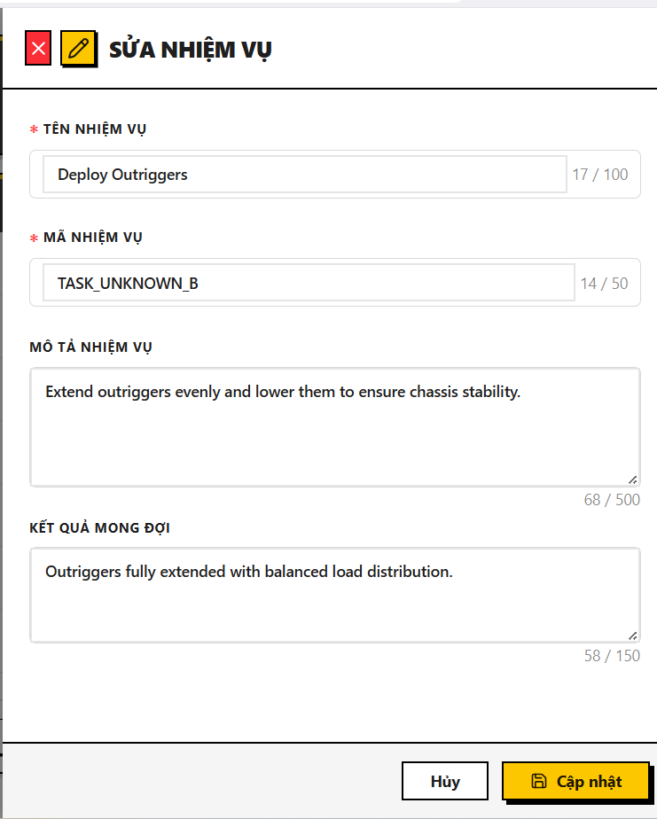

**Delete Task (Xóa Nhiệm vụ)**

**Usage Steps:**

1. **Trigger:** Click the **"Delete"** (Trash icon) on a task.
2. **Confirmation:** A modal appears: *"Are you sure you want to delete {taskName}?"*.
3. **Action:** Click **"Delete"** to confirm.

**System Logic (Critical Integrity Rule):**

* **Dependency Block:** The backend (TasksService.cs) checks if this Task is currently assigned to any Practice Scenario (PracticeTasks table).
* **Rule:** If the task is in use, the system **BLOCKS** the deletion and returns an error: *"Cannot delete a task associated with one or more practices."*
* **Soft Delete:** If safe to delete, the system sets IsDeleted = true.

**Manage Simulation Practices (Quản lý Bài Thực hành Mô phỏng)**

**Description:** Allows Simulation Managers to define complete practice scenarios by combining metadata (Duration, Difficulty) with specific operational tasks. These practices are the core content assigned to trainees for simulation training.

**Trigger:** Select **"Bài thực hành"** (Practices) from the Simulation Manager Sidebar.

**URL:** /simulation-manager/practices

**View Practice List**

**Usage Steps:**

1. **Access:** Upon loading the page, the system automatically fetches the list of existing practices.
2. **Display Data:** The table displays the following information:
   * **Mã bài thực hành (Practice Code):** Unique identifier for the scenario (e.g., "PRAC-001").
   * **Tên bài thực hành (Practice Name):** The descriptive title of the practice (e.g., "Vận hành cẩu cơ bản").
   * **Thời lượng (Duration):** Estimated time required to complete the practice (in minutes).
   * **Độ khó (Difficulty):** The skill level required, visualized by color-coded badges:
     + *Entry* (Easy/Green)
     + *Intermediate* (Medium/Yellow)
     + *Advanced* (Hard/Red)
   * **Số lần thử (Max Attempts):** The maximum number of retries allowed for a trainee.
   * **Trạng thái (Status):** Indicates availability (*Active* / *Inactive*).
3. **Actions:** Users can click the **Edit icon** (Eye/Pencil) to view details or the **Delete icon** (Trash bin) to remove a practice.

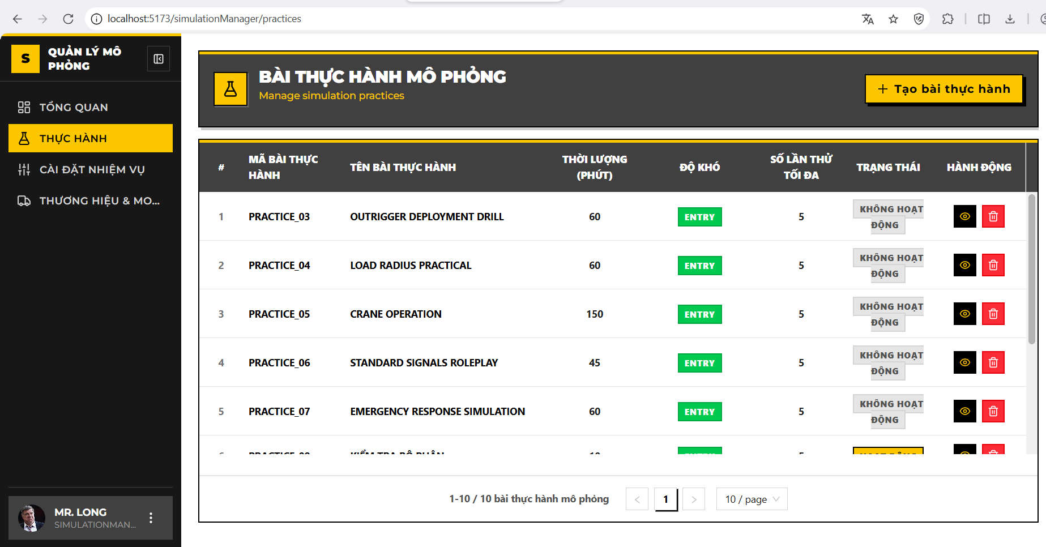

**Create New Practice (Tạo mới Bài thực hành)**

**Usage Steps:**

1. **Trigger:** Click the **"Tạo mới"** (Create) button (icon **+**) at the top-right corner of the page.
2. **[Action]:** The system navigates to the Create Practice form (/practices/create).
3. **Input the required fields** :
   * **Tên bài thực hành (Practice Name):**
     + *Input:* Text field.
     + *Validation:* Required, max 200 characters.
   * **Mã bài thực hành (Practice Code):**
     + *Input:* Text field.
     + *Validation:* Required, max 50 characters, must be uppercase and unique.
   * **Mô tả (Description):**
     + *Input:* Text Area.
     + *Validation:* Optional, max 1000 characters.
   * **Thời lượng (Duration):**
     + *Input:* Number field.
     + *Unit:* Minutes.
   * **Độ khó (Difficulty):**
     + *Input:* Dropdown menu.
     + *Options:* *Entry, Intermediate, Advanced*.
   * **Số lần thử (Max Attempts):**
     + *Input:* Number field.
     + *Constraint:* Must be between 1 and 10.
   * **Trạng thái (Active):**
     + *Input:* Toggle Switch.
     + *Default:* Active (On).
4. **Submission:** Click **"Tạo bài thực hành"** (Save) to submit the data.

**System Logic:**

* **Duplicate Check:** The system verifies if the PracticeCode already exists in the database. If a duplicate is found, it returns an error: *"Practice code already exists."*

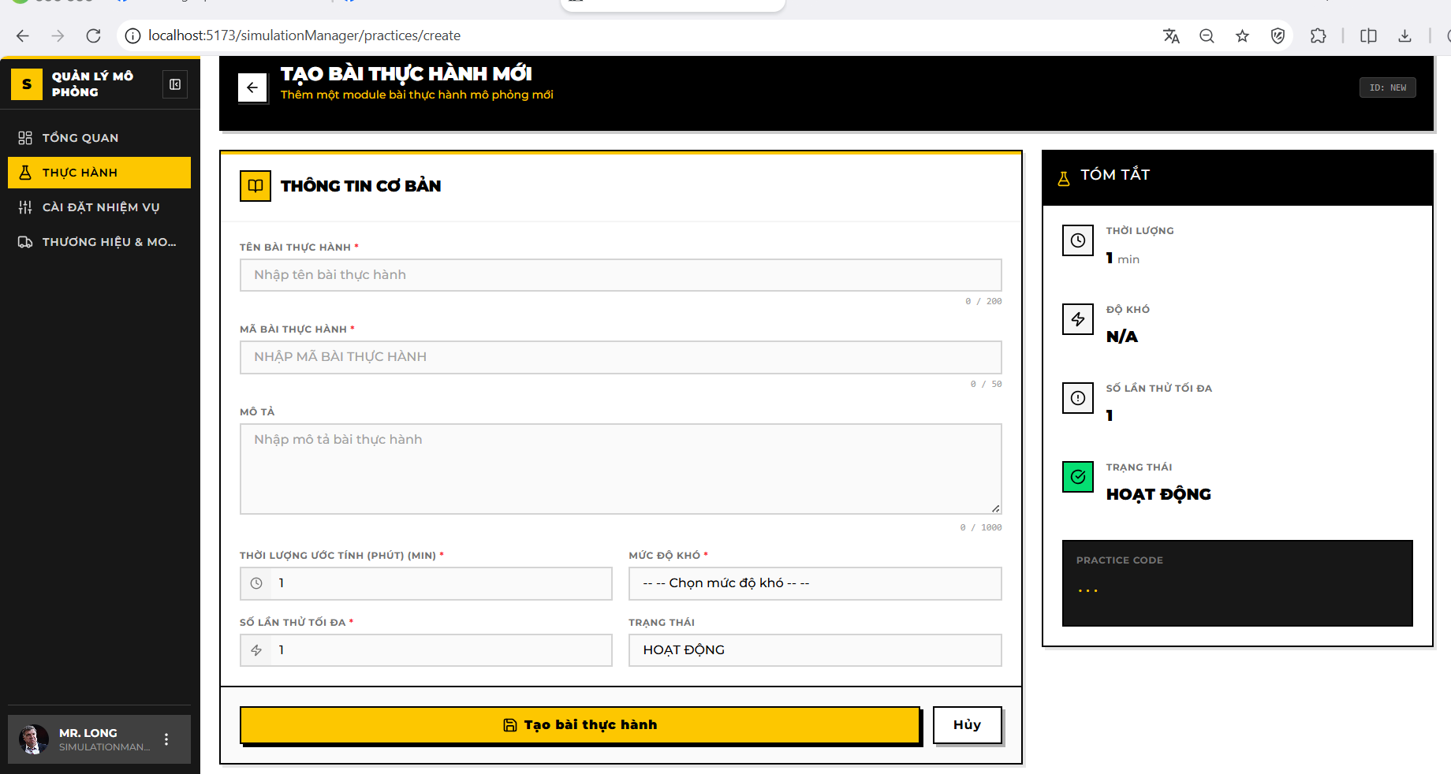

**Edit Practice & Manage Tasks (Cập nhật & Gán Nhiệm vụ)**

**Description:** This interface allows updating practice metadata and assigning specific operational tasks (from the Task Library) to the practice.

**Trigger:** Click the **"Chi tiết"** (View/Edit) button on a specific row in the list.

**Usage Steps:**

**A. Edit General Information:**

1. Modify the fields in the **"Thông tin cơ bản"** (Basic Information) section.
2. Click **"Lưu thay đổi"** (Save Changes) to update the metadata.

**B. Assign Tasks (Task Configuration):**

1. **Trigger:** Scroll to the **"Danh sách nhiệm vụ"** (Task List) section and click **"Thêm nhiệm vụ"** (Add Task / Assign Task).
2. **Selection:** A modal appears listing available tasks from the library.
3. **Action:** Check the boxes next to the desired tasks (e.g., "Nâng hàng", "Di chuyển zig-zag").
   * *Note:* Tasks already assigned to this practice are hidden or disabled to prevent duplicates.
4. **Confirm:** Click **"Gán"** (Assign) to link the selected tasks to the practice.
5. **Remove Task:** To unassign a task, click the **Delete icon** on the specific task row within the list.

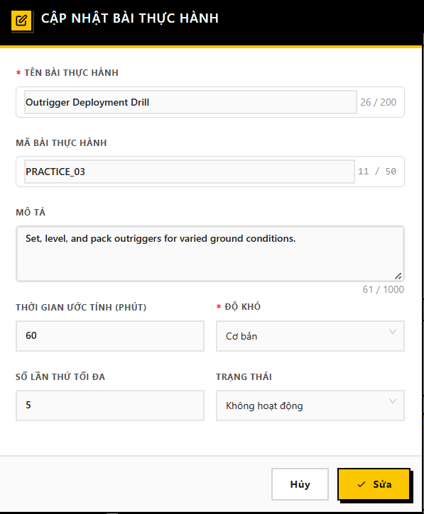

**Delete Practice (Xóa Bài thực hành)**

**Usage Steps:**

1. **Trigger:** Click the **"Xóa"** (Delete) button (icon Trash bin) on a specific row in the main list.
2. **Confirmation:** A dialog appears asking: *"Bạn có chắc chắn muốn xóa bài thực hành này?"* (Are you sure you want to delete this practice?).
3. **Action:** Click **"Xóa"** (Confirm) to proceed.

**System Logic (Integrity Check):**

* **Dependency Block:** The backend checks if this Practice is currently linked to any active **Training Curriculum** (Activities).
* **Rule:** If the practice is in use, the system **BLOCKS** the deletion to prevent breaking the course structure.

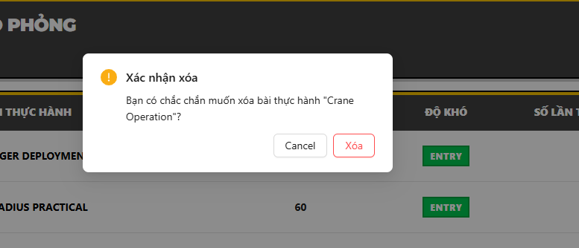

**Simulation Manager Dashboard (Bảng điều khiển quản lý mô phỏng)**

**Description:** Provides a comprehensive analytical view of the simulation training system. It aggregates real-time data regarding trainees, practice scenarios, and system usage to help managers assess training throughput and effectiveness.

**Trigger:** Select **"Tổng quan"** (Dashboard) from the Simulation Manager Sidebar.

**URL:** /simulation-manager/dashboard

**System Overview Statistics (Thống kê tổng quan)**

**Usage Steps:**

1. **Access:** Upon accessing the dashboard, the top section ("StatsOverview") automatically loads data from the server.
2. **Display Data:** Four key metric cards are displayed:
   * **Tổng học viên (Total Trainees):** Total number of active trainees in the system.
   * **Tổng thực hành (Total Practices):** Total number of practice scenarios defined.
   * **Tổng nhiệm vụ (Total Tasks):** Total number of atomic tasks available in the library.
   * **Tổng phiên mô phỏng (Total Simulation Sessions):** Cumulative count of all practice attempts made by trainees.

**System Logic (Backend Analysis - SimulationManagerDashboardService.cs):**

* **Data Aggregation:** The system queries the database using CountAsync filters.
* **Exclusion Rule:** All queries strictly filter out deleted records (IsDeleted == false) to ensure accuracy.
* **Role Validation:** The backend enforces a security check to ensure the requesting user has the SimulationManager role before returning data.

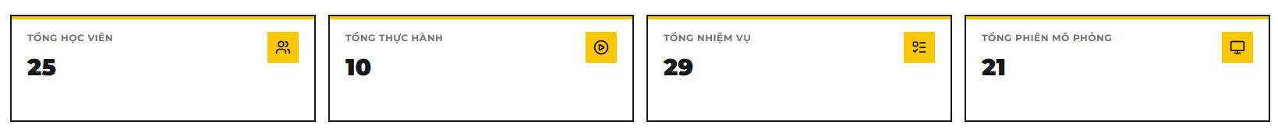

**Monthly Practice Completion Analytics (Phân tích hoàn thành thực hành)**

**Description:** A chart visualization showing the trend of successful vs. failed practice attempts over the months of a selected year.

**Usage Steps:**

1. **View Chart:** A bar chart displays two datasets per month:
   * **Completed (Hoàn thành):** Number of attempts where the trainee passed (IsPass == true).
   * **Not Completed (Chưa hoàn thành):** Number of attempts failed (IsPass == false).
2. **Filter by Year:** Use the year selector (Dropdown/Input) at the top of the chart to change the reporting period (Default is the current year).

**System Logic:**

* **API Call:** GET /api/simulation-manager/dashboard/completion-distribution?year={year}.
* **Grouping:** Data is aggregated from the PracticeAttempts table, grouped by Month.
* **Metric Definition:** "Completion" is strictly defined by the IsPass boolean flag in the database attempt record.

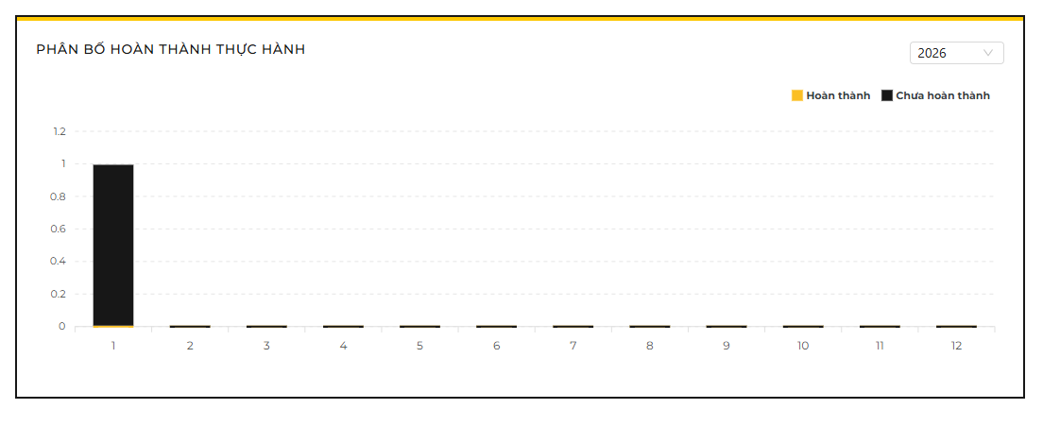

**Practice Duration Distribution (Phân bổ thời lượng thực hành)**

Description:

A pie/donut chart categorizing simulation sessions based on the complexity/length of the practices being attempted. This helps managers understand if trainees are focusing on short drills or long, complex scenarios.

**Usage Steps:**

1. **View Distribution:** The chart segments usage into three categories:
   * **Fast (< 15 mins):** Short exercises.
   * **Moderate (15-45 mins):** Standard training sessions.
   * **Slow (> 45 mins):** Long/Complex scenarios.
2. **Interaction:** Hover over chart segments to see the exact count of trainees/attempts in each category.

**System Logic (Code Insight):**

* **Classification Source:** The category is determined by the **Estimated Duration** (EstimatedDurationMinutes) defined in the *Practice configuration*, not the actual time the student spent.
  + *Logic:* Join(PracticeRepository) Check EstimatedDuration.
* **Buckets:**
  + Fast: Duration < 15.
  + Moderate: 15 <= Duration <= 45.
  + Slow: Duration > 45.

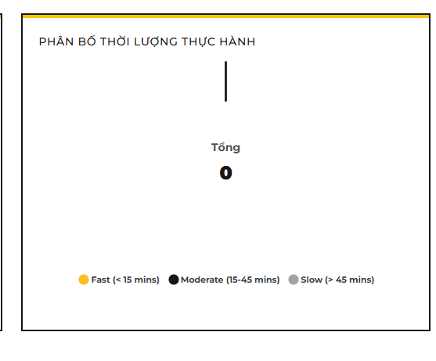

#### 3.3.8 Feature 7: Trainee Learning Portal

**Overview:** This feature serves as the primary interface for trainees to engage with the training program. It consolidates daily schedules, course materials (video/documents), simulation practice tracking, assessments, and certification. The system enforces progression rules (e.g., video completion triggers) to ensure training integrity.

**Actor:** Trainee **Pre-condition:** User must be logged in successfully with the **Trainee** role.

**View Weekly Schedule (Xem Lịch học)**

**Description:** Allows trainees to view their assigned class sessions. The system organizes time slots into a weekly grid view, helping trainees track upcoming theory lessons or simulation practice sessions. **Trigger:** Select "Lịch học" (Schedule) from the Sidebar. **URL:** /trainee/schedule

**Usage Steps:**

1. View Weekly Grid:
   * The interface calculates the current week (starting Monday) and displays a calendar grid.
   * Columns represent days (Monday - Sunday), and rows represent assigned Time Slots (e.g., Slot 1: 07:00 - 09:15).
   * [System Logic]: The system calls GET /api/timeslots/trainee/weekly with the dateInWeek parameter to fetch relevant sessions.
2. Navigation:
   * Click the "<" (Previous) or ">" (Next) buttons to navigate between weeks.
   * Click "Hôm nay" (Today) to return to the current week.
3. Session Details:
   * Occupied slots display the Class Name, Room/Lab location, and Attendance Status (e.g., "Có mặt", "Vắng").

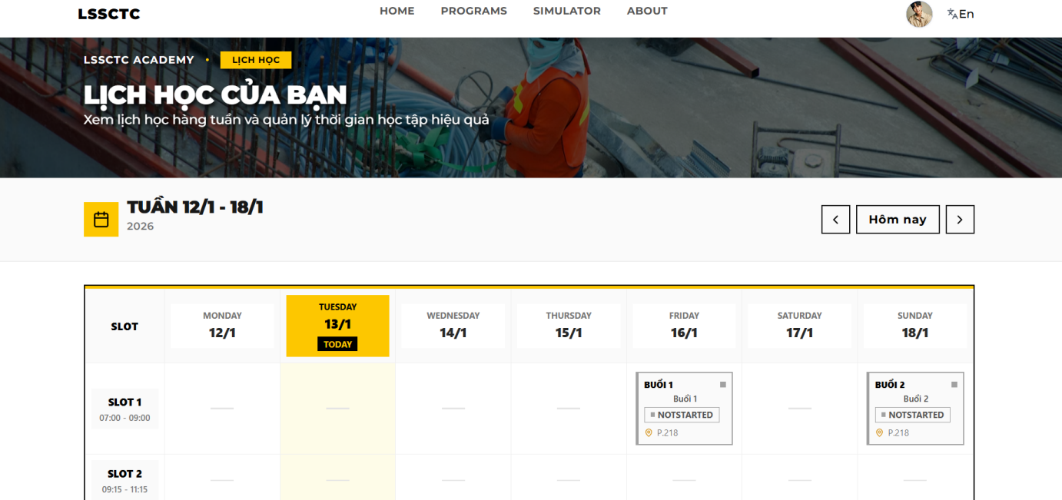

1. Attendance List:
   * Click onto the “Attendance” or “Điểm danh” button to navigate to all of your attendance records in the class

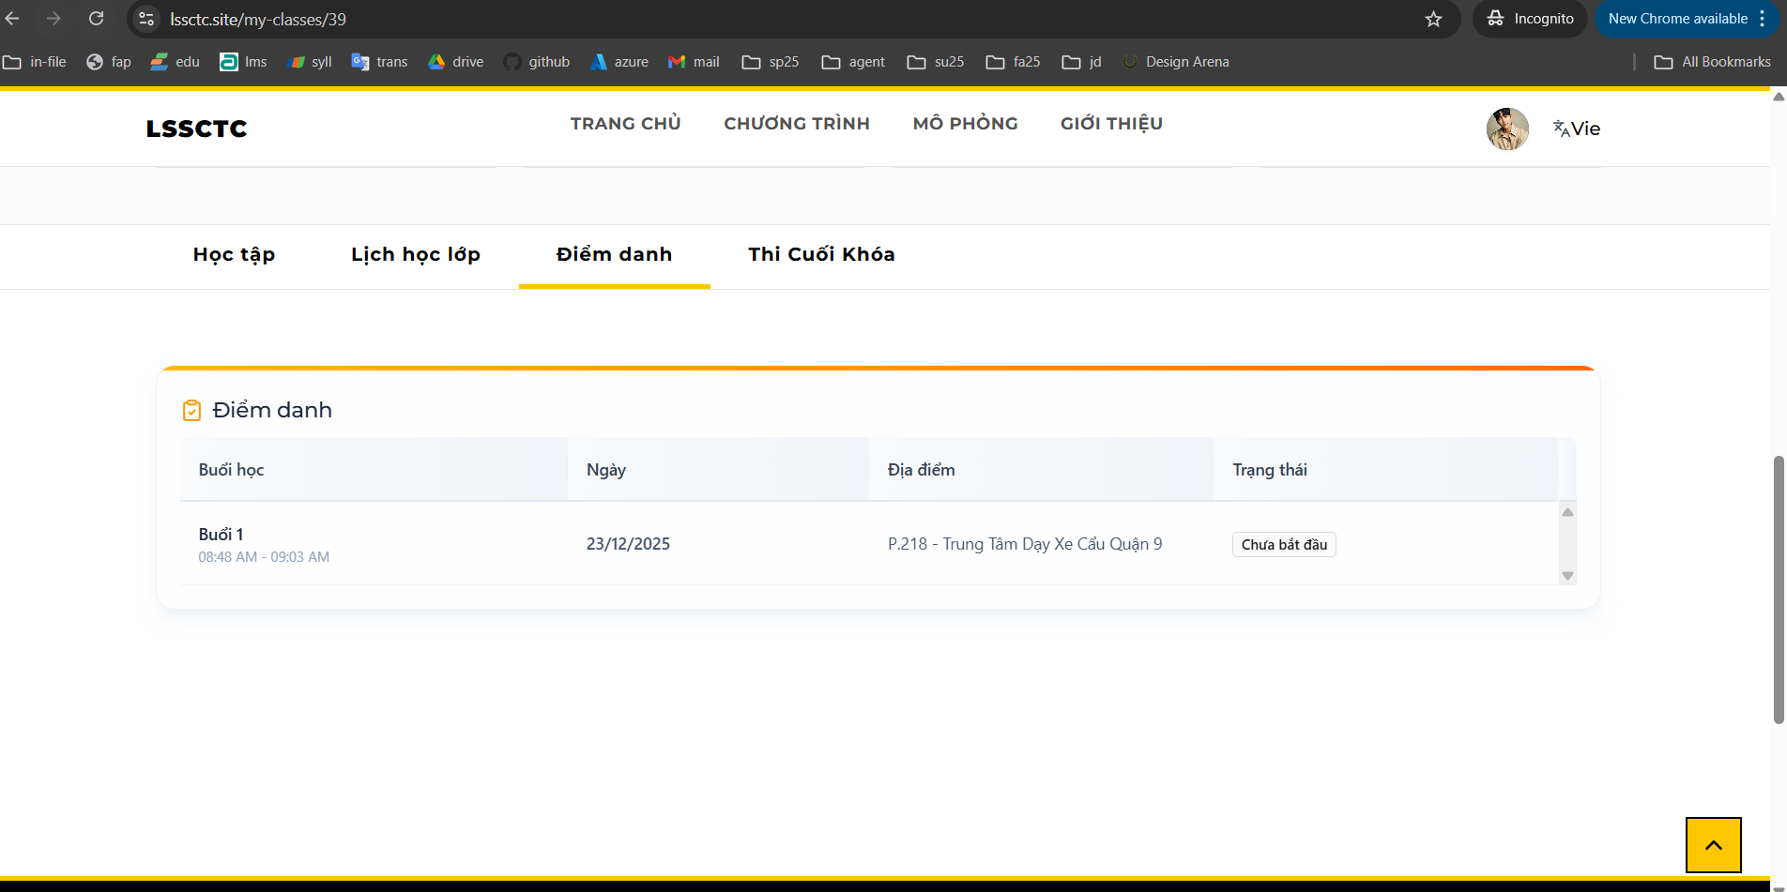

**Learn Course Material (Học tập)**

**Description:** The core learning interface where trainees consume lecture videos and reading materials. The system tracks engagement time and automatically updates progress status based on specific completion thresholds. **Trigger:** Select a specific Class > Course > Section > Activity from the "Program" menu. **URL:** /trainee/learn/:courseId/:sectionId/:partitionId

**Usage Steps:**

1. **Access Content:**
   * The sidebar displays the course curriculum tree (Sections and Activities).
   * Click on a "Video" or "Document" activity to load the content.
2. **Watch Video (Video Material):**
   * The embedded video player loads the lecture URL (supports YouTube integration).
   * [Constraint]: The system monitors the timeUpdate event.
   * [Business Rule]: The activity is marked as **"Completed"** only when the viewing progress reaches **≥ 95%**. A notification " User watched the video completely" is logged, and the status is synced to the backend.
3. **Read Document:**
   * For PDF/Text materials, the interface displays the content directly.
   * Click the "Hoàn thành" (Mark as Done) button (if manual completion is enabled) to update progress.

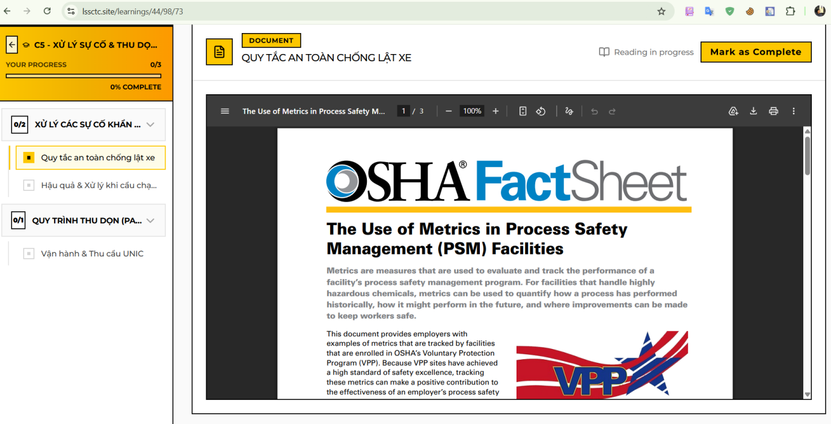

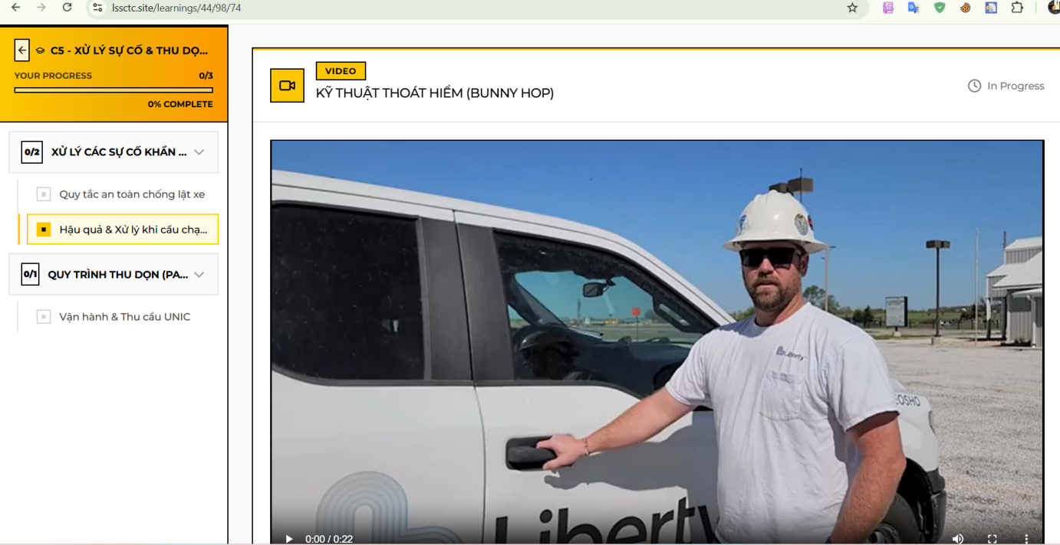

**Take Quiz (Làm bài kiểm tra)**

**Description:** Trainees take multiple-choice assessments to validate their knowledge. The system manages attempt limits, calculates scores in real-time, and provides immediate feedback. **Trigger:** Select a "Quiz" activity from the Course Sidebar. **URL:** /trainee/learn/.../quiz/:quizId

**Usage Steps:**

1. **View Quiz Info:**
   * The start screen displays: Quiz Title, Description, Time Limit, and Remaining Attempts (calculated via MaxAttempts - CurrentAttempts).
2. **Attempt Quiz:**
   * Click "Bắt đầu làm bài" (Start Quiz).
   * Select answers for each question. The system supports Single Choice and Multiple Choice formats.
   * A countdown timer (HeaderTimer) tracks the remaining time.
3. **Submit & Review:**
   * Click "Nộp bài" (Submit). The system calculates the score based on: (Correct Answers / Total Questions) \* 10.
   * **Pass/Fail Logic:** If Score ≥ PassingScore, the activity status updates to "Passed".
   * The "Result" screen displays the final score and allows reviewing answers (if configured).

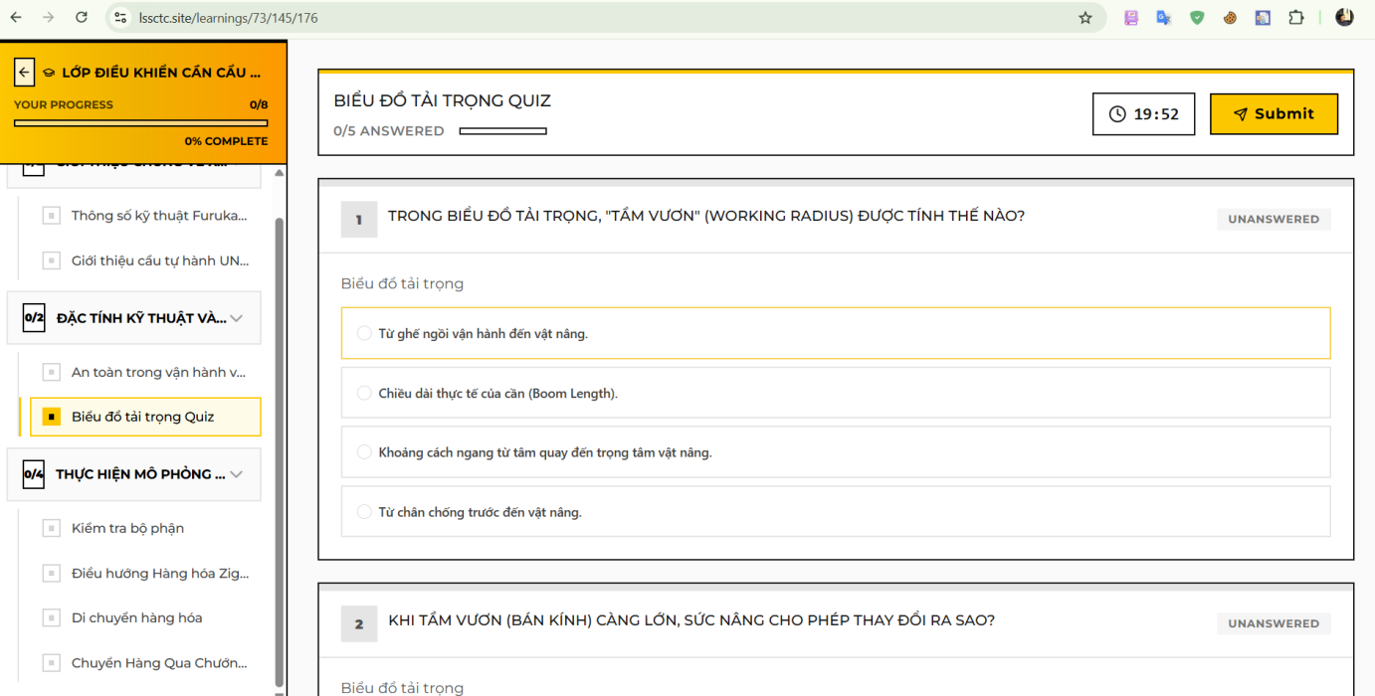

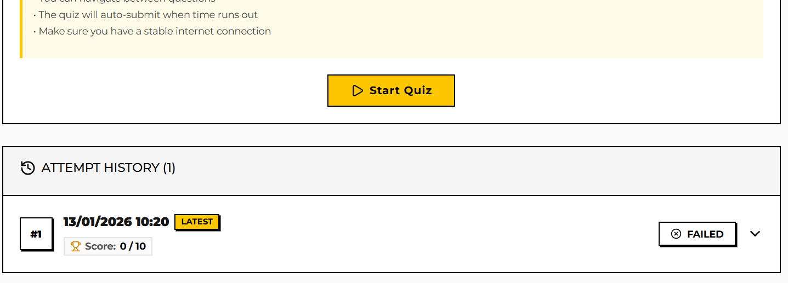

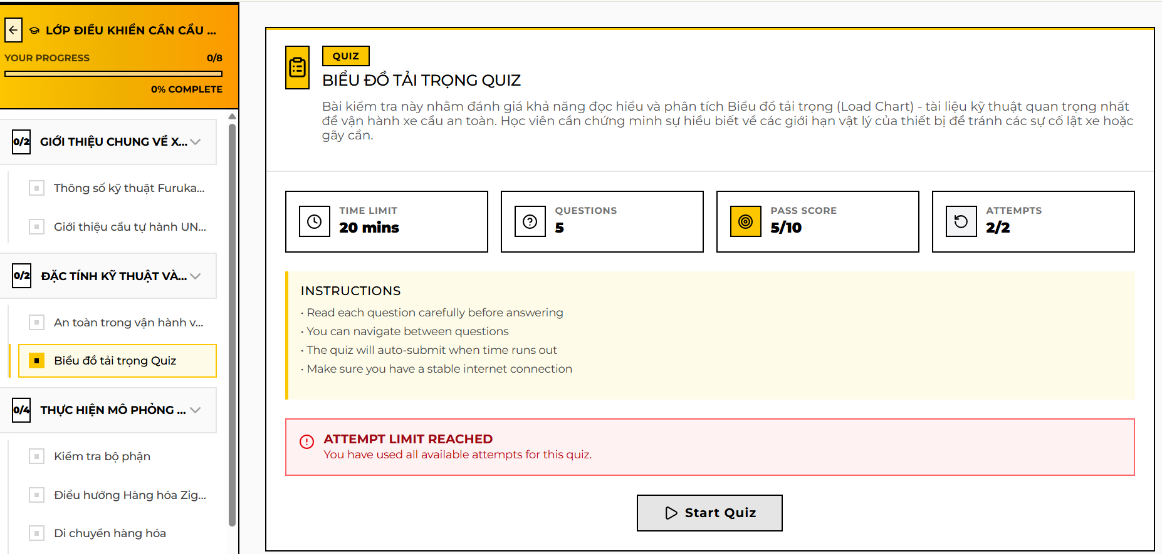

**View & Take Final Exam (Thi cuối khóa)**

**Description**: Trainees shall see their available status for the final exam of a specific class, and they can check related information with the final exam policy or results.

**Usage steps:**

1. Navigate to a specific class that you are enrolled in.
2. Click “Final exam” or “Thi cuối khóa”

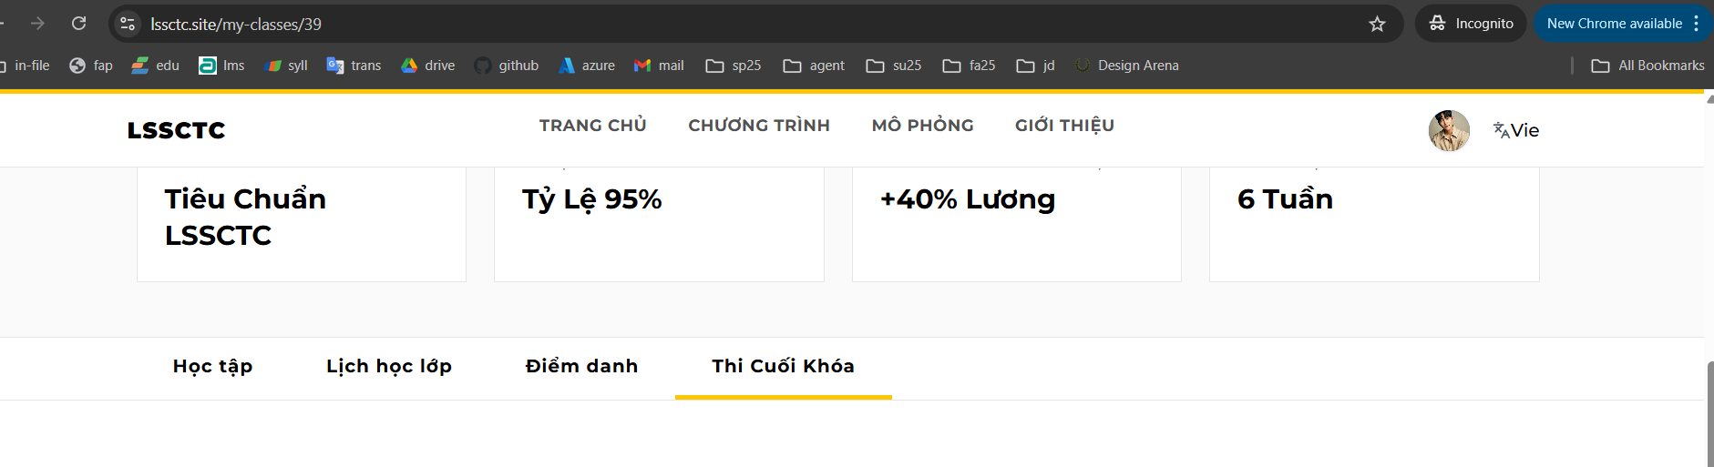

1. View the final exam open status and your prerequisites (if there is any). Final exam open status should be one of “Open” (Đang mở), “Not yet” (Chưa mở), “Closed” (Đã đóng).

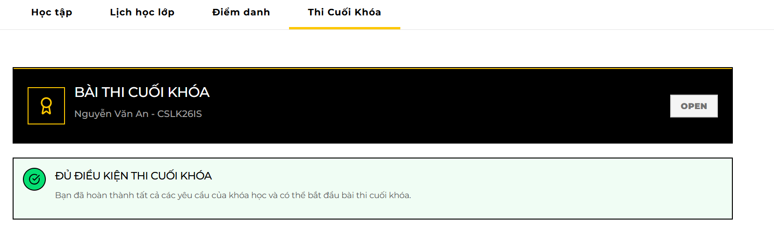

1. View the final exam detail partials and the specific date that the training center provides.

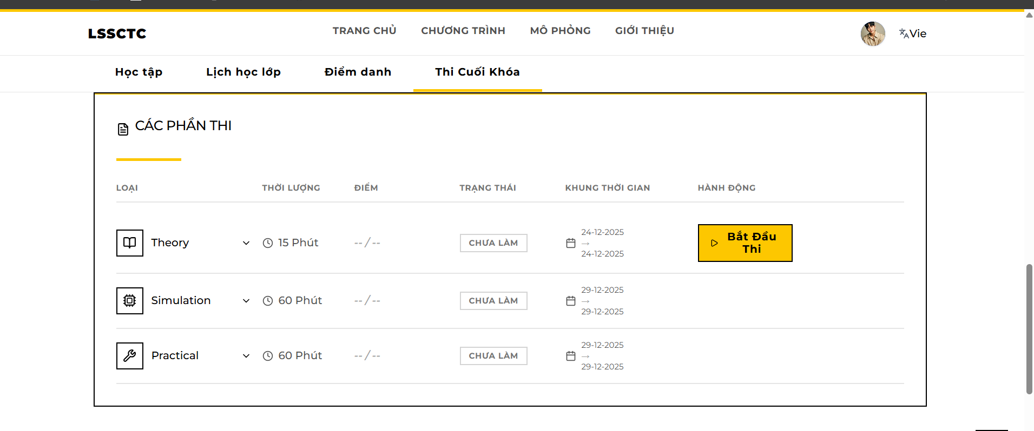

1. Follow instructor guide and allowance to attempt the exam. Usually, you should be appeared at a target place which is notified by the training center before the attempt.
2. Theory Exam requires access code (Mã làm bài) which is provided by instructor or center staff.

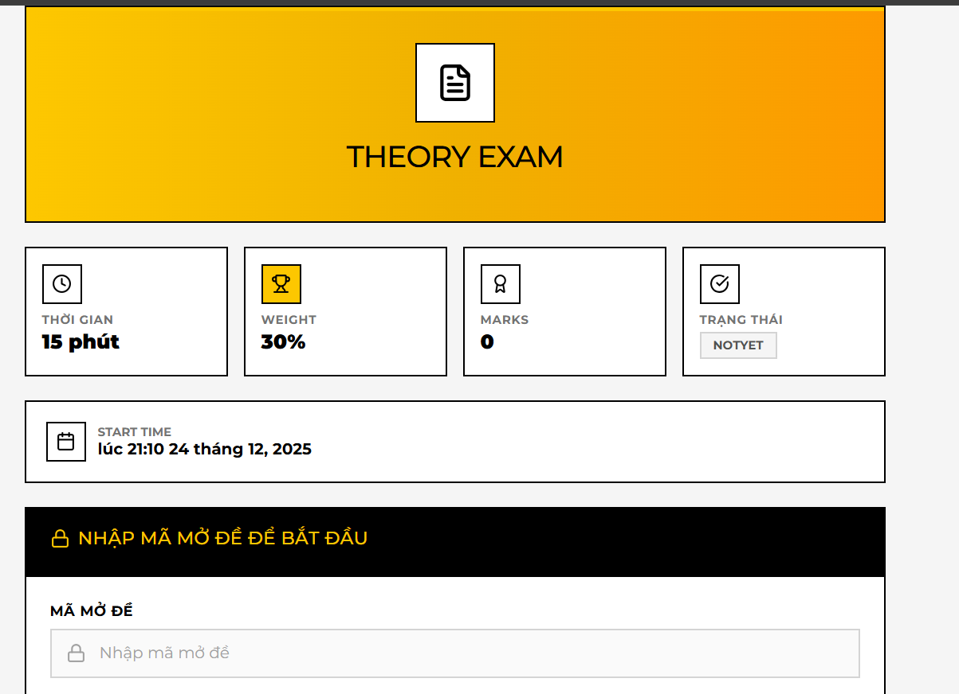

1. Simulation Exam is taken inside simulation engine in the same way with simulation practice.
2. Practical Exam is graded by instructor or assigned examiner. Trainees shall follow instructor / examiner steps to finish the practical exam.

**View & Download Certificate (Chứng chỉ)**

**Description:** A display of all certifications earned by the trainee upon completing courses. It provides visual indicators for certificate validity and allows downloading the official certificate file. **Trigger:** Select "Chứng chỉ" (Certificates) from the Sidebar. **URL:** /trainee/certificates

**Usage Steps:**

1. **View List:**
   * Click on user avatar and select Accomplishments / Thành tích.

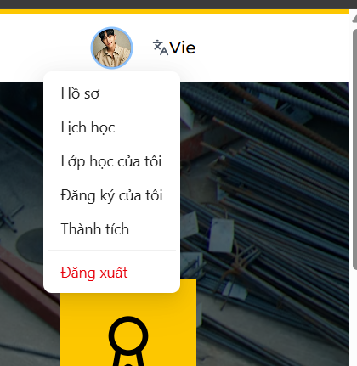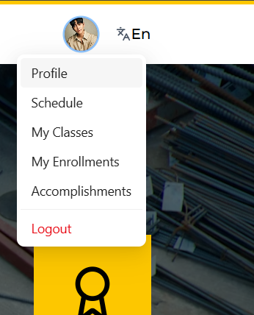

* + The page displays cards for each earned certificate containing: Course Name, Issue Date, and Expiration Date.



1. **Detail Preview:**
   * Click on a specific certificate to see the detail preview on website, information included in a certificate should includes:

* **Valid:** Displayed with a **Yellow/Standard** badge if the expiration date is far in the future.
* **Expiring Soon:** Displayed with an **Amber** badge if the certificate expires in less than **90 days**.
* **Expired:** Displayed with a **Red** badge if ExpireDate < CurrentDate.

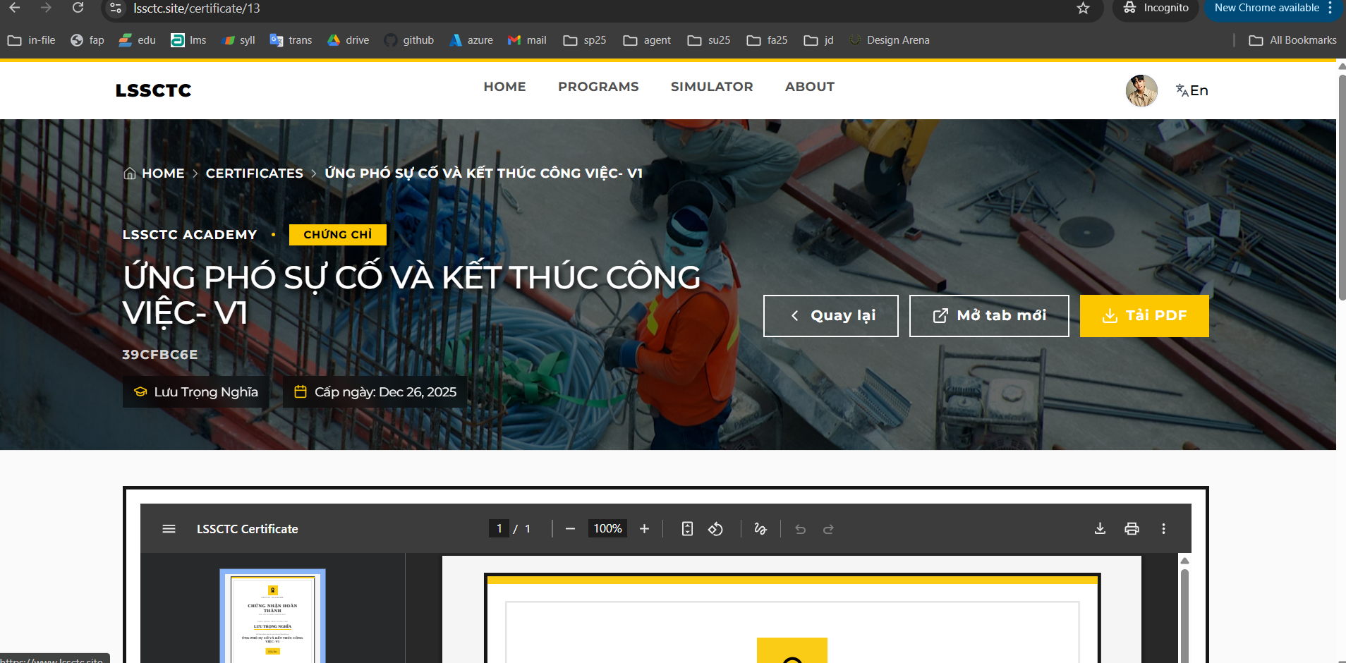



1. **Download:**
   * Click the "Download" or "Tải PDF" button to retrieve the generated PDF certificate from the center.

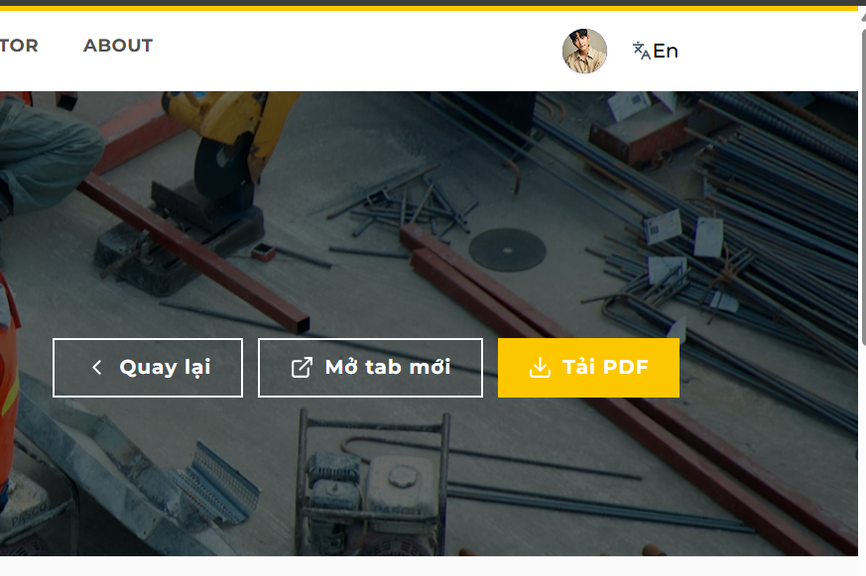

* + PDF format of the certificate should be opened on a new tab, and we can download it by clicking onto the download icon on the right side of task bar.



* + For a different approach, we shall print the certificate directly instead of downloading it.

